MATHEMATICS



## STANDARD SEVEN



**The Constitution of India**

## Chapter IV A

**Fundamental Duties**

**ARTICLE 51A**

**Fundamental Duties- It shall be the duty of every citizen of India-**

1. to abide by the Constitution and respect its ideals and institutions, the National Flag and the National Anthem;
2. to cherish and follow the noble ideals which inspired our national struggle for freedom;
3. to uphold and protect the sovereignty, unity and integrity of India;
4. to defend the country and render national service when called upon to do so;
5. to promote harmony and the spirit of common brotherhood amongst all the people of India transcending religious, linguistic and regional or sectional diversities, to renounce practices derogatory to the dignity of women;
6. to value and preserve the rich heritage of our composite culture;
7. to protect and improve the natural environment including forests, lakes, rivers and wild life and to have compassion for living creatures;
8. to develop the scientific temper, humanism and the spirit of inquiry

and reform;

1. to safeguard public property and to abjure violence;
2. to strive towards excellence in all spheres of individual and collective activity so that the nation constantly rises to higher levels of endeavour and achievement;
3. who is a parent or guardian to provide opportunities for education to his child or, as the case may be, ward between the age of six and fourteen years.

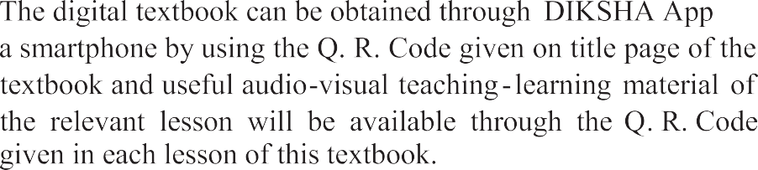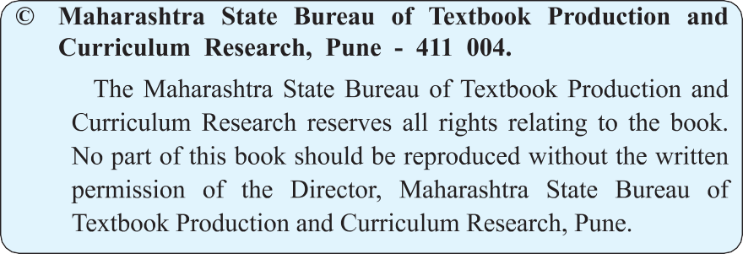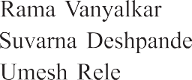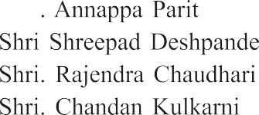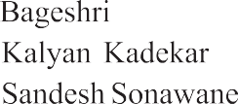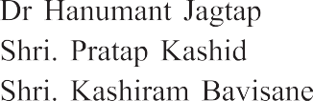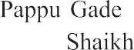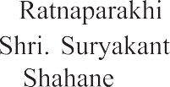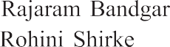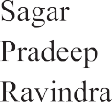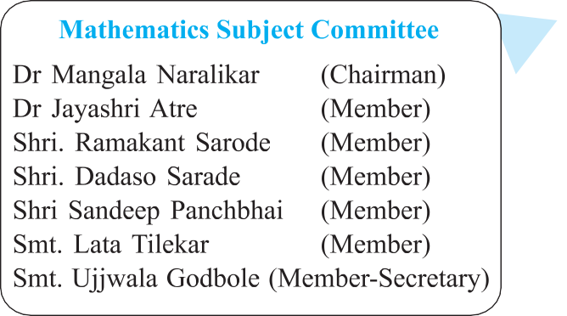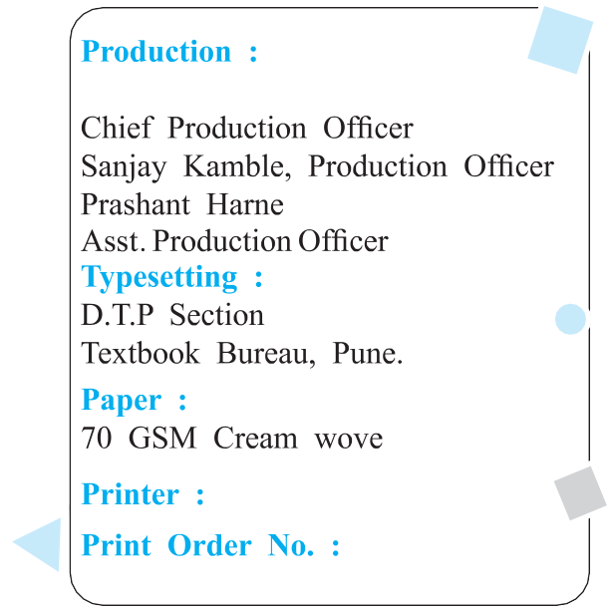

**Fifth Reprint : 2022**

Assistant Special Officer, English

Sachin Mehta

Harshwardhan Offset,Kolhapur

N/PB/2022-23/15,000

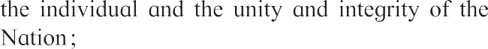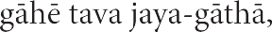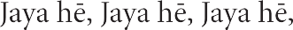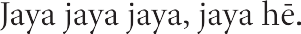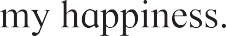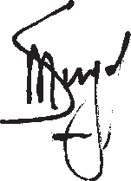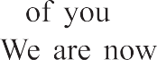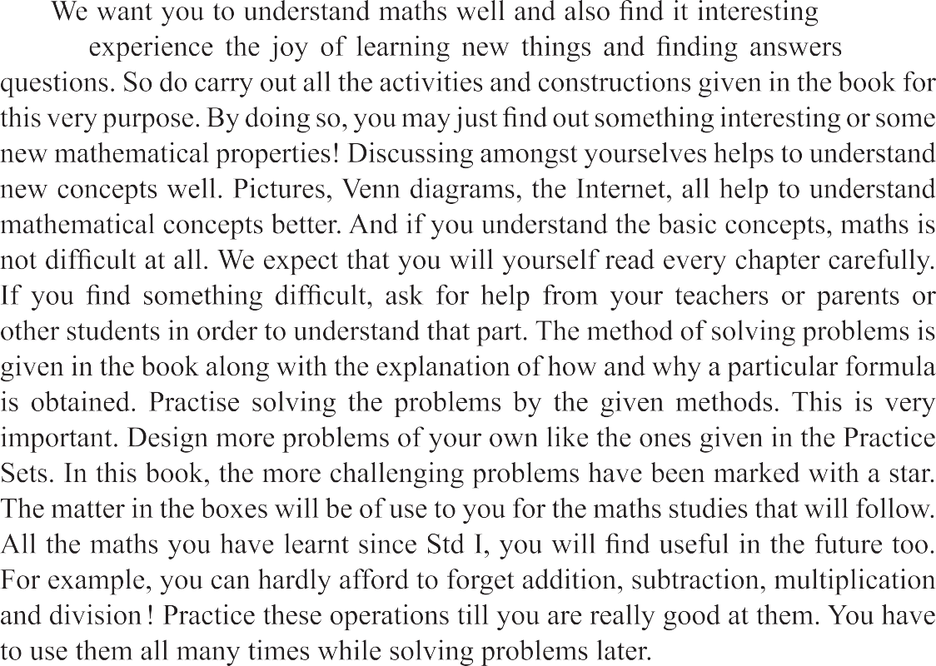

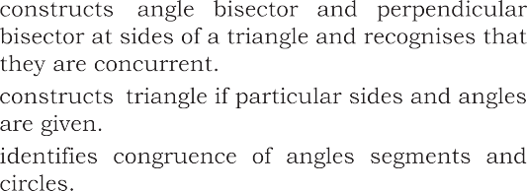   

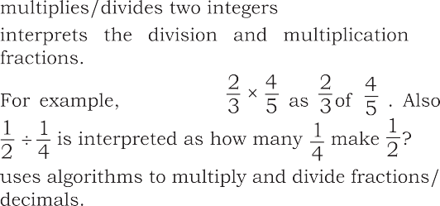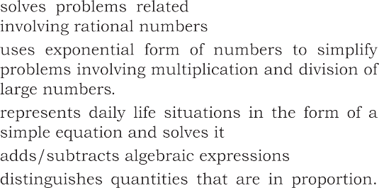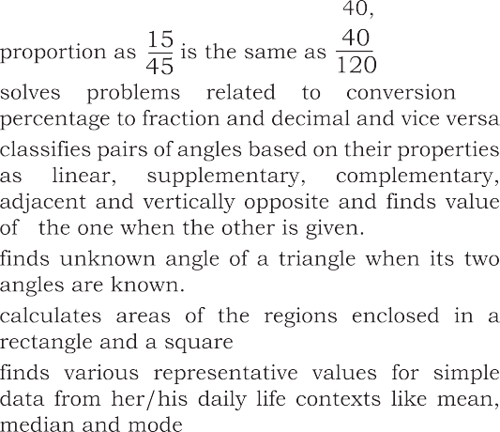



|  |  |
| --- | --- |
|  |  |
|  |  |

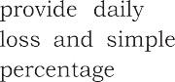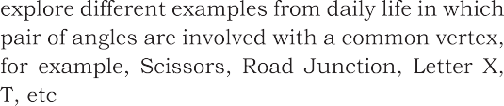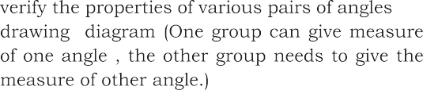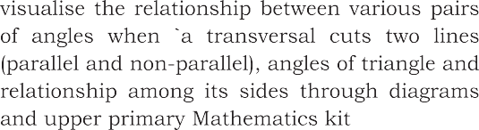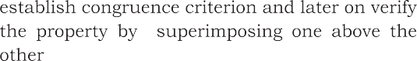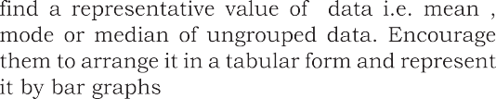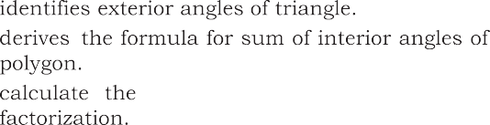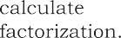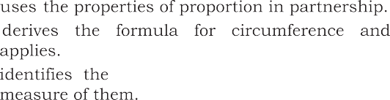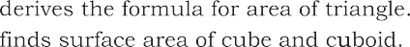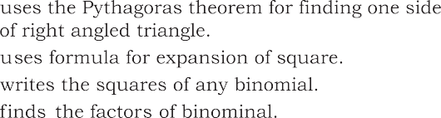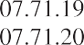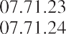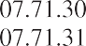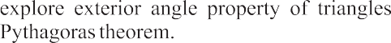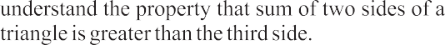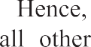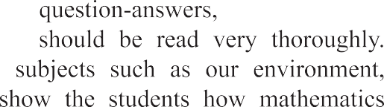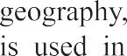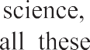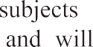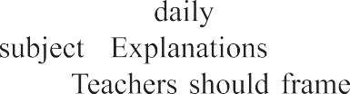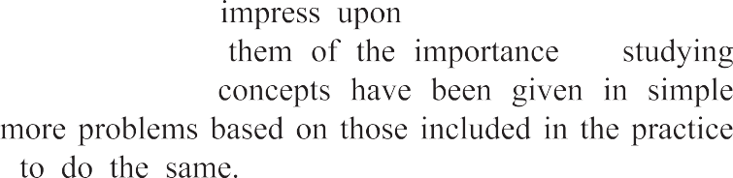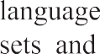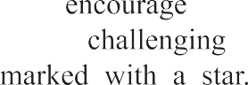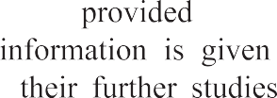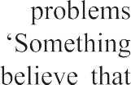

1

Geometrical Constructions Part One

In previous classes, we have learnt about the line, line segment, angle, angle bisector, etc. We measure an angle in degrees. If ABC measures 40°, we write it as *m*ABC = 40°.



A

M

C



**Let’s recall.**

Angle Bisector

You see the figure of ABC alongside.

An angle bisector divides an angle into two

### B

equal parts. Is ray BM the bisector of ABC?

Perpendicular Bisector of a Line Segment



C

M

P

S

D

Draw a line segment PS of length 4 cm and draw its perpendicular bisector.

Name it line CD.

* How will you verify that CD is the perpendicular bisector?

*m*CMS = °

* Is *l*(PM) = *l*(SM)?

The Property of the Angle Bisectors of a Triangle



**Let’s learn.**

**Activity**

* 1. Draw any PQR.
  2. Use a compass to draw the bisectors of all

three of its angles. (Extend the bisectors, if P



A

C

I

B

necessary, so that they intersect one another.)

* 1. These three bisectors pass through the same point. That is, they are **concurrent**.

Name the point of concurrence ‘I’. Note that

the point of concurrence of the angle bisectors

of a triangle is in the interior of the triangle. Q R

* 1. Draw perpendiculars IA, IB and IC respectively from I on to the sides of the

triangle PQ, QR and PR. Measure the lengths of these perpendiculars.

Note that IA = IB = IC.

The Property of Perpendicular Bisectors of the Sides of a Triangle

**Activity**

1. Use a ruler to draw an acute-angled triangle and an obtuse-angled triangle. Draw the perpendicular bisectors of each

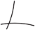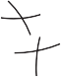

X

C

Y

C

X

side of the two triangles. Z

Y

1. In each triangle, note that the

perpendicular bisectors of the sides are concurrent.

1. Name their point of concurrence ‘C’. Measure the distance between C and the vertices of the triangle.

Note that CX = CY = CZ Z

1. Observe the location of the point of concurrence of the perpendicular bisectors.



* **Something more**

(1)

I

The angle bisectors of a triangle are **concurrent**. Their point of concurrence is called the **incentre**,

and is shown by the letter ‘I’.

(2) The perpendicular bisectors of the sides of a triangle are **concurrent**. Their point of concurrence is called the **circumcentre** and is shown by the letter ‘C’.

C

**Practice Set 1**

1. Draw line segments of the lengths given below and draw their perpendicular bisectors.

(1) 5.3 cm (2) 6.7 cm (3) 3.8 cm

1. Draw angles of the measures given below and draw their bisectors.

(1) 105° (2) 55° (3) 90°

1. Draw an obtuse-angled triangle and a right-angled triangle. Find the points of concurrence of the angle bisectors of

each triangle. Where do the points of concurrence lie?

1. Draw a right-angled triangle. Draw the perpendicular bisectors of its sides. Where does the point of concurrence lie ?

5*. Maithili, Shaila and Ajay live in three different places in the city. A toy shop is equidistant from the three houses. Which geometrical construction should be used to represent this? Explain your answer.

Construction of a Triangle



**Let’s learn.**

**Activity**

Let us see if we can draw the triangles when the measures of some sides and angles, are given.

Before constructing any building, the structure of the building is first drawn on paper. You might have even seen a small model of some such building. It becomes easier to construct the building from a drawing. In a similar way, a rough sketch of a geometrical construction makes it easier to draw the required figure. It helps to plan the sequence of the steps in the construction.

Draw ABC such that

*l*(AB) = 4 cm, and *l*(BC) = 3 cm.

* Can this triangle be drawn?
* A number of triangles can be drawn to fulfil these conditions. Try it out.
* Which further condition must be placed if we are to draw a unique triangle using the above information?
  1. **To construct a triangle given the lengths of its three sides**

**Example** Draw XYZ such that *l*(XY) = 6 cm, *l*(YZ) = 4 cm, *l*(XZ) = 5 cm

* Let us draw a rough figure quickly and show the given information in it as accurately as possible. For example, side XY is the longest, so, in the rough figure, too, XY should be the longest side.

**Steps**

* + 1. According to the rough figure, segment XY of length 6 cm is drawn as the base.
    2. As *l*(XZ) is 5 cm, draw an arc on one side of seg XY with the compass opened to 5 cm and with its point at X.

Z

* + 1. Next, with the point at Y and the compass opened to 4 cm, draw an arc to cut the first arc at Z. Draw segs XY and YZ.

### X

A similar construction can be drawn on X

the other side of the base as shown below.

Z Rough figure

### X Y

6 cm

### Y

6 cm

6 cm

### Y

Z

#### X 6 cm Y

Rough figure

### Z

**Practice Set 2**

1. Draw triangles with the measures given below.
   1. In ABC, *l*(AB) = 5.5 cm,

*l*(BC) = 4.2 cm, *l*(AC) = 3.5 cm

* 1. In STU, *l*(ST) = 7 cm,

*l*(TU) = 4 cm, *l*(SU) = 5 cm

* 1. In PQR, *l*(PQ) = 6 cm,

*l*(QR) = 3.8 cm, *l*(PR) = 4.5 cm

1. Draw an isosceles triangle with base 5 cm and the other sides 3.5 cm each.
2. Draw an equilateral triangle with side 6.5 cm.
3. Choose the lengths of the sides yourself and draw one equilateral, one isosceles and one scalene triangle.
   1. **To construct a triangle given two sides and the angle included by them Example** Draw PQR such that *l*(PQ) = 5.5 cm, *m*P = 50°, *l*(PR) = 5 cm.

(A rough figure has been drawn showing the given information. P is an acute angle and that is shown in the rough figure, too. )

Steps

R

P 50

#### 5.5 cm

Rough figure

### Q

* + 1. According to the rough figure, seg PQ forms the base of length 5.5 cm.
    2. Ray PG is drawn so that *m*GPQ = 50°
    3. Open the compass to 5 cm. Placing the compass point on P, draw an arc to cut ray PG at R. Join points Q and R. PQR is the required triangle.

### P Q



G

R

50

#### 5.5 cm

The ray PG may be drawn on the other side

of the seg PQ. Its rough figure will be as P



50

R

G

shown below.

#### cm Q

Rough figure

### P Q

5.5 cm

50

R

**Practice Set 3**

* Draw triangles with the measures given below.
  + 1. In MAT, *l*(MA) = 5.2 cm,

*m*A = 80°, *l*(AT) = 6 cm

* + 1. In ∆NTS, *m*T = 40°,

*l*(NT) = *l*(TS) = 5 cm

* + 1. In FUN, *l*(FU) = 5 cm,

*l*(UN) = 4.6 cm, *m*U = 110°

* + 1. In ∆PRS, *l*(RS) = 5.5 cm,

*l*(RP) = 4.2 cm, *m*R = 90°

* 1. To construct a triangle given two angles and the included side

**Example** Construct ∆XYZ such that *l*(YX) = 6 cm, *m*ZXY = 30°, *m*XYZ = 100°

XYZ is an obtuse angle and that is shown in the rough figure.

Steps

* + 1. According to the rough figure, draw seg YX as base of length 6 cm.
    2. Draw ray YR such that

*m*XYR = 100°

* + 1. On the same side of seg YX as point R, draw ray XD so that *m*YXD = 30°. Name the point of intersection of rays YR and XD, Z.

XYZ is the required triangle.

* + 1. See how an identical triangle can be drawn on the other side of the base.

Z Rough figure

### Y X



D

R

Z

100

30

Y

100

30

X



**Use your brain power.**

**Example** In ABC, *m*A = 60°, *m*B = 40°, *l*(AC) = 6. Can you draw ∆ABC?

What further information is required before it can be drawn? Which property can be used to get it? Draw the rough figure to find out.

Recall the property of the sum of the angles of a triangle. Using that property, can we find the measures of two angles and an included side AC ?

**Practice Set 4**

* Construct triangles of the measures given below.

1. In SAT, *l*(AT) = 6.4 cm,

*m*A = 45°, *m*T = 105°

1. In MNP, *l*(NP) = 5.2 cm,

*m*N = 70°, *m*P = 40°

1. In EFG, *l*(EG) = 6 cm,

*m*F = 65°, *m*G = 45°

1. In XYZ, *l*(XY) = 7.3 cm,

*m*X = 34°, *m*Y = 95°

* 1. To construct a right-angled triangle given the hypotenuse and one side

We know that a triangle with a right angle is called a right-angled triangle. In such a triangle, the **side opposite the right angle** is called the **hypotenuse**.

**Example** Draw LMN such that *m*LMN = 90°, hypotenuse = 5 cm, *l*(MN) = 3 cm.

Let us draw the rough figure using the given information.

As *m*LMN = 90°, we draw a right-angled triangle approximately and mark the right angle. Thus we show the given information in the rough figure.

Steps

* + 1. As shown in the rough figure, draw the base seg MN of length 3 cm.
    2. At point M of seg MN, draw ray MT to make an angle of 90° to seg MN.
    3. Opening the compass to 5 cm and with the point at N, draw an arc to cut seg MT at L.

∆LMN is the required triangle.

* + 1. Note that a similar figure can be drawn on the other side of the base.

L Rough figure

### M N

3 cm

T



L

M N

#### 3 cm

**Practice Set 5**

* Construct triangles of the measures given below.

1. In ∆MAN, *m*MAN = 90°,

*l*(AN) = 8 cm, *l*(MN) = 10 cm.

1. In the right-angled ∆STU, hypotenuse SU = 5 cm and *l*(ST) = 4 cm.
2. In ∆ABC, *l*(AC) = 7.5 cm,

*m*ABC = 90° , *l*(BC) = 5.5 cm.

1. In ∆PQR, *l*(PQ) = 4.5 cm,

*l*(PR) = 11.7 cm, *m*PQR = 90°.

1. Students should take examples of their own and practise construction of triangles.

Activity

Try to draw triangles with the following data.

* 1. ∆ABC in which *m*A = 85°, *m*B = 115° *l*(AB) = 5 cm
  2. ∆PQR in which *l*(QR) = 2 cm, *l*(PQ) = 4 cm, *l*(PR) = 2 cm

Could you draw these triangles? If not, look for the reasons why you could not do so.

* **An activity for learning something more**

**Example** Draw ABC such that *l*(BC) = 8 cm, *l*(CA) = 6 cm, *m*ABC = 40°.

Draw a ray to make an angle of 40° with the base BC, *l*(BC) = 8 cm.

We have to obtain point ‘A’ on the ray. With ‘C’ as the centre, draw an arc of radius 6 cm to do so. What do we observe? The arc intersects the

ray in two different points. Thus, we get two triangles of two different shapes having the given measures.

Can a triangle be drawn if the three angles are given, but not any side?

How many such triangles can be drawn?

Congruence of Segments



**Let’s learn.**

**Activity I** Take a rectangular paper. Place two

opposite sides one upon the other. B

They coincide exactly.

**Activity II** Using the ruler measure the lengths

of seg AB and seg PQ. A

*l*(AB) = ............. *l*(PQ) = ............. P Q

Are they of the same length? You cannot pick up and place one segment over the other. Trace the seg AB along with the names of the points on a sheet of transparent paper. Place this new segment on seg PQ. Verify that if point A is placed on point P, then B falls on Q. It means that seg AB is **congruent** with seg PQ.

We can infer from this that if two line segments have the same lengths, they coincide exactly with each other. That is, they are **congruent**. If seg AB and seg PQ are congruent, it is written as seg AB  seg PQ.



**Now I know !**

If given line segments are equal in length, they are congruent.

 If seg AB  seg PQ it means that seg PQ  seg AB.

 Note also that if seg AB  seg PQ and seg PQ  seg MN, then seg AB  seg MN.

In other words, if one line segment is congruent to another and that segment is congruent to a third, then the first segment is also congruent to the third.

Activity I

Take any box. Measure the lengths of each of its edges. Which of them are congruent?

Activity II

From the shape shown below, write the names of the pairs of congruent line segments.

### A D

C

E

* + 1. seg AB  seg DC

### B

* + 1. seg AE  seg BH

F (3) seg EF  seg .......

H G (4) seg DF  seg .......

**Practice Set 6**

1. Write the names of pairs of congruent line segments. (Use a divider to find them.)

### B

N

G

M

R

D

E

* 1. ...........................
  2. ...........................
  3. ...........................
  4. ...........................

### C

1. On the line below, the distance between any two adjoining points shown on it is equal. Hence, fill in the blanks.

### Q P Z Y X W A B C



(i) seg AB  seg....... (ii) seg AP  seg....... (iii) seg AC  seg.......

1. seg.......  seg BY (v) seg.......  seg YQ (vi) seg BW  seg.......

Congruence of Angles



**Let’s learn.**

Observe the given angles and write the names of those having equal measures.

A N



P

100

Q



90

I

T

T



35

B

C

S R



90

P I



S

35



R

100

M T S

**Activity**



L

40



X

40

### M N Y Z

Draw two angles LMN and XYZ of 40° each as shown in the figure. Trace the arms of LMN and the names of the points on a transparent paper. Now lift the transparent paper and place the angle you obtain on XYZ. Observe that if point M is placed on Y and ray MN on ray YZ, then ray ML falls on ray YX. We can infer that angles of equal measure are congruent. The congruence of angles does not depend on the length of their arms. It depends upon the measures of those angles. That LMN is congruent with XYZ is written as LMN  XYZ.



**Now I know !**

Two angles with equal measures are congruent to each other.

 If LMN  XYZ then XYZ  LMN.

 If LMN  ABC and ABC  XYZ then LMN  XYZ.



**Let’s discuss.**

1. What time does this clock show?
2. 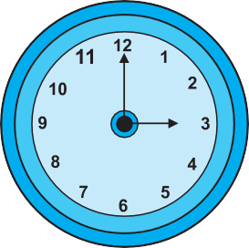What is the measure of the angle between its two hands?
3. At which other times is the angle between the hands congruent with this angle?

**Practice Set 7**

* Some angles are given below. Using the symbol of congruence write the names of the pairs of congruent angles in these figures.

### S



A

B

45

D

O

30

C

**Let’s learn.**



P

90

Q

R

L

### M



45

R

T



30

N

Congruence of Circles

(a) (b) (c) (d)

1 cm

2 cm

1 cm

1.3 cm

Activity I

Observe the circles in the figures above. Draw similar circles of radii 1 cm, 2 cm, 1 cm and 1.3 cm on a paper and cut out these circular discs. Place them one upon the other to find out which ones coincide exactly.

**Observations** : 1. The circles in (a) and (c) coincide.

2. Circles in fig (b) and (c) and in fig (a) and (d) do not coincide. Are there other pairs like these ?

Circles which coincide exactly are said to be **congruent circles.**

**Activity II** Get bangles of different sizes but equal thickness and find the congruent ones among them.

**Activity III** Find congruent circles in your surroundings.

**Activity IV** Take some round bowls and plates. Place their edges one upon the other to find pairs of congruent edges.



**Now I know !**

Circles of equal radii are congruent circles.



**ICT Tools or Links**

Use the construction tools in the Geogebra software to draw triangles and circles.





2

Multiplication and Division of Integers

* + In the previous class, we have learnt to add and subtract integers. Using those methods, fill in the blanks below.



**Let’s recall.**

(1) 5 + 7 =  (2) 10 + ( 5) =  (3) 4 + 3 =

(4) ( 7) + ( 2) =  (5) (+ 8) (+ 3) =  (6) (+ 8) ( 3) =

* + Write a number in each bracket to obtain the answer ‘3’ in each operation.

( 6) + ( ) 4 ( ) 7 + ( )

3

( 5) ( ) 8 + ( ) 9 ( )

Multiplication of Integers



**Let’s learn.**

Mayuri’s bicycle got punctured on the way back from school and she did not have enough money to get it repaired. Sushant, Snehal and Kalpana lent her five rupees each. Thus she borrowed 15 rupees altogether and got the bicycle repaired. We show borrowed money, or a debt, using the ‘ ’ (minus) sign. That is, Mayuri had a debt of 15 rupees or Mayuri had

15 rupees.

We see here that ( 5) + ( 5) + ( 5) = 15 Hence note that ( 5) × 3 = 3 × ( 5) = 15

Of course, Mayuri paid back her debt the next day.

We have learnt the multiplication and division of whole numbers. We have even made tables to carry out the multiplication. Now let us learn to multiply integers i.e. multiplication of numbers in the set that includes negative numbers, positive numbers and zero.

( 3) + ( 3) + ( 3) + ( 3) This addition is the addition of ( 3) taken 4 times. It equals 12. It can be written as ( 3) × 4 = 12.

Similarly, ( 5) × 6 = 30, ( 7) × 2 = 14, 8 × ( 7) = 56

Now, let us make the table of ( 4).

( 4) × 0 = 0

( 4) × 1 = 4

( 4) × 2 = 8

( 4) × 3 = 12

Observe the pattern here. As the multiplier of ( 4) increases by 1, the product is reduced by 4.

Keeping the same pattern, if we extend the table upwards, decreasing the multiplier, this is what we will get.

( 4) × ( 2) = 8

( 4) × ( 1) = 4

( 4) × 0 = 0

As the multiplier of ( 4) decreases by one unit, the product increases by 4.

The table for ( 5) is given below. Complete the tables of ( 6) and ( 7).

|  |  |  |
| --- | --- | --- |
| ( 5) × ( 3) = 15 | ( 6) × ( 3) = | ( 7) × ( 3) = |
| ( 5) × ( 2) = 10 | ( 6) × ( 2) = | ( 7) × ( 2) = |
| ( 5) × ( 1) = 5 | ( 6) × ( 1) = | ( 7) × ( 1) = |
| ( 5) × 0 = 0 | ( 6) × 0 = | ( 7) × 0 = |
| ( 5) × 1 = 5 | ( 6) × 1 = | ( 7) × 1 = |
| ( 5) × 2 = 10 | ( 6) × 2 = | ( 7) × 2 = |
| ( 5) × 3 = 15 | ( 6) × 3 = | ( 7) × 3 = |
| ( 5) × 4 = 20 | ( 6) × 4 = | ( 7) × 4 = |

Now I know !



* The product of two positive (+ve) integers is a positive (+ve) integer.
* The product of one positive (+ve) and one negative ( ve) integer is a negative integer.
* The product of two negative ( ve) integers is a positive (+ve) integer.

(+ve number) × (+ve number) = (+ve number) (+ve number) × ( ve number) = ( ve number) ( ve number) × (+ve number) = ( ve number) ( ve number) × ( ve number) = (+ve number)

|  |  |  |
| --- | --- | --- |
|  | **Practice Set 8** |  |
| * Multiply.   (i) ( 5) × ( 7) | (ii) ( 9) × (6) (iii) (9) × ( 4) | (iv) (8) × ( 7) |
| (v) ( 124) × ( 1) | (vi) ( 12) × ( 7) (vii) ( 63) × ( 7) | (viii) ( 7) × (15) |

Division of Integers



**Let’s learn.**

We have learnt how to divide one positive integer by another. We also know that the quotient of such a division may be an integer or a fraction.

**Example** 6 ÷ 2 = 6

2

= 3, 5 ÷ 3 = 5

3

= 1 + 2

3

On the number line, we can show negative integers on the left of the zero. We can show parts of integers also in the same way.

− 5 2



− 3 2

3 5

2 2

#### -4 -3 -2 -1 0 1 2 3 4

Here, the numbers  5

2

,  3 2

, 3 2

, 5 2

are shown on the number line.

  1 , 1  3 , 3  5 , 5

Note that  2 2 ,  2  ,  2  are mutually opposite numbers.



2



2









1

That is, 2

+ 1 = 0, 3

2 2

+ 3

2

= 0, - 5 2

5

2 = 0

+

Pairs of opposite numbers are also called pairs of additive inverse numbers. We have

seen that (- 1) × (- 1) = 1. If the two sides of this equation are divided by (-1) we get

the equation (- 1) = 1

1

1

. Therefore, the quotient of the division 1

is (-1).

Hence, we see that 6 × (- 1) = 6 ×

1

1 =

6

1 .

To divide any positive integer by a negative integer

|  |  |  |  |  |  |  |
| --- | --- | --- | --- | --- | --- | --- |
| 7 = 7 1 = 7 × 1 × 1 = 7 × (- | | | | 1) × 1 = | 71 | =  7 |
| 2 | 1 2 | 1 | 2 1 | 2 | 2 | 2 |

**To divide any negative integer by a negative integer**

13 =

113

=

1 13  1

= 1 1  13  1 13  13

2 1 2

1

25

2

25

1 2 2 2

18 18

Similarly, verify that

− 4 = 4 ,

2 =

2 = 9 etc.

This explains the division of negative integers.

When one integer is divided by another non-zero integer, it is customary to write the denominator of the quotient as a positive integer.

Hence we write 7

2

=  7 2

11 11

3 = 3

,



**Now I know !**

The rules of division of integers are like the rules of multiplication of integers.

* We cannot divide any number by zero.
* The quotient of two positive integers is a positive number.
* The quotient of two negative integers is a positive number.
* The quotient of a positive integer and a negative integer is always a negative number.

|  |  |  |  |
| --- | --- | --- | --- |
| **Practice Set 9** | | | |
| 1. Solve :    1. (- 96) ÷ 16 | (ii) 98 ÷ (- 28) | (iii) (- 51) ÷ 68 | (iv) 38 ÷ (- 57) |
| (v) (- 85) ÷ 20  (ix) 78 ÷ 65 | (vi) (-150) ÷ (- 25)  (x) (- 5) ÷ (- 315) | (vii) 100 ÷ 60 | (viii) 9 ÷ (- 54) |

2*. Write three divisions of integers such that the fractional form of each will be

24

5 .

3*. Write three divisions of integers such that the fractional form of each will be 5 .

7

4. The fish in the pond below, carry some numbers. Choose any 4 pairs and carry out four multiplications with those numbers. Now, choose four other pairs and carry out divisions with these numbers.

For example,

1. 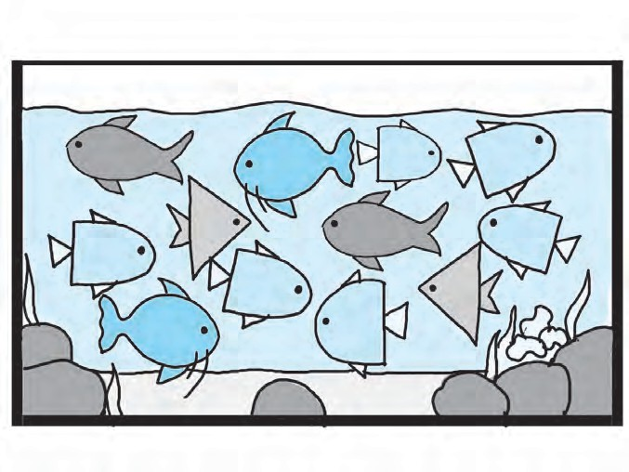(-13) × (-15) = 195 2. (-24) ÷ 9 = 24  8

9 3

- 13 - 27 - 24 + 9

- 15

+ 41 + 12 + 13

- 8

- 18

- 28

- 37





3

HCF and LCM

* Which is the smallest prime number?



**Let’s recall.**

* List the prime numbers from 1 to 50. How many are they?
* Circle the prime numbers in the list below.

17, 15, 4, 3, 1, 2, 12, 23, 27, 35, 41, 43, 58, 51, 72, 79, 91, 97

**Co-prime numbers :** Two numbers which have only 1 as a common factor are said to be **co-prime** or **relatively prime** or **mutually prime numbers**.

For example, 10 and 21 are co-primes, because the divisors of 10 are 1, 2, 5, 10

while the divisiors of 21 are 1, 3, 7, 21 and the only factor common to both 10

and 21 is 1.

Some other co-prime numbers are (3, 8) ; (4, 9); (21, 22) ; (22, 23) ; (23, 24). Verify that any two consecutive natural numbers are co-primes.

Twin Prime Numbers



**Let’s learn.**

If the difference between two co-prime numbers is 2, the numbers are said to be twin prime numbers.

For example : (3, 5) ; (5, 7) ; (11, 13) ; (29, 31) etc.

**Practice Set 10**

1. Which number is neither a prime number nor a composite number?
2. Which of the following are pairs of co-primes?

(i) 8, 14 (ii) 4, 5 (iii) 17, 19 (iv) 27, 15

1. List the prime numbers from 25 to 100 and say how many they are.
2. Write all the twin prime numbers from 51 to 100.
3. Write 5 pairs of twin prime numbers from 1 to 50.
4. Which are the even prime numbers?

Factorising a Number into its Prime Factors



**Let’s learn.**

A simple but important rule given by Euclid is often used to find the GCD or HCF and LCM of numbers. The rule says that **any composite number can be written as the product of prime numbers**.

Let us learn how to find the prime factors of a number.

**Example** Write the number 24 in the form of the product of its prime factors.

Method for finding prime factors

Vertical arrangement

24 = 2 × 12

Horizontal arrangement

= 2 × 2 × 6 ...12 is factorised.

2 24

2 12

2 6

3 3

1

= 2 × 2 × 2 × 3 ...6 is factorised. The prime factors are 2 and 3.

24 = 2 × 2 × 2 × 3

**Remember :**

**To write a given number as a product of its prime factors is to factorise it into primes.**

**Example** Write each of the given numbers as a product of its prime factors.

63

7



9

7 

3 

3

45

5 

9

5

 3  3

20

2

 10

2 

2 

5

63 = 7 × 3 × 3

45 = 5 × 3 × 3

20 = 2 × 2 × 5

**Example** Factorise into primes : 117. **Example** Factorise into primes : 250.

117 = 13 × 9

|  |  |
| --- | --- |
| 3 | 117 |
| 3 | 39 |
| 13 | 13 |
|  | 1 |

= 13 × 3 × 3

250 = 2 × 125

= 2 × 5 × 25

|  |  |
| --- | --- |
| 2 | 250 |
| 5 | 125 |
| 5 | 25 |
| 5 | 5 |
|  | 1 |

= 2 × 5 × 5 × 5

117 = 3 × 3 × 13

250 = 2 × 5 × 5 × 5

**Example** Find the prime factors of 40.

**Vertical arrangement Horizontal arrangement**

|  |  |
| --- | --- |
| 2 | 40 |
| 2 | 20 |
| 2 | 10 |
| 5 | 5 |
|  | 1 |

40 = 2 × 2 × 2 × 5

40 = 10 × 4

= 5 × 2 × 2 × 2

40 = 8 × 5

= 2 × 2 × 2 × 5

**Practice Set 11**

* Factorise the following numbers into primes.

|  |  |  |  |  |
| --- | --- | --- | --- | --- |
| (i) 32 | (ii) 57 | (iii) 23 | (iv) 150 | (v) 216 |
| (vi) 208 | (vii) 765 | (viii) 342 | (ix) 377 | (x) 559 |



**Let’s recall.**

Greatest Common Divisor (GCD) or Highest Common Factor (HCF)

We are familiar with the HCF and LCM of positive integers. Let us learn something more about them. The **HCF** or the **GCD** of given numbers is their greatest common divisor or factor.

In each of the following examples, write all the factors of the numbers and find the greatest common divisor.

#### (i) 28, 42 (ii) 51, 27 (iii) 25, 15, 35

Prime Factors Method



**Let’s learn.**

It is easy to find the HCF of numbers by first factorising all the numbers.

**Example** Find the HCF of 24 and 32 by the prime factors method.

#### 24 = 4 × 6

|  |  |
| --- | --- |
| 2 | 24 |
| 2 | 12 |
| 2 | 6 |
| 3 | 3 |
|  | 1 |

|  |  |  |  |
| --- | --- | --- | --- |
| 2 | 32 | | 32 = 8  4 |
| 2 | 16 | = 2  2  2  2  2 | |
| 2 | 8 |  | |
| 2 | 4 |  | |
| 2 | 2 |  | |
|  | 1 |  | |

= 2 × 2 × 2 × 3

The common factor 2 occurs thrice in each number. Therefore, the HCF = 2×2×2 = 8.

**Example** Find the HCF of 195, 312, 546.

195 = 5 × 39

= 5 × 3 × 13

312 = 4 × 78

= 2 × 2 × 2 × 39

= 2 × 2 × 2 × 3 × 13

546 = 2 × 273

= 2 × 3 × 91

= 2 × 3 × 7 × 13

The common factors 3 and 13 each occur once in all the numbers.

 HCF = 3 × 13 = 39

**Example** Find the HCF of 10, 15, 12.

10 = 2 × 5 15 = 3 × 5 12 = 2 × 2 × 3

No number except 1 is a common divisor. Hence, HCF = 1

**Example** Find the HCF of 60, 12, 36.

60 = 4 × 15

= 2 × 2 × 3 × 5

12 = 2 × 6

= 2 × 2 × 3

36 = 3 × 12

= 3 × 3 × 4

= 2 × 2 × 3 × 3

 HCF = 2 × 2 × 3 = 12

Let us work out this example in the vertical arrangement. We write all the numbers in one line and find their factors.

 HCF = 2 × 2 × 3 = 12

|  |  |  |  |
| --- | --- | --- | --- |
| 2 | 60 | 12 | 36 |
| 2 | 30 | 6 | 18 |
| 3 | 15 | 3 | 9 |
|  | 5 | 1 | 3 |

Note that 12 is a divisor of 36 and 60.



**Now I know !**

* If one of the given numbers is a divisor of all the others, then it is the HCF of the given numbers.
* If no prime number is a common divisor of all the given numbers, then 1 is their HCF because it is the only common divisor.

* **Something more**

2 is the HCF of any two consecutive even numbers and 1 is the HCF of any two consecutive odd numbers.

Verify the rule, by taking many different examples.

**The Division Method for Finding the HCF Example** Find the HCF of 144 and 252.

* 1. Divide the bigger number by the smaller one.

144) 252( 1

-144

108)144( 1

-

108 36)108(3

- 108

000

* 1. Divide the previous divisor by the remainder in this division.
  2. Divide the divisor of step 2 by the remainder obtained in the division in step 2.
  3. Continue like this till the remainder becomes zero. The divisor in the division in which the remainder is zero is the HCF of the given numbers.

 The HCF of 144 and 252 = 36

209

**Example** Reduce 247

to its simplest form.

209) 247 ( 1

-209

To reduce the number to its simplest form,

we will find the common factors of 209 and 247. Let us find their HCF by the division method.

Here, 19 is the HCF. That is, the numerator and denominator are both divisible by 19.

38)209 (5

-

190

19)38(2

-

 209

247

= 209 ÷19

247 ÷19

11 38

= 13 00

**Practice Set 12**

1. Find the HCF.

|  |  |  |  |  |
| --- | --- | --- | --- | --- |
| (i) 25, 40 | (ii) 56, 32 | (iii) 40, 60, 75 | (iv) 16, 27 |  |
| (v) 18, 32, 48 | (vi) 105, 154 | (vii) 42, 45, 48 | (viii) 57, 75, | 102 |
|  | (ix) 56, 57 | (x) 777, 315, 588 |  |  |

1. Find the HCF by the division method and reduce to the simplest form.

275

* 1. 525
  2. 76

133

* 1. 161

69



**Let’s recall.**

Least Common Multiple (LCM)

The Least Common Multiple of the given numbers is the smallest number that is divisible by each of the given numbers.

* Write the tables of the given numbers and find their LCM.

#### (i) 6, 7 (ii) 8, 12 (iii) 5, 6, 15



**Let’s learn.**

**Example** Find the LCM of 60 and 48.

Let us find the prime factors of each number.

60 = 2 × 2 × 3 × 5 48 = 2 × 2 × 2 × 2 × 3

Let us consider each prime number in these multiplications.

1. occurs a maximum of 4 times. (in the factors of 48)
2. occurs only once (in the factors of 60) 5 occurs only once (in the factors of 60)

 LCM = 2 × 2 × 2 × 2 × 3 × 5 = 10 × 24 = 240

**Example** Find the LCM of 18, 30, 50.

18 = 2 × 9

= 2 × 3 × 3

30 = 2 × 15

= 2 × 3 × 5

50 = 2 × 25

= 2 × 5 × 5

2, 3, 5 are the prime numbers that occur in the multiplications above.

In the products above, the number 2 occurs a maximum of  times, 3 occurs a maximum of  times and 5 a maximum of  times.

 LCM = 2 × 3 × 3 × 5 × 5 = 450  The LCM of 18, 30, 50 is 450.

**Example** Find the LCM of 16, 28, 40.

|  |  |  |  |
| --- | --- | --- | --- |
| 2 | 16 | 28 | 40 |
| 2 | 8 | 14 | 20 |
| 2 | 4 | 7 | 10 |
|  | 2 | 7 | 5 |
|  |  |  |  |

Vertical arrangement

* + - Use the tests of divisibility to find the prime number that divides all the numbers and then divide the given numbers. Repeat this process for the quotients as many times as possible.
    - Now find the number that divides at least two of the numbers obtained and divide those numbers by the number you find. Do this as many times as possible. If a number cannot be divided, leave it as it is.
    - Stop when the only common divisor you get is 1.
    - Find the product of the numbers in the column on the left. Multiply this product by the numbers in the last row. LCM = 2 × 2 × 2 × 2 × 5 × 7 = 560

**Example** Find the LCM and HCF of 18 and 30. Compare the product of the LCM and HCF with the product of the given numbers.

|  |  |  |
| --- | --- | --- |
| 2 | 18 | 30 |
| 3 | 9 | 15 |
|  | 3 | 5 |
|  |  |  |

HCF = 2 × 3 = 6

LCM = 2 × 3 × 3 × 5 = 90

HCF × LCM = 6 × 90 = 540

Product of the two given numbers = 18 × 30 = 540 Product of the two given numbers = HCF × LCM

We see that the product of two numbers is equal to the product of their GCD and LCM. Verify this statement for the following pairs of numbers : (15, 48), (14, 63), (75, 120)

**Example** Find the LCM and HCF of 15, 45 and 105.

15 = 3 × 5

|  |  |  |  |
| --- | --- | --- | --- |
| 3 | 15 | 45 | 105 |
| 5 | 5 | 15 | 35 |
|  | 1 | 3 | 7 |
|  |  |  |  |

45 = 3 × 3 × 5

105 = 3 × 5 × 7

GCD = 3 × 5 = 15

LCM = 3 × 3 × 5 × 7 = 315

**Example** The product of two 2-digit numbers is 1280 and the GCD = 4.

What is their LCM?

GCD × LCM = Product of given numbers 4 × LCM = 1280

 LCM = 1280 4

= 320

|  |  |  |
| --- | --- | --- |
|  | **Practice Set 13** |  |
| 1. Find the LCM.  (i) 12, 15 | (ii) 6, 8, 10 (iii) 18, 32 (iv) 10, 15, 20 | (v) 45, 86 |
| (vi) 15, 30, 90 | (vii) 105, 195 (viii) 12, 15, 45 | (ix) 63, 81 |
| (x) 18, 36, 27 |  |  |

2. Find the HCF and LCM of the numbers given below. Verify that their product is equal to the product of the given numbers.

(i) 32, 37 (ii) 46, 51 (iii) 15, 60 (iv) 18, 63 (v) 78, 104

The Use of LCM and HCF

**Example** A shop sells a 450 g bottle of jam for 96 rupees and a bigger bottle of 600 g for 124 rupees. Which bottle is it more profitable to buy?

**Solution** : We have learnt the unitary method. Using that we can find the cost of

1 gm jam in each bottle and compare. However, the calculation is easier if we use a bigger common factor rather than a smaller one.



Let us use 150, the HCF of 450 and 600 to compare.

450 = 150 × 3, 600 = 150 × 4

|  |  |  |  |
| --- | --- | --- | --- |
|  |  | 21 |  |
|  |  |

 In the small bottle, 150 g of jam costs 96

3

= 32 rupees.

In the large bottle, 150 g of jam costs 124 = 31 rupees.

4

 Thus, it is more profitable to buy the 600 g bottle of jam.

**Example** Add 17

28

+ 11

35

**Method 1** In order to add, let us make the denominators of the fractions equal.

Solution :

17 + 11

= 17  35 11 28

= 595  308

903

=

903

=

129

=

28 35

28 35

28 35

28 35

980

140

**Method 2** Let us find the LCM of 28 and 35 in order to add the fractions.

LCM = 7 × 4 × 5 = 140

Solution : 17

28

+ 11

35

= 17  5

28 5

+ 11 4

35 4

85  44

= 140

129

= 140

Taking the LCM rather than multiplying the denominators made our calculations so much easier!

**Example** On dividing a certain number by 8, 10, 12, 14 the remainder is always 3. Which is the smallest such number?

|  |  |  |  |  |
| --- | --- | --- | --- | --- |
| 2 | 8 | 10 | 12 | 14 |
| 2 | 4 | 5 | 6 | 7 |
|  | 2 | 5 | 3 | 7 |
|  |  |  |  |  |

Solution :

To find this multiple, let us find the LCM of the given divisors.

LCM = 2 × 2 × 2 × 5 × 3 × 7 = 840

To the LCM we add the remainder obtained every time.

Hence, that number = LCM + remainder

= 840 + 3 = 843

**Example** Find the LCM of the numbers 16, 20, 80.

Solution :

16 = 2 × 2 × 2 × 2

20 = 2 × 2 × 5

|  |  |  |  |
| --- | --- | --- | --- |
| 4 | 16 | 20 | 80 |
| 4 | 4 | 5 | 20 |
| 5 | 1 | 5 | 5 |
|  | 1 | 1 | 1 |

80 = 2 × 2 × 2 × 2 × 5

LCM = 4 × 4 × 5 = 80

Did you notice that here 80 is one of the given numbers and that the other numbers 16 and 20, are its divisors.

**Remember :**

If the greatest of the given numbers is divisible by the other numbers, then that greatest number is the LCM of the given numbers.

In order to verify the above rule, examine these groups of numbers (18,90) (35,140,70).

**Example** Shreyas, Shalaka and Snehal start running from the same point on a circular track at the same time and complete one lap of the track in 16 minutes, 24 minutes and 18 minutes respectively. What is shortest period of time in which they will all reach the starting point together ?

**Solution** : The number of minutes they will take to reach together will be a multiple of 16, 24 and 18. To find out the smallest such number, we will find the LCM. 16 = 2 × 2 × 2 × 2 24 = 2 × 2 × 2 × 3 18 = 2 × 3 × 3

LCM = 2 × 2 × 2 × 2 × 3 × 3 = 144

They will come together in 144 minutes or 2 hours 24 minutes.

**Practice Set 14**

1. Choose the right option.
   1. The HCF of 120 and 150 is ................... .

(1) 30 (2) 45 (3) 20 (4) 120

* 1. The HCF of this pair of numbers is not 1.

(1) 13, 17 (2) 29, 20 (3) 40, 20 (4) 14, 15

1. Find the HCF and LCM.

(i) 14, 28 (ii) 32, 16 (iii) 17, 102, 170 (iv) 23, 69 (v) 21, 49, 84

1. Find the LCM.

(i) 36, 42 (ii) 15, 25, 30 (iii) 18, 42, 48 (iv) 4, 12, 20 (v) 24, 40, 80, 120

1. Find the smallest number which when divided by 8, 9, 10, 15, 20 gives a remainder of 5 every time.
2. Reduce the fractions 348 , 221 , 437 to the lowest terms.

319 247 551

1. The LCM and HCF of two numbers are 432 and 72 respectively. If one of the numbers is 216, what is the other?
2. The product of two two-digit numbers is 765 and their HCF is 3. What is their LCM?
3. A trader has three bundles of string 392 m, 308 m and 490 m long. What is the greatest length of string that the bundles can be cut up into without any left over string?

9*. Which two consecutive even numbers have an LCM of 180?





4

Angles and Pairs of Angles

* Write the name of the angle shown alongside .................... .



A



**Let’s recall.**

* Write the name of its vertex ................ .
* Write the names of its arms .....................

B C • Write the names of the points marked on its arms ..................... .



**Let’s learn.**

The Interior and Exterior of an Angle

In the plane of the figure alongside, the group of points like point N, point M, point T which are not on the arms of the angle, form the **interior** of the PQR.

The group of points in the plane of the angle like point G, point D, point E, which are neither on the arms of the angle nor in its interior, form the **exterior** of the angle.

M

P N T G O



D

Q S R E

Adjacent Angles

Look at the angles in the figure alongside. The ray MQ is a common arm of the angles BMQ and

QMD while M is their common vertex. The interiors of these angles do not have a single common point. They may be said to be neighbouring angles. Such angles are called adjacent angles.



B

Q

Adjacent angles have one common arm and the other arms lie on opposite sides of the common arm.

M D They have a common vertex. Adjacent angles have

separate interiors.

In the given figure, MB is the common arm of the angles BMD and BMQ. However, they are not adjacent angles because they do not have separate interiors.



**Now I know !**

Two angles which have a common vertex, a common arm and separate interiors are said to be adjacent angles.

**Practice Set 15**

1. Observe the figure and complete the table for AWB.

N



|  |  |
| --- | --- |
| Points in the interior |  |
| Points in the exterior |  |
| Points on the arms of the angles |  |

A R X T C

U

W • Q

### G B Y

V

1. Name the pairs of adjacent angles in the figures below.

### T S



R

S

N

Q

T

M

P



P

R

Q



B

N

A

C

1. Are the following pairs adjacent angles? If not, state the reason.

(i) PMQ and RMQ (ii) RMQ and SMR

* 1. RMS and RMT (iv) SMT and RMS

Complementary Angles



**Let’s learn.**

* + 1. • Draw PQR, a right angle.



S

* + - * Take any point S in its interior.
      * Draw ray QS.
      * Add the measures of the angles

PQS and SQR. What will be the

* + 1. R sum of their measures?

If the sum of the measures of two angles is 90° they are known as complementary angles.

Here, PQS and SQR are mutually complementary angles.

**Example** Observe the angles in the figure and enter the proper number in the box.

*m*ABC = °



A

40

C



P

50

*m*PQR = °

Q *m*ABC + *m*PQR = °

### B R

The sum of the measures of ABC and PQR is 90°. Therefore, they are complementary angles.

**Example** Find the measure of the

complement of an angle of

measure 70°?

**Solution** : Let the measure of the

complementary angle be *x*. 70 + *x* = 90

 70 + *x* 70 = 90 70

*x* = 20°

The measure of the complement of an angle of measure 70° is 20°.

**Example** Angles of measures (*a* + 15)° and (2*a*)° are complementary. What is the measure of each angle?

**Solution** : *a* + 15 + 2*a* = 90

3*a* + 15 = 90

3*a* = 75

*a* = 25

 *a* + 15 = 25 + 15 = 40°

and 2*a* = 2 × 25 = 50°

**Practice Set 16**

1. The measures of some angles are given below. Write the measures of their complementary angles.

(i) 40° (ii) 63° (iii) 45° (iv) 55° (v) 20° (vi) 90° (vii) *x*°

1. (y 20)° and (y + 30)° are the measures of complementary angles. Find the measure of each angle.



**Let’s recall.**

### A T B

T is a point on line AB.

* What kind of angle is ATB ?



* What is its measure?

**Let’s learn.**

### D

A B C

Supplementary Angles

* A line AC is shown in the figure alongside.



A ray BD stands on it. How many angles are formed here?

*m*ABD =  °, *m*DBC =  °

*m*ABD + *m*DBC = °

If the sum of the measures of two angles is 180° they are known as supplementary angles.

Here ABD and DBC are supplementary angles.

**Example** Observe the angles in the figure below and enter the proper number in the box.

*m*PQR = ° *m*MNT = °



R

110

P

Q



M

70

T

*m*PQR + *m*MNT = °

### N

PQR and MNT are supplementary angles.

**Example** Find the measure of the

supplement of an angle of 135°.

**Solution** : Let the supplementary angle measure p°.

The sum of the measures of two

supplementary angles is 180°. 135 + p = 180

 135 + p 135 = 180 135

 p = 45

 The measure of the supplement of an angle of 135° is 45°.

**Example** (*a* + 30)° and (2*a*)° are the measures of two supplementary angles. What is the measure of

each angle?

**Solution** : *a* + 30 + 2*a* = 180

 3*a* = 180 30

 3*a* = 150

 *a* = 50

*a* + 30 = 50 + 30 = 80°

 2*a* = 2 × 50 = 100°

 The measures of the angles are 80° and 100°.

**Practice Set 17**

1. Write the measures of the supplements of the angles given below.

(i) 15° (ii) 85° (iii) 120° (iv) 37° (v) 108° (vi) 0° (vii) *a*°

1. The measures of some angles are given below. Use them to make pairs of complementary and supplementary angles.

*m*B = 60° *m*N = 30° *m*Y = 90° *m*J = 150°

*m*D = 75° *m*E = 0° *m*F = 15° *m*G = 120°

1. In XYZ, *m*Y = 90°. What kind of a pair do X and Z make?
2. The difference between the measures of the two angles of a complementary pair is

40°. Find the measures of the two angles. P T

1. PTNM is a rectangle. Write the names of the pairs of

supplementary angles. M N

6*. If *m*A = 70°, what is the measure of the supplement of the complement of A?

1. If A and B are supplementary angles and *m*B = (*x* + 20)°, then what would be

*m*A?



**Let’s discuss.**

Discuss the following statements. If a statement is right, give an example. If it is wrong, state why.

* Two acute angles can make a pair of complementary angles.
* Two right angles can make a pair of complementary angles.
* One acute angle and one obtuse angle can make a pair of complementary angles.
* Two acute angles can form a pair of

supplementary angles.

* Two right angles can form a pair of supplementary angles.
* One acute angle and one obtuse angle can form a pair of supplementary angles.

Opposite Rays



**Let’s learn.**

B (1) Name the rays in the figure alongside.

1. Name the origin of the rays.



A

Figure (i)

C

1. Name the angle in figure (i).

### A B C

#### Figure (ii)

* 1. Name the angle in figure (ii) alongside.
  2. Name the rays whose origin is point B.



In figure (i), ray BC and ray BA meet to form an obtuse angle while in figure (ii) ray BC and ray BA meet to form a straight angle and we get a straight line. Here, ray BC and ray BA are opposite rays.



**Now I know !**

Two rays which have a common origin and form a straight line are said to be opposite rays.

**Practice Set 18**

* + 1. Name the pairs of opposite rays in the figure alongside.
    2. Are the ray PM and PT opposite rays? Give reasons for your answer.



L

T

P

N

M

Angles in a Linear Pair



**Let’s learn.**

* + - * Write the names of the angles in the figure alongside.



R

P

Q

S

* + - * What type of a pair of angles is it?
      * Which arms of the angles are not the common arms?
      * *m*PQR = ° • *m*RQS = °
      * *m*PQR + *m*RQS = 180°

The angles PQR and RQS in the figure above are adjacent angles and are also supplementary angles. The arms that are not common to both angles form a pair of opposite rays i.e. these arms form a straight line. We say that these angles form a linear pair. **The sum of the measures of the angles in a linear pair is 180°.**



**Now I know !**

Angles which have a common arm and whose other arms form a straight line are said to be angles in a linear pair. Angles in a linear pair are supplementary angles.

**Activity** : Use straws or sticks to make all the kinds of angles that you have learnt about.

**Practice Set 19**

Draw the pairs of angles as described below. If that is not possible, say why.

1. Complementary angles that are not adjacent.

(iii) Complementary angles that do not form a linear pair.

(v) Angles which are neither complementary nor adjacent.

1. Angles in a linear pair which are not supplementary.
2. Adjacent angles which are not in a linear pair.

(vi) Angles in a linear pair which are complementary.

Vertically Opposite Angles



**Let’s learn.**

In the figure alongside, line PT and line RS intersect each other at point Q. Thus, four angles are formed. PQR is formed by the rays QP and QR. The



P

S

Q

R

T

rays opposite to ray QP and QR are QT

and QS respectively. These opposite rays form the angle SQT. Hence, SQT is called the opposite angle of PQR.



**Now I know !**

The angle formed by the opposite rays of the arms of an angle is said to be its opposite angle.

The Property of Vertically Opposite Angles



**Let’s learn.**

* Name the angle opposite to PQS in the figure.

As shown in the figure, *m*PQS = *a*, *m*SQT = b, *m*TQR = c, *m*PQR = d.

PQS and SQT are the angles in a linear pair.

 *a* + b = 180°



R

P

*d*

*c* Q

*a*

T

*b*

S

Also *m*SQT and *m*TQR are two angles in a linear pair.

 *b* + *c* = 180°

 *a* + *b* = *b* + *c*

 *a* = *c* (Subtracting *b* from both sides.)

 PQS and TQR are congruent angles.

Also, *m*PQR = *m*SQT

i.e. PQR and SQT are congruent angles.



**Now I know !**

The vertically opposite angles formed when two lines intersect, are of equal measure.



**Let’s learn.**

**Practice Set 20**

Q

R

M

*x*°

C

S

D

P

P

47°

B

A

1. Lines AC and BD intersect at point P. *m*APD = 47° Find the measures of APB, BPC, CPD.
2. Lines PQ and RS intersect at point M. *m*PMR = *x*° What are the measures of PMS, SMQ and QMR?

**Interior Angles of a Polygon**

A Interior Angles of a Triangle

A, B, C are the interior angles of ABC.

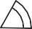

*m*ABC + *m*BAC + *m*ACB = °

### B C

Observe the table given below and draw your conclusions.

|  |  |  |  |  |
| --- | --- | --- | --- | --- |
| **Number of sides** | **Name of the polygon** | **Polygon** | **Number of**  **triangles** | **Sum of interior angles** |
| 3 | Triangle |  | 1 | 180° × 1 = |
| 4 | Quadrilateral |  | 2 | 180° × 2 = |
| 5 | Pentagon |  | 3 | 180° × 3 = |
| 6 | Hexagon |  | 4 | 180° × = |
| 7 | Heptagon |  | 5 |  |
| 8 | Octagon |  | 6 |  |
| . . . . | . . . . | . . . . | . . . . | . . . . |
| n | A figure with n sides |  | (n-2) | 180° × (n-2) |

Note that the number of triangles formed in a polygon as shown above is two less than the number of sides the polygon has.



**Now I know !**

The sum of the measures of the interior angles of a polygon is = 180° × (n-2)

The Exterior Angle of a Triangle



**Let’s learn.**

If the side BC of ABC is extended as shown in the figure, an angle ACD is formed which lies outside the triangle.



P A

B

Q

C

D

ACD is an exterior angle of ABC. ACD and ACB are angles in a linear pair.

PAB and QBC are also exterior angles of ABC.



**Now I know !**

On extending one side of a triangle, the angle obtained which forms a linear pair with the adjacent interior angle of the triangle is called an exterior angle of that triangle.

**Example** In the figure alongside, all exterior angles of a triangle are shown. *a*, *b*, *c*, *d*, *e*, *f* are the exterior angles of PQR. In the same way, every triangle has six exterior angles.



P

*a*

*b*

*c*

*e*

Q

*d*

*f*

R

The Property of an Exterior Angle of a Triangle



**Let’s learn.**

In the figure alongside, PRS is an exterior angle of PQR. The interior angle adjacent to it is PRQ. The other two interior angles, P and

Q are further away from PRS. They are called the remote interior angles of PRS.

P

Q R S



*m*P + *m*Q + *m*PRQ = °...........(sum of the three angles of a triangle)

*m*PRS + *m*PRQ = °...........(angles in a linear pair)

 *m*P + *m*Q + *m*PRQ = *m*PRS + *m*PRQ

 *m*P + *m*Q = *m*PRS ....... (subtracting *m*PRQ from both sides)



**Now I know !**

The measure of an exterior angle of a triangle is equal to the sum of the measures of its remote interior angles.

**Practice Set 21**

1. ACD is an exterior angle of ABC. The measures of A and B are equal. If *m*ACD = 140°, find the measures of the angles A and B.
2. Using the measures of the angles given in the figure alongside, find the measures of the remaining three angles.

A

B C D



140

3*. In the isosceles triangle ABC, A and B are equal. ACD is an exterior angle of

A

B

F

4y

8y

O

C

6y

E

D

ABC. The measures of ACB and ACD are (3*x* - 17)° and (8*x* + 10)° respectively. Find the measures of ACB and ACD.

Also find the measures of A and B.



**ICT Tools or Links**

* With the help of Geogebra, draw two rays with a common origin. Using the ‘Move’ option, turn one ray and observe the position where the two rays become opposite rays.
* Form angles in a linear pair. By ‘moving’ the common arm, form many different pairs of angles all of which are linear pairs.
* Using Polygon Tools from Geogebra, draw many polygons. Verify the property of the interior angles of a polygon.





5

Operations on Rational Numbers

Rational Numbers



**Let’s learn.**

In previous standards, we have learnt that the counting numbers 1, 2, 3, 4, ..... are called natural numbers. We know that natural numbers, zero, and the opposite numbers of natural

numbers together form the group of integers. We are also familiar with fractions like 7 , 2 , 1 .

Is there then, a group that includes both integers and fractions? Let us see.

11 5 7

4 = 12 , 7 = 7 , - 3 = 3 , 0 = 0 Thus, we also know that all integers can be written

3 1 1 2

*m m*

in the form *n* . If *m* is any integer and *n* is any non-zero integer, then the number *n* is called

a rational number.

This group of rational numbers includes all types of numbers mentioned before.

Complete the table given below.

Rational Numbers 5 , 3 , 17 , 2.17 etc.

7 4 28

Integers - 3, - 8, - 1 etc.

Whole Numbers 0

Natural Numbers 1, 2, 3, .....

|  |  |  |  |  |  |
| --- | --- | --- | --- | --- | --- |
|  | 3 | 3  5 | 17 | − 5  11 | 5 |
| Natural Number |  |  |  |  | ✓ |
| Integers | ✓ |  |  |  |  |
| Rational Number | ✓ |  |  |  |  |

Operations on Rational Numbers

Rational numbers are written like fractions using a numerator and a denominator. That is why, operations on rational numbers are carried out as on fractions.

(1)

|  |  |  |  |  |  |  |  |
| --- | --- | --- | --- | --- | --- | --- | --- |
| 5 9 55  63 118  + = = | | | | (2) 1 - 3 = 4  21 | | | = 17 |
| 7 | 11 | 77 | 77 | 7 | 4 | 28 | 28 |

|  |  |  |  |  |  |  |  |  |  |  |  |
| --- | --- | --- | --- | --- | --- | --- | --- | --- | --- | --- | --- |
| (3) 2 | 1  7 | + 3 | 8 14 | = | 15  7 | + | 50  14 | (4) | 9  13 | × | 4 9  4 36  7 = 13 7 = 91 |
|  |  |  |  | = | 30  14 | + | 50  14 | (5) | 3  5 | × | (4) = 34 = 12  5 5 5 25 |
|  |  |  |  | = | 80  14 | = | 40 7 | (6) | 9  13 | × | 26 = 3 2 = 6  3 1 1 |



**Let’s recall.**

To divide one number by another is to multiply the first by the multiplicative

**inverse of the other.**

We have seen that

5 and 6 ,

6

5

2

11 and

11

2 are pairs of multiplicative inverses.

 5 

 4 

 7 

 2 

 5 

 4 

Similarly,  

4

5

 

×

5

 

 

  = 1 ;

  ×  

 

2

7

 

= 1 Thus  

 

4

and  

as also

 7 

 2 

5 4 7

  and  

2

7

 

 

are pairs of multiplicative inverses. Similarly, 4

and 5 or

2 and

2 5

7 are pairs of multiplicative inverses. That is, 4

4

and 5

are each other’s multiplicative

inverses and so are 7

2

and 2 .

7



**Take care!**

**Example** The product of 11 and 9 is -1. Therefore, 11 , 9 is not a pair of

multiplicative inverses.

9 11

9 11



**Let’s discuss.**

Let us look at the characteristics of various groups of numbers. Discuss them in class to help you complete the following table. Consider the groups of natural numbers, integers and rational numbers. In front of each group, write the inference you make after carrying out the operations of addition, subtraction, multiplication and division, using a (✓) or a (×). Remember that you cannot divide by zero.

* If natural numbers are added, their sum is always a natural number. So, we put a tick (✓) under ‘addition’ in front of the group of natural numbers.
* However, if we subtract one natural number from another, the answer is not always a natural number. There are numerous examples like 710 = 3. So, under subtraction, we put a (**×**). If there is a cross in the table, explain why. To explain the reason for a (**×**), giving only one of the numerous examples is sufficient.

|  |  |  |  |  |
| --- | --- | --- | --- | --- |
| **Group of numbers** | **Addition** | **Subtraction** | **Multiplication** | **Division** |
| Natural numbers | ✓ | **×**  (7 - 10 =  3) | ✓ | **×** 3  (3 **÷** 5 = 5 ) |
| Integers |  |  |  |  |
| Rational numbers |  |  |  |  |



**Now I know !**

* The group of natural numbers is closed for the addition and multiplication but not for the subtraction and division. In other words, the difference of any two natural numbers or the quotient obtained on dividing one natural number by another will not always be natural number.
* The group of integers is closed for addition, subtraction and multiplication but not for division.
* The group of rational numbers is closed for all operations - addition, subtraction, multiplication and division. However, we cannot divide by zero.

**Practice Set 22**

1. Carry out the following additions of rational numbers. (i)
2. Carry out the following subtractions involving rational numbers.

|  |  |  |  |  |  |  |
| --- | --- | --- | --- | --- | --- | --- |
| 5 + 6 | (ii) 1 2 + | 2 4 | 11 13  (iii) + | | (iv) 2 3 + | 3  1 |
| 36 42 | 3 | 5 | 17 | 19 | 11 | 77 |

* 1. 7 3

11 7

* 1. 13 2

36 40

* 1. 1 2

3

3 5 (iv) 4 1 3 1

6 2 3

1. Multiply the following rational numbers. (i)

|  |  |  |  |  |  |  |
| --- | --- | --- | --- | --- | --- | --- |
| 3 2 | 12 | 4 | 8 | 3 | 0 | 3 |
| 11 × 5 | (ii) 5 × 15 | | (iii) 9 | × 4 | (iv) 6 × 4 | |

1. Write the multiplicative inverse.

2

* 1. 5

3

* 1. 8
  2. 17

39

* 1. 7 (v) 7 1

3

1. Carry out the divisions of rational numbers. (i)

|  |  |  |  |  |  |
| --- | --- | --- | --- | --- | --- |
| 40 ÷ 10 | (ii) 10 ÷ 11 | | 7 3  (iii) ÷ | | (iv) 2 |
| 12 4 | 11 | 10 | 8 | 6 | 3 |

÷ ( 4)

1. 2 1

5

÷ 5 3

6

5

1. 13

÷ 7 26

1. 9

÷ 8

1. 5 ÷ 2

5

Numbers in between Rational Numbers



**Let’s learn.**

11

* Write all the natural numbers between 2 and 9.
* Write all the integers between 4 and 5.
* Which rational numbers are there between 1

2

and 3 ?

4

**Example** Let us look for rational numbers between the two rational numbers 1

2

and 4 .

7

To do that, let us convert these numbers into fractions with equal denominators.

1 1 7

2 = 2  7

7

= 14

, 4

7

= 4 2

7  2

8

= 14

7 and 8 are consecutive natural numbers. But, are 7

14

and 8

14

consecutive rational numbers?

The denominator of any number can be increased. Then the numerator also increases the same number of times.

7 70

14 = 140

, 8 14

80

= 140

. . . . . (Multiplying the numerator and denominator by 10)

70

Now,

< 71 ..... < 79

80

<

So, how many numbers do we find between 7

and 8 ?

140

140

140

140

14 14

Also, 7

14

= 700

1400

, 8

14

800

= 1400 ..... (Multiplying the numerator and denominator by 100)

700

Hence,

< 701 ...... < 799

800

<

1400

1400

1400

1400

Thus, when rational numbers are converted into equivalent fractions with increasingly bigger denominators, more and more rational numbers which lie between them can be expressed.

For example, let us find numbers between the rational numbers 1

2

and 3 .

5

Let us first convert each of the numbers into their equivalent fractions.

For example, 1 = 5 , and 3 = 6

2 10

− 1 0



10

5 10

11

20

5 6 1

10 10

On the number line, there are points showing the numbers 5

10

and 6 . Let us find the

10

mid-point of the line segment joining these two points and see what number it shows.

1.  5  6  = 11 This is the mid-point of the line segment.
2.  10 10  20





Because 6

10

− 11

20

= 12 11

20

= 1

20

and also 11

20

− 5 10

= 1110

20

= 1

20

Thus, 11 is the number that lies exactly in the middle of 5 and 6 . It means that,

11 20 1 3

10 10

20 is a number that lies between 2 and 5 . Similarly, we can find numbers that lie between

1 11

2 and 20

and between 11

20

and 3 .

5



**Now I know !**

There are innumerable rational numbers between any two rational numbers.

**Practice Set 23**

* Write three rational numbers that lie between the two given numbers. (i)

|  |  |  |  |  |  |  |
| --- | --- | --- | --- | --- | --- | --- |
| 2 , 6 | 4  (ii) | 2  , | 2  (iii) | 4  , | 7  (iv) , | 5 |
| 7 7 | 5 | 3 | 3 | 5 | 9 | 9 |

1. 3

, 5

1. 7 , 5
2. 5 , 11
3. 0, 3

4 4 8 3 7 7 4

* **Something more**

If *m* is an integer, then *m* + 1 is the next bigger integer. There is no integer between *m* and *m* + 1. The integers that lie between any two non-consecutive integers can be counted. However, there are infinitely many rational numbers between any two rational numbers.



**Let’s recall.**

We have learnt to multiply and divide decimal fractions.

35.1

10

= 35.1 ×

1

10 =

351 ×

10

1

10 =

351

100 = 3.51

35.1

100

= 35.1  1

1 100

= 351 × 1

10 100

 351 

 1000 

=

= 0.351

35.1 × 10 = 351

10

 

× 10 = 351.0

35.1 × 1000 = 351 × 1000 =  351000  = 35100.0



10  10 



Thus we see that we can divide a decimal fraction by 100, by moving the decimal point two places to the left. To multiply by 1000, we move the point three places to the right.

The following rules are useful while multiplying and dividing.

No matter how many zeros we place at the end of the fractional part of a decimal fraction, and no matter how many zeros we place before the integral part of the number, it does not change the value of the given fraction.

1.35 =

135

100 ×

100

100 =

13500

10000 = 1.3500

135

1.35 = 100

1000

× 1000

= 135000

100000

= 1.35000 etc.

Also, see how we use : 1.35 = 001.35.

1.35

100



**Let’s learn.**

= 001.35

100

= 0.0135

Decimal Form of Rational Numbers

**Example** Write the rational number

7

4 in decimal form.

1.75

4)7.000

- 4

30

- 28

20

- 20

00

**Example** Write 2 1

5

1. 7 = 7.0 = 7.000 (Any number of zeros can be added after the

fractional part.)

1. 1 is the quotient and 3 the remainder after dividing 7 by 4. Now we place a decimal point after the integer 1. Writing the 0 from the dividend after the remainder 3, we divide 30 by 4. As the quotient we get now is fractional, we write 7 after the decimal point. Again we bring down the next 0 from the dividend and complete the division.

in decimal form.

We shall find the decimal form of 2 1

5

= 11

5

in three different ways.

Find the decimal form of 1 .

5

(I) (II) (III)

0.2

5)1.0

- 0

1 = 0.2

5

2.2

5)11.000

- 10

010

11 11 2

5 5 2

=

= 22

10

- 10

00

 2 1

5

= 2.2

- 10

00

11

5

5

= 2.2

10

= 2.2

**Example** Write the rational number

5

8 in decimal form.

5

The decimal form of 8 obtained by division is 0.625.  8 = 0.625

In all the above examples, we have obtained zero as the remainder. This type of decimal form of a rational number is called the terminating decimal form.

**Example** Let us see how the decimal form of some rational numbers is different.

1. Write the number

1.66

3)5.00

- 3

5

3 in decimal form.

2

1. Write the number 11 in decimal form.

0.18

11)2.00

- 0

2 0

- 1 8

5

 3 = 1.666.......

20

- 11

2

 11 = 0.1818.......

20  5 •

90 2

- 18

2

3 = 1.6

1 1 7

- 88

20

 11 = 0.18

5

1. Find the decimal form of 2 3 . 2 3 =

2.33

3)7.00

- 6

1. (iv) Work out the decimal form of 6 .

0.833

6)50

- 48

10 2 1

3

- 9

 2 1

= 2.33...

•

020

- 18

020

5 = 0.833...

6

 5 •

10 3 = 2.3

-

9

01

- 18

02

6 = 0.83

In all the above examples, the division does not come to an end. **Here, a single**

digit or a group of digits occurs repeatedly on the right of the decimal point. This type of decimal form of a rational number is called the recurring decimal form.

If in a decimal fraction, a single digit occurs repeatedly on the right of the decimal

point, we put a point above it as shown here. 2 1 •

3 = 2.33... = 2.3, and if a group of digits occurs repeatedly, we show it with a horizontal line above the digits.

2 5 •

Thus, 11 = 0.1818........= 0.18 and 6 = 0.83



**Now I know !**

Some rational numbers have a terminating decimal form, while some have a recurring decimal form.



**Let’s discuss.**

* Without using division, can we tell from the denominator of a fraction, whether the decimal form of the fraction will be a terminating decimal ? Find out.

**Practice Set 24**

* + Write the following rational numbers in decimal form.
    1. 13

4

* + 1. 7 8

3

* + 1. 7 5
    2. 5

12

* + 1. 22

7

* + 1. 4

3

* + 1. 7

9



**Let’s discuss.**

An arrangement of numbers expressed using the signs of addition, subtraction, multiplication and division is called a mathematical expression.

Simplify the expression 72 ÷ 6 + 2 × 2 and find its value.

Hausa’s method Mangru’s Method

72 ÷ 6 + 2 × 2 72 ÷ 6 + 2 × 2

= 12 + 2 × 2 = 12 + 2 × 2

= 12 + 4 = 14 × 2

= 16 = 28

We got two different answers because the two children carried out the operations in different orders. To prevent this, some rules have been made which decide the order in which the operations are carried out. If these rules are followed, we will always get the same answer. When an operation is to be carried out first, it is shown using brackets in the expression.

Rules for Simplifying an Expression

* + - 1. If more than one operation is to be carried out, then multiplication and division are carried out first, in the order in which they occur from left to right.
      2. After that, addition and subtraction are carried out in the order in which they occur from left to right.
      3. If there are more than one operations in the brackets, follow the above two rules while carrying out the operations.

On applying the above rules, we see that Hausa’s method is the right one.

 72 ÷ 6 + 2 × 2 = 16

Let’s evaluate the expressions below.

**Example** 40 × 10 ÷ 5 + 17

= 400 ÷ 5 + 17

= 80 + 17

= 97

**Example** 80 ÷ (15 + 8 - 3) + 5

= 80 ÷ (23 - 3) + 5

= 80 ÷ 20 + 5

= 4 + 5

= 9

**Example** 2 × {25 × [(113 - 9) + (4 ÷ 2 × 13)]}

= 2 × {25 × [104 + (4 ÷ 2 × 13)]}

= 2 × {25 × [104 + (2 × 13)]}

= 2 × {25 × [104 + 26]}

Example

3 -

4

= 3 4

5

7 ×

5

- 21

1

3

(multiplication first)

= 2 × {25 × 130}

= 3 21 5 4 (then,

= 2 × 3250

= 6500

84

63  20

= 84

subtraction)

= 43 84



**Remember :**

Brackets may be used more than once to clearly specify the order of the operations. Different kinds of brackets such as round brackets ( ), square brackets [ ], curly brackets { }, may be used for this purpose.

When solving brackets, solve the innermost bracket first and follow it up by solving the brackets outside in turn.

**Practice Set 25**

* Simplify the following expressions.

1. 50 × 5 ÷ 2 + 24 2. (13 × 4) ÷ 2-26

3. 140 ÷ [(-11) × (-3) - (-42) ÷ 14 -1)] 4. {(220-140) + [10 × 9 + (-2 × 5)]}-100

3 3 6

5. 5 + 8 ÷ 4

**Activity** : Use the signs and numbers in the boxes and form an expression such that its value will be 112.

0, 1, 2, 3, 4, 5,

6, 7, 8, 9

+ 

 -

* **Something more**

The order of the signs when simplifying an expression

B

( )

First, the operations in the

brackets

O



Of multiplication

e.g. 4 of 200

= 200  4

D M

 

Division Multiplication

A

+

Addition

S

-

Subtraction

1

1



6

Indices



**Let’s recall.**

Each of 7 children was given 4 books.

Total notebooks = 4 + 4 + 4 + 4 + 4 + 4 + 4 = 28 notebooks



Here, addition is the operation that is carried out repeatedly.

Addition of the same number again and again can be shown as a multiplication.

Total notebooks = 4 + 4 + 4 + 4 + 4 + 4 + 4 = 4 × 7 = 28

Base and Index



**Let’s learn.**

Let us see how the multiplication of a number by itself several times is expressed in short.

2 × 2 × 2 × 2 × 2 × 2 × 2 × 2 : Here, 2 is multiplied by itself 8 times. This is written as 28 in short. This is the index form of the multiplication.

Here, 2 is called the **base** and 8, the **index** or the **exponent**.

2

8

Index

Base

**Example** 5 × 5 × 5 × 5 = 54 Here 54 is in the index form. In the number 54, 5 is the base and 4 is the index.

This is read as ‘5 raised to the power 4’ or ‘5 raised to 4’, or ‘the 4th power of 5’. Generally, if *a* is any number, *a* × *a* × *a* ×.......... (*m* times) = *am*

Read *am* as ‘*a* raised to the power *m*’ or ‘the mth power of *a*’. Here *m* is a natural number.

 54 = 5 × 5 × 5 × 5 = 625. Or, the value of the number 54 = 625.

Similarly,

⬆ 2 3

⬇ 3 ✗ =

2 2

3 × 3 ×

2 8

3 = 27 means that the value of

⬆ 2 3

⬇ 3 ✗ is

8 27 .

Note that 71 = 7, 101 = 10. **The first power of any number is that number itself.** If the power or index of a number is 1, the convention is not to write it.

Thus 51 = 5, *a*1 = *a.*

**Practice Set 26**

1. Complete the table below.

|  |  |  |  |  |  |
| --- | --- | --- | --- | --- | --- |
| **Sr. No.** | **Indices** (Numbers in index form) | **Base** | **Index** | **Multiplication form** | **Value** |
| (i) | 34 | 3 | 4 | 3 × 3 × 3 × 3 | 81 |
| (ii) | 163 |  |  |  |  |
| (iii) |  | (-8) | 2 |  |  |
| (iv) |  |  |  | 3  3  3  3  7 7 7 7 | 81 2401 |
| (v) | (-13)4 |  |  |  |  |

1. Find the value.
   1. 210 (ii) 53 (iii) (-7)4 (iv) (-6)3 (v) 93



(vi) 81 (vii)

 4 3

(viii) 

1 4



−

 5 

 2 

 

Square and Cube

32 = 3 × 3 53 = 5 × 5 × 5

32 is read as ‘3 raised to 2’ 53 is read as ‘5 raised to 3’

or 3 ‘squared’ or ‘the square of 3’ or ‘5 cubed’ or ‘the cube of 5’.

**Remember :**

**The second power of any number is the square of that number.**

**The third power of any number is the cube of that number.**

Multiplication of Indices with the Same Base.



**Let’s learn.**

**Example** 24 × 23

= 2 × 2 × 2 × 2 × 2 × 2 × 2

= 27

Therefore, 24 × 23 = 24 + 3 = 27

**Example** (-3)2 × (-3)3

= (-3) ×(-3) × (-3) × (-3) ×(-3)

= (-3)5

Therefore, (-3)2 × (-3)3 = (-3)2 + 3 = (-3)5

 2 2  2 3  2   2   2   2   2   2 5

Example

5

5

 

5

5

5

5

5

  ×

 

=  

   

5





×  

 

×  

 

×  

 

×  

 

=  

 

 2 2

 2 3

 2 23

 2 5

Therefore,  

5

 

× =  

 5   

3

=  

 

5



**Now I know !**

If *a* is a rational number and *m* and *n* are positive integers, then *am* × *an* = *am+n*

**Practice Set 27**

1. Simplify.
   1. 74 × 72 (ii) (-11)5 × (-11)2 (iii)

 6 3

 7  

 6 5

 7 

   

3 5

3 3

 P 3

 P 7

1.  

   

1. *a*16 × *a*7 (vi) 

 ×  5 

   

2

2

   

 5   

Division of Indices with the Same Base



**Let’s learn.**

**Example** 64 ÷ 62 =? **Example** (- 2)5 ÷ (- 2)3 =?

64 =

62

6  6  6  6

6  6

25

23 =

22222

222

= 6 × 6

= 62

 64 ÷ 62 = 64 - 2 = 62

= (-2)2

 (-2)5 ÷ (-2)3 = (-2)2



**Now I know !**

If *a* is a non-zero rational number, *m* and *n* are positive integers and *m* > *n,* then

*am*

*an* =

*am**n*

The meaning of *a*°

The meaning of *a*-*m*

*a*-*m* = 1

*am*

1

1

 *a*-1 = *a*

If *a*  0

*am*

*a*-*m* = *a*-*m* × 1

*am*

*a* × *a* = 1,  *a* × *a*-1 = 1

Then *am* = 1

= *a*-*m* × *am*

 *a* - 1 is the multiplicative

inverse of *a.*

Also,

*am*

*am* = *a m**m*

= *a*°

*a**m**m*

= *am*

Thus, the multiplicative inverse

*a*0

= *am*

*a*-*m* = 1

*am*



*a*° = 1

1

= *am*

of 5 is 3 .

3

5



 5 1

 3 

 

3

= 5

 4 3

 4 3 1 1

343

 7 3

**Example** Let us consider

7 . 7

   

   

= 4  4  4

7 7 7

= 64 =

343

64 =  



**Now I know!**

Hence, we get the rule that if *a* ≠ 0, *b* ≠ 0 and *m* is a positive integer,

then 

  *a* *m*

  *b* *m*

 *b* 



=  *a* 

 

Let us see what rule we get by observing the following examples :

 3 2  3 5

**Example** (3)4 ÷ (3)6

Example

 5  ÷  

   5 

34

= 36

3  3

= 5 5 =

1 3  3  3  3  3

1

3  3  3

= 1

 3 3

= 3 3 3 3 =  5 

3 3 3 3 3 3 32

5 5 5 5 5

5 5 5  

34 ÷ 36 = 34 - 6 = 3- 2

 3 2

  5  ÷

 3 5

 5  =

 3 25

 5 

 3 3

=  5 

       



**Now I know!**

If *a* is a rational number, *a* ≠ 0 and *m* and *n* are positive integers, then *an* =

*am*

*am**n*



**Let’s learn.**

Observe what happens if the base is (- 1) and the index is a whole number.

(-1)6 = (-1) × (-1) × (-1) × (-1) × (-1) × (-1) = 1 × 1 × 1 = 1

(-1)5 = (-1) × (-1) × (-1) × (-1) × (-1) = 1 × 1 × (-1) = -1

If *m* is an even number then (-1)*m* = 1, and if *m* is an odd number, then (-1)*m* = -1

**Practice Set 28**

1. Simplify.
   1. *a*6 ÷ *a*4 (ii) *m*5 ÷ *m*8 (iii) *p*3 ÷ *p*13 (iv) *x*10 ÷ *x*10
2. Find the value.

(i) (-7)12 ÷ (-7)12 (ii) 75 ÷ 73 (iii)

 4 3

 5  ÷

 4 2

 5  (iv) 47 ÷ 45

   

 4 

The Index of the Product or Quotient of Two Numbers



**Let’s learn.**

Let us observe the following examples to see what rule we get.

 4 3

**Example** (2 × 3)4

**Example**  

 5 

4 4 4

= (2 × 3) × (2 × 3) × (2 × 3) × (2 × 3)

= 5 × 5 × 5

= 2 × 2 × 2 × 2 × 3 × 3 × 3 × 3 = 24 × 34 =

4  4  4 43

5 5 5 = 53



**Now I know!**

If *a* and *b* are non-zero rational numbers and *m* is an integer, then

(1) (*a* × *b*)*m* = *am* × *bm*

(2)

  *a* *m*

 

  *b*

*b*

=

*am*

*m*

*am* *n ,* that is, the Power of a Number in Index Form

**Example**

52 3

= 52 × 52 × 52

Example

72 5  1

72 5

= 52 + 2 + 2

= 52 × 3

= 56

 1 72  72  72  72  72

 1 7(2)5

= 1  710

*a* *m*  1

*am*

710

 2 2 3

Example

 5  

  

 2 2

 2 2

 2 2

 2 (2)(2)(2)

 2 6

=  

×  

×  

=  5 

=  

 5 

 5 

 5   

 5 

*am* *n* = *a m* × *a m* × *a m* ×......... *n* times = *a m* + *m* + *m*......... *n* times = *a m* × *n*

From the above examples, we get the following rule.



**Now I know!**

If *a* is a non-zero rational number and *m* and *n* are integers, then *am* *n* = *am* × *n* = *amn*

Laws of Indices

**Remember :**

If *a* is a non-zero number and *m* and *n* are integers, then

*am* × *an* = *am*

+

*n* ,

*am* ÷ *an* = *am*

- *n*,

*a*1 = *a* ,

*a*0 = 1 ,

*a* *m*  1 ,

(*ab*)*m* = *am* × *bm* ,

  *a* *m*

*am*

 *b*  =

 

*am*

  *a* *m*   *b* *m*

*b*

*m* ,

(*am*)*n* = *amn,*

 

 *b* 

=  

 *a* 

**Practice Set 29**

1. Simplify.

 15 3 4

 1 3 4

 2 2 3

* 1.   

2

(ii)

34 

1.   
2.   

65 

 12  

4

 7  

 5  

      

 6 5 2

 2  4 5

 5 3 2

 3 6 1

 2 3 2

1.   

 3  

1.   

(ix)   

(x)   

 7  

  

 8  

 4  

 5  

1. Write the following numbers using positive indices.

2 2

 11 5

 1 3

* 1.  
  2.  
  3.  
  4. (*y*)-4

 7 

 3 

 6 

 



**My friend, Maths : In science, in astronomy.**

The powers of 10 are especially useful in writing numbers in the decimal system.

1. The distance between Earth and Moon is 38,40,00,000 m. It can be expressed using the powers of 10 as follows.

When writing a very large or a very small number, it is expressed as the product of a decimal fraction with a one-digit integer and the proper power of 10. This is known as the standard form of the number.

384000000 = 384 × 106

384000000 = 38.4 × 107

384000000 = 3.84 × 108 (Standard form)

1. The diameter of an oxygen atom is given below in millimetres. 0.0000000000000356 = 3.56 × 10-14
2. 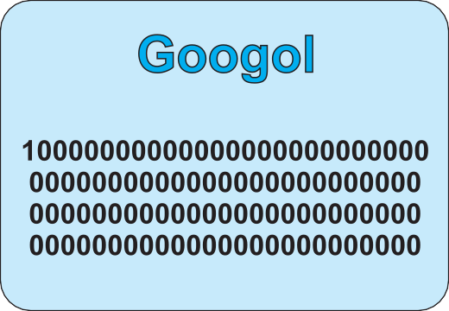Try to write the following numbers in the standard form.

The diameter of the sun is 1400000000 m. The velocity of light is 300000000 m/sec.

1. The box alongside shows the number called Googol. Try to write it as a power of 10.

Finding the square root of a perfect square



**Let’s recall.**

When a number is multiplied by itself the product obtained is the square of the number.

**Example** 6 × 6 = 62 = 36

62 = 36 is read as ‘The square of 6 is 36.’

**Example** ( 5) × ( 5) = ( 5)2 = 25

( 5)2 = 25 is read as ‘The square of ( 5) is 25.’



**Let’s learn.**

* Finding the square root of a given number

**Example** 3 × 3 = 32 = 9 Here, the square of 3 is 9.

Or, we can say that the square root of 9 is 3. The symbol 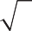 is used for ‘square root’.

means the square root of 9.  = 3

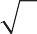

9



9

**Example** 7 × 7 = 72 = 49  = 7

49

**Example** 8 × 8 = 82 = 64. Hence = 8

64

( 8) × ( 8) = ( 8)2 = 64. Hence, = 8.

64

Thus, if *x* is a positive number, it has two square roots.

Of these, the negative square root is shown as  and

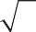

*x*

the positive one as .

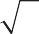

*x*

**Example** Find the square root of 81.

81 = 9 × 9 = 9 × 9 

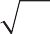

81

Mostly, we consider the positive square root.

= 9 and = 9

* + **Finding the square root by the factors method Example** Find the square root of 144.



81

Find the prime factors of the given number and put them in pairs of equal numbers.

|  |  |
| --- | --- |
| 2 | 144 |
| 2 | 72 |
| 2 | 36 |
| 2 | 18 |
| 3 | 9 |
| 3 | 3 |
|  | 1 |

144 = 2 × 72

= 2 × 2 × 36

= 2 × 2 × 2 × 18

= 2 × 2 × 2 × 2 × 3 × 3

Form pairs of equal factors from the prime factors obtained.

Take one factor from each pair and multiply.

144

= 2 × 2 × 3 = 12 

144

= 12

**Example** Find the square root of 324.

|  |  |
| --- | --- |
| 2 | 324 |
| 2 | 162 |
| 3 | 81 |
| 3 | 27 |
| 3 | 9 |
| 3 | 3 |
|  | 1 |

Find the prime factors of the given number and put them in pairs of equal factors.

324 = 2 × 162

= 2 × 2 × 81

= 2 × 2 × 3 × 27

= 2 × 2 × 3 × 3 × 9

= 2 × 2 × 3 × 3 × 3 × 3

To find the square root, take one number from each pair and multiply.

324

= 2 × 3 × 3 = 18 

324

= 18

**Practice Set 30**

* Find the square root. (i) 625 (ii) 1225 (iii) 289 (iv) 4096 (v) 1089
* **Something more (Square root by the division method)**

Find the square root of :

(1) 9801 (2) 19321 (3) 141.61

9801  99

This method can be used to find the square root of numbers which have many prime factors and are, therefore, difficult to factorise.

Now let us take 137 to see one more use.

137

> 11.7

But (11.8)2 = 139.24

 11.7 <

137

< 11.8

Thus, we can find the approximate value of

137 .

This method can be used to find the approximate square root of a number whose square root is not a whole number.

|  |  |
| --- | --- |
|  | 99 |
| 9  + 9 | -9801  81 |
| 189 | 1701 |
| + 9 |
| -1701 |
| 198 | 0000 |

|  |  |
| --- | --- |
|  | 139 |
| 1  + 1 | 19321  -1 |
| 23  + 3 | 093  - 69 |
| 269  + 9 | 2421  - 2421 |
| 278 | 0000 |

|  |  |
| --- | --- |
|  | 11.9 |
| 1  + 1 | 141.61  -1 |
| 21  + 1 | 041  - 21 |
| 229  + 9 | 2061  - 2061 |
| 238 | 0000 |

|  |  |  |  |
| --- | --- | --- | --- |
|  | | 11.7 | |
| 1 | | 137.00 | |
| + 1 | | -1 | |
|  | 21 | 037 | |
| + | 1 | - 21 | |
| 227 | |  | 1600 |
| + 7 | | - | 1589 |
| 234 | | 11 | |





7

Joint Bar Graph

**Let’s discuss.**

Joint Bar Graph

Observe the two bar graphs below which show the wheat production in quintals in Ajay’s and Vijay’s farms.

**Ajay’s wheat production Vijay’s wheat production**

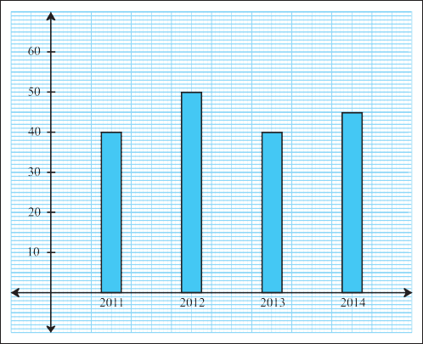

Y-axis Scaleः on Y-axis : 1 cm = 10 quintals

0

Year

X-axis

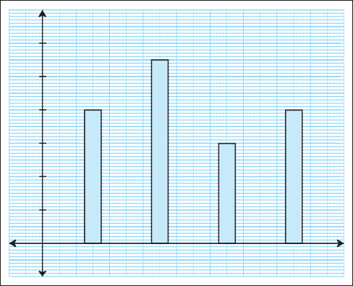

Y-axis

60

Scaleः on Y-axis : 1 cm = 10 quintals

50

40

30

20

10

0

2011

2012

2013

2014

Year

X -axis

Production (quintals)

Let us see if we can show the information from both graphs in a single graph. Look at the graph below. In this way, more information can be given using less space. Besides, comparing Ajay and Vijay’s wheat production also becomes easier. Such graphs are called joint bar graphs.

Production (quintals)

**Ajay and Vijay’s wheat production**

Observe the graph shown alongside and answer the following questions.

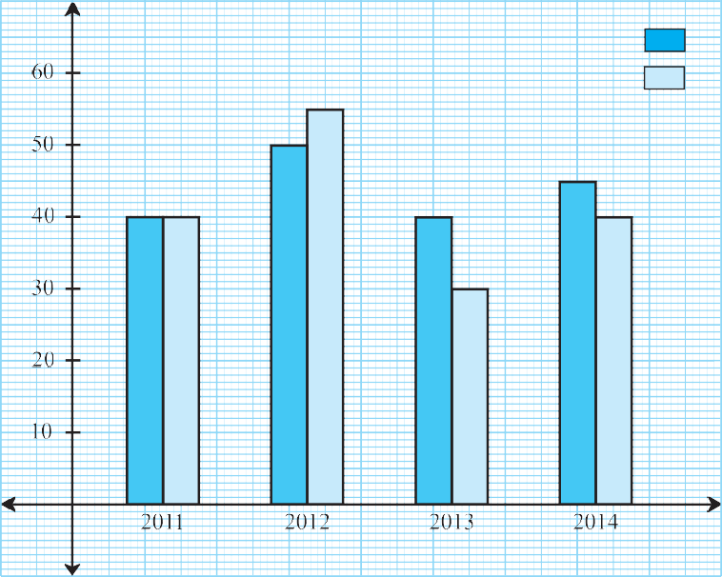

Y-axis

Scale ः on Y-axis ः 1 cm = 10 quintal

Ajay

Vijay

0

X-axis

Year

Production (quintals)

* + In which year did they both produce equal quantities of wheat ?
  + In year 2014, who produced more wheat?
  + In year 2013, how much wheat did Ajay and Vijay each produce?

Reading a Joint Bar Graph

The minimum and maximum temperature in Pune for five days is given. Read the joint bar graph and answer the questions below.

* + - What data is shown on X-axis?

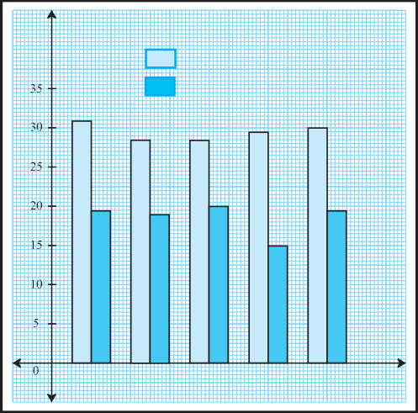

Y-axis

Scale on Y-axis ः 1 cm = 5° C

Maximum temperature Minimum temperature

Mon Tue Wed Thu Fri X-axis

* + - What data is shown on Y-axis?

Temperature

* + - Which day had the highest temperature ?
    - On which day is the minimum temperature the highest?
    - On Thursday, what is the difference between the minimum and maximum temperature?
    - On which day is the difference between the minimum and maximum temperature the greatest ?

Drawing a Joint Bar Graph



**Let’s learn.**

The number of boys and girls in a school is given. Draw a joint bar graph to show this information.

|  |  |  |  |  |  |  |
| --- | --- | --- | --- | --- | --- | --- |
| Class | 5th | 6th | 7th | 8th | 9th | 10th |
| Boys | 52 | 68 | 67 | 50 | 62 | 60 |
| Girls | 57 | 63 | 64 | 48 | 62 | 64 |

Steps for drawing a Joint Bar Graph

1. On a graph paper, draw the X-axis and Y-axis and their point of intersection.

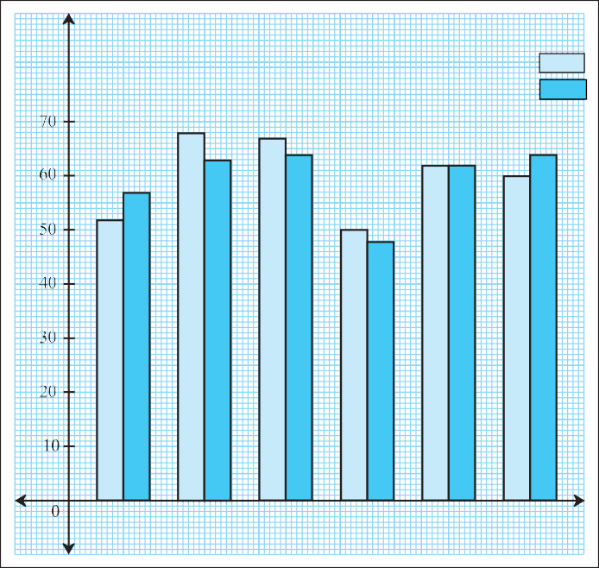

Y-axis

Scale 1cm = 10 Students

Boys Girls

5th

6th

7th 8th

9th

10thX-axis

1. Keeping the distance between two sets of joint bars equal, show the classes on X-axis.

Number of students

1. Choose a scale for the Y-axis.

For example, 1 unit = 10 girls/boys. Mark the numbers of boys and girls on the Y-axis.

1. Using the scale, work out the height of columns required to show the numbers of boys and girls in each class. Use different colours to show the different bars in each set.

|  |  |  |  |
| --- | --- | --- | --- |
|  | 52 |  |  |
|  |  |



**Now I know!**

* In a joint bar graph, the width of all columns should be equal.
* The distance between any two consecutive sets of joint bars should be equal.
* A joint bar graph is used for a comparative study.



**My friend, Maths :** newspapers, magazines, presentation

of data.

* + Collect various kinds of graphs from newspapers and discuss them.

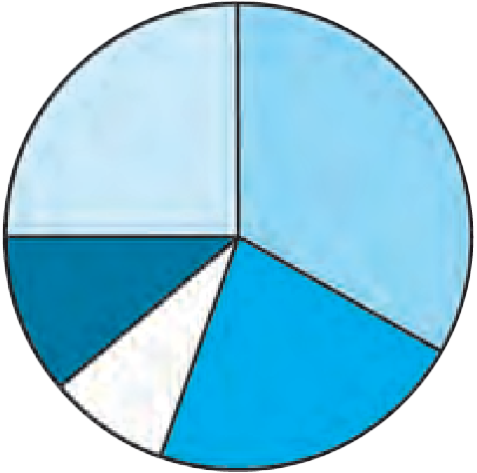

1. Histogram 2. Line Graph 3. Pie Chart



When presenting data, different kinds of graphs are used instead of only bar graphs. With the help of your teacher, take a look at the various kinds of graphs seen in MS-Excel, Graph Matica, Geogebra.

**ICT Tools or Links**

**Practice Set 31**

1. The number of saplings planted by schools on World Tree Day is given in the table below. Draw a joint bar graph to show these figures.

|  |  |  |  |  |  |
| --- | --- | --- | --- | --- | --- |
| Name of sapling  School Name | Almond | Karanj | Neem | Ashok | Gulmohar |
| Nutan Vidyalaya | 40 | 60 | 72 | 15 | 42 |
| Bharat Vidyalaya | 42 | 38 | 60 | 25 | 40 |

1. The table below shows the number of people who had the different juices at a juice bar on a Saturday and a Sunday. Draw a joint bar graph for this data.

|  |  |  |  |  |
| --- | --- | --- | --- | --- |
| Days Fruits | Sweet Lime | Orange | Apple | Pineapple |
| Saturday | 43 | 30 | 56 | 40 |
| Sunday | 59 | 65 | 78 | 67 |

1. The following numbers of votes were cast at 5 polling booths during the Gram Panchayat elections. Draw a joint bar graph for this data.

|  |  |  |  |  |  |
| --- | --- | --- | --- | --- | --- |
| Persons Booth No. | 1 | 2 | 3 | 4 | 5 |
| Men | 200 | 270 | 560 | 820 | 850 |
| Women | 700 | 240 | 340 | 640 | 470 |

1. The maximum and minimum temperatures of five Indian cities are given in °C. Draw a joint bar graph for this data.

|  |  |  |  |  |  |
| --- | --- | --- | --- | --- | --- |
| Temperature City | Delhi | Mumbai | Kolkata | Nagpur | Kapurthala |
| Maximum temperature | 35 | 32 | 37 | 41 | 37 |
| Minimum temperature | 26 | 25 | 26 | 29 | 26 |

1. The numbers of children vaccinated in one day at the government hospitals in Solapur and Pune are given in the table. Draw a joint bar graph for this data.

|  |  |  |  |  |
| --- | --- | --- | --- | --- |
| Vaccine  City | D.P.T.  (Booster) | Polio (Booster) | Measles | Hepatitis |
| Solapur | 65 | 60 | 65 | 63 |
| Pune | 89 | 87 | 88 | 86 |

1. The percentage of literate people in the states of Maharashtra and Gujarat are given below. Draw a joint bar graph for this data.

|  |  |  |  |  |  |
| --- | --- | --- | --- | --- | --- |
| State Year | 1971 | 1981 | 1991 | 2001 | 2011 |
| Maharashtra | 46 | 57 | 65 | 77 | 83 |
| Gujarat | 40 | 45 | 61 | 69 | 79 |

A joint bar graph is useful for drawing conclusions from observations recorded in a science experiment as well in geography and economics.

**Maths is fun!**

1 + 3 = 22

1 + 3 + 5 = 32

1 + 3 + 5 + 7 = 42

Can you obtain the formula 1 + 3 +... + (2n 1) = n2?

Verify this formula for n = 6, 7, 8, ....





**Let’s learn.**

8

Algebraic Expressions and Operations on them

**Algebraic Expressions**

Look at the arrangements of sticks given below and observe the pattern.

|  |  |  |  |  |  |  |  |  |
| --- | --- | --- | --- | --- | --- | --- | --- | --- |
| Arrangements of sticks |  |  |  | ...... | .. | ...... | .. | ...... |
| Squares | 1 | 2 | 3 | 4 | .. | 10 | .. | *n* |
| Number of sticks | 4 | 7 | 10 | 13 | .. | ...... | .. | ...... |
|  | 3 + 1 | 6 + 1 | 9 + 1 | 12 + 1 | .. | ...... | .. | ...... |
|  | 3  1 + 1 | 3  2 + 1 | 3  3 + 1 | 3  4 + 1 |  | 3  10 + 1 |  | 3  *n* + 1 |

On observing the pattern above, we notice that Number of sticks = 3 × number of squares + 1

Here, the number of squares changes. It could be any of the numbers 2, 3, 4, ... , 10, ... If we do not know the number of squares, we write a letter in its place. Here, the number of squares is shown by the letter *n*.

‘*n*’ is a variable. 3 × *n* + 1 which is the same as 3*n* + 1 is an algebraic expression in the variable *n*.



= 3 balls

= 3 triangles

= 3*t’s*

*l*



+

=

balls +

bats

+

=

mangoes +

guavas

*x* + *x* + *y* + *y* + *y* = 2*x* + 3*y*

*b b* Perimeter of a rectangle = 2*l* + 2*b*

= 2(*l* + *b*)

*l*



**Now I know!**

3*n* + 1, 3t, 2*x* + 3*y*, 2(*l* + *b*) are algebraic expressions.

*n*, t, *y*, *l*, *b*, *x* are the variables in these expressions.



**Let’s learn.**

In the expression 3*x*, 3 is the coefficient of the variable *x*.

In the expression 15*t*, 15 is the coefficient of the variable *t*.

An expression in which multiplication is the only operation is called a ‘term’. An algebraic expression may have one term or may be the sum of several terms.

|  |  |  |
| --- | --- | --- |
| **Term** | **Coefficient** | **Variables** |
| 11*mn* | 11 | *m, n* |
| 9*x*2*y*3 | 9 | *x, y* |
| 5 *p*  6 | 5  6 | *p* |
| *a* | 1 | *a* |

**Example** In the algebraic expression 4*x*2 2*y* + 5 *xz,*

4*x*2 is the first term and 6

1. is the coefficient in it.

2*y* is the second term with the coefficient 2.

1. *xz* is the third term and 5 is the coefficient

6 6

in it.

**Remember** :

* The algebraic expression 15 *x* has two terms. The first term 15 is a number. The second term is *x*. Here, the coefficient of the variable *x* is ( 1).
* Terms which have the same variables with the same powers are called ‘like terms’.

Like terms Unlike terms

(i) 2*x*, 5*x*, 2 *x*, (ii) 5*x*2*y*, 6 *yx*2 (i) 7*xy*, 9*y*2, 2*xyz*, (ii) 8*mn*, 8*m*2*n*2, 8*m*3*n*

3 7

Types of Algebraic Expressions

Expressions are named after the number of terms they have. Expressions with one term are called monomials, those with two terms, binomials, with three terms, trinominals and if they have more than three terms, they are called polynomials.

Polynomials

|  |  |  |  |  |  |  |
| --- | --- | --- | --- | --- | --- | --- |
| Monomials | | Binomials | | Trinomials | |  |
| * 4*x* | | * 2*x* 3*y* | | * *a* + *b* + *c* | |  |
|  | 5 *m* | • | 2*l* + 2*b* | • | *x*2 5*x* + 6 | • |
|  | 6 |  |  |  |  |  |
| • | 7 | • | 3*mn* 5*m*2*n* | • | 8*a*3 5*a*2*b* + *c* | • |

*a*3 3*a*2*b* + 3*ab b*3

4*x*4 7*x*2 + 9 5*x*3 16*x*

1

5*x*5 2 *x* + 8*x*3 5

**Practice Set 32**

* Classify the following algebraic expressions as monomials, binomials, trinomials or polynomials.

|  |  |  |  |  |  |  |  |  |  |
| --- | --- | --- | --- | --- | --- | --- | --- | --- | --- |
| (i) 7*x* |  | (ii) 5*y* | 7*z* | (iii) 3*x*3 5*x*2 | 11 | (iv) 1 | 8*a* | 7*a*2 | 7*a*3 |
| (v) 5*m* | 3 | (vi) *a* |  | (vii) 4 |  | (viii) 3*y*2 |  | 7*y* + 5 |  |

Addition of Algebraic Expressions



**Let’s learn.**

* + **Addition of monomials Example** 3 guavas + 4 guavas = (3 + 4) guavas = 7 guavas **Example** 3*x* + 4*x* = (3 + 4) *x* = 7*x*

Like terms are added as we would add up things of the same kind.

**Example** Add.

Think about it.

3*x* + 4*y* = How many ?

3 guavas + 4 mangoes = 7 guavas ? 7*m* 2*n* = 5*m* ?

* 1. 3*x* 8*x* + 5*x* = ( 3 8 + 5)*x* = 6*x*
  2. 2 *ab*  5 *ab* = ( 2 5 ) *ab* = 1 *ab*

3 7 3 7 21

* 1. 2*p*2 + 7*p*2 = ( 2 + 7)*p*2 = 5*p*2
     + Addition of binomial expressions

**Horizontal arrangement Example** (2*x* + 4*y*) + (3*x* + 2*y*)

*=* 2*x* + 3*x* + 4*y* + 2*y*

*=* 5*x* + 6*y*

Vertical arrangement

2*x* + 4*y*

+ 3*x* + 2*y*

5*x* + 6*y*

To add like terms, we add their coefficients and write the variable after their sum.

**Example** Add. 9*x*2*y*2 7*xy* ; 3*x*2*y*2 + 4*xy*

Horizontal arrangement Vertical arrangement

(9*x*2*y*2 7*xy*) + (3*x*2*y*2 + 4*xy*)

= 9*x*2*y*2 7*xy* + 3*x*2*y*2 + 4*xy*

= (9*x*2*y*2 + 3*x*2*y*2) + ( 7*xy* + 4*xy*)

= 12*x*2*y*2 3*xy*

9*x*2*y*2 7*xy*

+ 3*x*2*y*2 + 4*xy* 12*x*2*y*2 3*xy*



**Take care !**

In 3*x* + 7*y,* the two terms are not like terms. Hence, their sum can only be written as 3*x* + 7*y* or as 7*y* + 3*x*.

**Practice Set 33**

* Add.

(i) 9p + 16q ; 13p + 2q (ii) 2a + 6b + 8c; 16a + 13c + 18b

1. 13*x*2 12*y*2 ; 6*x*2 8*y*2 (iv) 17*a*2*b*2 + 16c ; 28c 28*a*2*b*2

(v) 3*y*2 10*y* + 16 ; 2*y* 7 (vi) 3*y*2 + 10*y* 16 ; 7*y*2 + 8

Subtraction of Algebraic Expressions



**Let’s learn.**

We have learnt that to subtract one integer from another is to add its opposite integer to the other.

We shall use the same rule for subtraction of algebraic expressions.

**Example** 18 7

= 18 + ( 7) = 11

**Example** 9*x* 4*x*

*=* [9 + ( 4)]*x* = 5*x*

**Example** Subtract the second expression from the first.

16*x* + 23*y* + 12*z* ; 9*x* 27*y* + 14*z*

Horizontal arrangement

Vertical arrangement

(16*x* + 23*y* + 12*z*) (9*x* 27*y* + 14*z*)

= 16*x* + 23*y* + 12*z* 9*x* + 27*y* 14*z*

= (16*x* 9*x*) + (23*y* + 27*y*) + (12*z* 14*z*)

= 7*x* + 50*y* 2*z*

- 16*x* + 23*y* + 12*z*

**+ 9*x* - 27*y* + 14*z*

- + -

7*x* + 50*y* - 2*z*

(Change the sign of every term in the expression to be subtracted and then add the two expressions.)

**Practice Set 34**

* Subtract the second expression from the first.

(i) (4*xy* 9*z*) ; (3*xy* 16*z*) (ii) (5*x* + 4*y* + 7*z*) ; (*x* + 2*y* + 3*z*)

1. (14*x*2 + 8*xy* + 3*y*2) ; (26*x*2 8*xy* 17*y*2) (iv) (6*x*2 + 7*xy* + 16*y*2) ; (16*x*2 17*xy*)

(v) (4*x* + 16*z*) ; (19*y* 14*z* + 16*x*)

Multiplication of Algebraic Expressions



**Let’s learn.**

* **Multiplying a monomial by a monomial**

**Example** 3*x* × 12*y* **Example** ( 12*x*) × 3*y* 2

*=* 3 × 12 × *x* × *y =* 12 × 3 × *x* × *y* × *y*

*=* 36*xy =* 36*xy* 2

**Example** 2*a*2 × 3*ab*2 **Example** ( 3*x*2) × ( 4*xy*)

*=* 2 × 3 × *a*2 × *a* × *b*2 *=* ( 3) × ( 4) × *x*2 × *x* × *y*

*=* 6*a*3 *b*2 *=* 12*x*3*y*

When multiplying two monomials, first multiply the coefficients along with the signs. Then multiply the variables.

**Example** *x* (*x* + *y*)

* Multiplying a binomial by a monomial

**Example** (7*x* 6*y*) × 3*z =* 7*x* × 3*z* 6*y* × 3*z*

*= x* × *x* + *x* × *y*

*= x*2 + *xy*

## Example

*=* 7 × 3 × *x* × *z* 6 × 3 × *y* × *z*

*=* 21*xz* 18*yz*

* Multiplying a binomial by a binomial

3*x* + 4*y*

 5*x* + 7*y*

(3*x* + 4*y*) (5*x* + 7*y*)

= 3*x* (5*x* + 7*y*) + 4*y* (5*x* + 7*y*)

15*x*2 + 20*xy*

+ 21*xy* + 28*y*2 15*x*2 + 41*xy* + 28*y*2

[Multiplying by 5*x*]

[Multiplying by 7*y*] [adding]

= 3*x*  5*x* + 3*x*  7*y* + 4*y*  5*x* + 4*y*  7*y*

= 15*x*2 + 21*xy* + 20*xy* + 28*y*2

= 15*x*2 + 41*xy* + 28*y*2

#### **Example** Find the area of a rectangular field whose length is (2*x* + 7) m and breadth is (*x* + 2) m.

**Solution** : Area of rectangular field = length × breadth = (2*x* + 7) × (*x* + 2)

= 2*x* (*x* + 2) + 7 (*x* + 2)

#### = 2*x*2 + 11*x* + 14

Area of rectangular field (2*x*2 + 11*x* + 14) m2

**Practice Set 35**

1. Multiply.

(i) 16*xy* × 18*xy* (ii) 23*xy*2 × 4*yz*2

(iii) (12*a* + 17*b*) × 4*c* (iv) (4*x* + 5*y*) × (9*x* + 7*y*)

1. A rectangle is (8*x* + 5) cm long and (5*x* + 3) cm broad. Find its area.



**Let’s recall.**

Equations in One Variable

Solve the following equations.

(1) *x* + 7 = 4 (2) 4*p* = 12 (3) *m* 5 = 4 (4) t = 6

3



**Let’s learn.**

|  |  |  |
| --- | --- | --- |
| **Example** 2*x* + 2 = 8 | **Example** | 3*x* 5 = *x* 17 |
|  2*x* + 2 2 = 8 2 |  | 3*x* 5 + 5 *x* = *x* 17 + 5 *x* |
|  2*x* = 6 |  |  2*x* = 12 |
|  *x* = 3 |  |  *x* = 6 |

**Example** The length of a rectangle is 1 cm more than twice its breadth. If the perimeter of the rectangle is 50 cm, find its length.

##### Solution:

Let the breadth of the rectangle be *x* cm.

Then the length of the rectangle will be (2*x* +1)cm. 2 × length + 2 × breadth = perimeter of rectangle

2 (2*x* + 1) + 2*x* = 50

 4*x* + 2 + 2*x* = 50

 6*x* + 2 = 50

 6*x* = 50 2 = 48

 *x* = 8 Breadth of rectangle is 8 cm.

Length of the rectangle = 2*x* + 1 = 2 × 8 + 1

 Length of rectangle = 17 cm.

**Example** The sum of two consecutive natural numbers is 69. Find the numbers.

##### Solution:

Let one natural number be *x.*

The next natural number is *x* + 1

(*x*) + (*x* + 1) = 69

 *x* + *x* + 1 = 69

 2*x* + 1 = 69

2*x* = 69 1

2*x* = 68

 *x* = 34 1st natural number = 34

2nd natural number = 34 + 1

= 35

##### Remember :

###### From the solved examples above, we see that if a term is ‘transposed’ from one side to the other of the ‘=’ sign in an equation, that term’s sign must be changed.

**Practice Set 36**

1. Simplify (3*x* 11*y*) (17*x* + 13*y*) and choose the right answer.

(i) 7*x* 12*y* (ii) 14*x* 54*y* (iii) 3 (5*x* + 4*y* ) (iv) 2 (7*x* + 12*y* )

###### The product of (23 *x2 y3z*) and ( 15*x3yz2*) is .................... .

* 1. 345 *x5 y4 z3* (ii) 345 *x2 y3 z5* (iii) 145 *x3 y2 z* (iv) 170 *x3 y2 z3*

###### Solve the following equations.

* 1. 4*x* + 1 = 9

2 2

###### (ii) 10 = 2*y* + 5 (iii) 5*m* 4 = 1

1. 6*x* 1 = 3*x* + 8 (v) 2 (*x* 4) = 4*x* + 2 (vi) 5 (*x* + 1) = 74
2. Rakesh’s age is less than Sania’s age by 5 years. The sum of their ages is 27 years. How old are they?
3. When planting a forest, the number of jambhul trees planted was greater than the number of ashoka trees by 60. If there are altogether 200 trees of these two types, how many jambhul trees were planted ?
4. Shubhangi has twice as many 20-rupee notes as she has 50-rupee notes. Altogether, she has 2700 rupees. How many 50-rupee notes does she have ?

7*. Virat made twice as many runs as Rohit. The total of their scores is 2 less than a double century. How many runs did each of them make ?



##### Miscellaneous Problems : Set 1

1. Solve the following.

(i) ( 16) × ( 5) (ii) (72) ÷ ( 12) (iii) ( 24) × (2)

1. 125 ÷ 5 (v) ( 104) ÷ ( 13) (vi) 25 × ( 4)
2. Find the prime factors of the following numbers and find their LCM and HCF.

(i) 75, 135 (ii) 114, 76 (iii) 153, 187 (iv) 32, 24, 48

3*. Simplify.

* 1. 322

391

* 1. 247

209

* 1. 117

156

1. Find the square root of the following numbers.

(i) 784 (ii) 225 (iii) 1296 (iv) 2025 (v) 256

1. There are four polling booths for a certain election. The numbers of men and women who cast their vote at each booth is given in the table below. Draw a joint bar graph for this data.

|  |  |  |  |  |
| --- | --- | --- | --- | --- |
| Polling  Booths | Navodaya  Vidyalaya | Vidyaniketan  School | City High  School | Eklavya  School |
| Women | 500 | 520 | 680 | 800 |
| Men | 440 | 640 | 760 | 600 |

1. Simplify the expressions.

(i) 45 ÷ 5 + 20 × 4 12 (ii) (38 8) × 2 ÷ 5 + 13

(iii)

5  4  32

* 1. 3 × { 4 [ 85 + 5 (15 ÷ 3) ] + 2 }

3 7 21

1. Solve.

(i) 5  7 (ii) 3 2  2 1

1. 12  10 (iv*) 4 3

÷ 25

12 16

5 4 5 3

8 18

1. Construct ∆ABC such that *m*A = 55°, *m*B = 60°, and *l*(AB) = 5.9 cm.
2. Construct ∆XYZ such that, *l*(XY) = 3.7 cm, *l*(YZ) = 7.7 cm, *l*(XZ) = 6.3 cm.
3. Construct ∆PQR such that, *m*P = 80°, *m*Q = 70°, *l*(QR) = 5.7 cm.
4. Construct ∆EFG from the given measures. *l*(FG) = 5 cm, *m*EFG = 90°,

*l*(EG) = 7 cm.

1. In ∆LMN, *l*(LM) = 6.2 cm, *m*LMN = 60°, *l*(MN) = 4 cm. Construct ∆LMN.
2. Find the measures of the complementary angles of the following angles.

(i) 35° (ii) *a*° (iii) 22° (iv) (40 *x*)°

1. Find the measures of the supplements of the following angles.

(i) 111° (ii) 47° (iii) 180° (iv) (90 *x*)°

1. Construct the following figures.

(i) A pair of adjacent angles (ii) Two supplementary angles which are not adjacent angles. (iii) A pair of adjacent complementary angles.

P

Q R T



In ∆PQR, the measures of P and Q are equal and *m*PRQ = 70°. Find the measures of the following angles.

(i) *m*PRT (ii)*m*P (iii)*m*Q

1. Simplify.

 2 6

 2 9

 7 8

 7 6

 4 2

 5 

(i) 54 × 53 (ii)   ÷  3  (iii)

 2   2 

 5  ÷  4 

 3   

###### Find the value.

   

   

(i) 1716 ÷ 1716 (ii) 10-3 (iii) (23)2 (iv) 46 × 4-4

|  |  |  |  |
| --- | --- | --- | --- |
| 19. | Solve. |  | |
|  | (i) (6*a* 5*b* 8*c*) | + (15*b*+2*a* 5*c*) | (ii) (3*x*+2*y*)(7*x* 8*y*) |
|  | (iii) (7*m* 5*n*) | ( 4*n* 11*m*) | (iv) (11*m* 12*n*+3*p*) (9*m*+7*n* 8*p*) |

20. Solve the following equations.

(i) 4(*x* + 12) = 8 (ii) 3*y* + 4 = 5*y* 6

##### Multiple Choice Questions

Choose the right answer from the options given after every question.

1. The three angle bisectors of a triangle are concurrent. Their point of concurrence is called the ....................... .

(i) circumcentre (ii) apex (iii) incentre (iv) point of intersection.

 3 3 4

1.  7   = .................

  

* 1.  3 7

 7 

* 1.  3 10

 7 

* 1.  7 12

 3 

* 1.  3 20

 7 

       

###### The simplest form of 5 ÷  3   1 is ..................... .

 2  3

  1

###### (i) 3 (ii) 5 (iii) 0 (iv) 3

1. The solution of the equation 3*x* 1

2

= 5 2

###### + *x* is ..................... .

* 1. 5

3

* 1. 7

2

* 1. 4 (iv) 3 2

5*. Which of the following expressions has the value 37 ?

(i) 10 × 3 + (5 + 2) (ii) 10 × 4 + (5 3)

(iii) 8 × 4 + 3 (iv) (9 × 3) + 2





9

Part Two

Direct Proportion and Inverse Proportion

**Direct proportion**

In the previous class we have learnt how to compare two numbers and write them in the form of a ratio.



**Let’s discuss.**

**Example** Look at the picture below. We see divisions of a circle made by its diameters.

(A) (B) (C) (D)

Do you see any relationship between the number of diameters and the number of divisions they give rise to?

In figure (A) **one** diameter makes parts of the circle. In figure (B) **two** diameters make parts of the circle. In figure (D) **four** diameters make parts of the circle.

8

#### No. of diameters 1

No. of divisions = 2 =

=

2 3

4 = 6

1. . Here, the ratio of the number of diameters

to the number of divisions remains constant.

**Example** The number of notebooks that the students of a Government School received is shown in the table below.

Number of children Number of notebooks

|  |  |  |  |  |
| --- | --- | --- | --- | --- |
| **Children** | 15 | 12 | 10 | 5 |
| **Notebooks** | 90 | 72 | 60 | 30 |

= 15

90

= 12

72

= 10

60

= 5 = 1

30 6

In other words, the ratio 1:6 remains the same or constant.

In the examples above, we see that when the number of diameters increases the number of divisions also increases. As the number of children decreases the number of notebooks also falls. The number of diameters and the number of divisions are in direct proportion as are the number of students and the number of notebooks.

**Activity :** Think : Are the amount of petrol filled in a motorcycle and the distance travelled by it, in direct proportion ?

* Discuss : Can you give examples from science or everyday life, of quantities that vary in direct proportion ?

**Example** If 10 pens cost 60 rupees, what is the cost of 13 such pens?

**Solution** : Let us suppose the cost of 13 pens is *x* rupees.

The number of pens and their cost vary in direct proportion. Let us express the ratios and obtain an equation.

10 = 13

60 *x*

######  10*x* = 780 (multiplying both sides by

60*x*)

 *x* = 78

Cost of 13 pens is ` 78.

**Practice Set 37**

1. If 7 kg onions cost 140 rupees, how much must we pay for 12 kg onions?
2. If 600 rupees buy 15 bunches of feed, how many will 1280 rupees buy?
3. For 9 cows, 13 kg 500 g of food supplement are required every day. In the same proportion, how much will be needed for 12 cows?
4. The cost of 12 quintals of soyabean is 36,000 rupees. How much will 8 quintals cost?

###### Two mobiles cost 16,000 rupees. How much money will be required to buy 13 such mobiles ?

Inverse Proportion



**Let’s learn.**

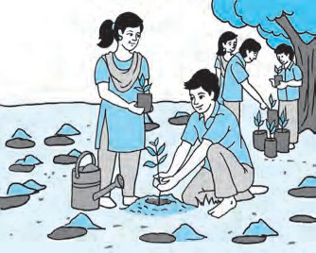Some volunteers have gathered to dig 90 pits for a tree plantation programme. One volunteer digs one pit in one day. If there are 15 volunteers, they will

90

take

15 = 6 days to dig the pits.

90

10 volunteers will take 10 = 9 days.

Are the number of pits and the number of volunteers in direct proportion?

If the number of volunteers **decreases**, **more** days are required; and if the number of volunteers **increases**, **fewer** days are required for the job. However, the product of the number of days and number of volunteers remains constant. We say that these numbers are in **inverse** proportion.

* Suppose Sudha has to solve 48 problems in a problem set. If she solves 1 problem every day, she will need 48 days to complete the set. But, if she solves

8 problems every day, she will complete the set in 48 = 6 days and if she solves

48 8

12 problems a day, she will need 12 = 4 days. The number of problems solved

in a day and the number of days needed are in inverse proportion. Their product

is constant.

Thus, note that 8 × 6 = 12 × 4 = 48 × 1

**Example** Fifteen workers take 8 hours to build a wall. How many hours will 12 workers need to build the same wall?

**Solution** : As the number of workers increases, the number of hours decreases.

The number of workers and number of hours are in inverse proportion. The product of the number of workers and the number of hours needed to build the wall is constant. Let us use the variable *x* to solve this problem.

Suppose, 12 workers take *x* hours. 15 workers take 8 hours.

12 workers take *x* hours.

12 × *x* = 15 × 8

 12*x* = 120

 *x* = 10

Thus, 12 workers will take 10 hours to build the wall.

**Example** A 40-page class magazine is to be written. If one student would require 80 days to write it, how many would 4 students require ?

**Solution** : If more students help to do the same task, fewer days will be required. That is, the number of students and number of days are in inverse proportion.

Suppose 4 students need *x* days.

4*x* = 80 × 1

|  |  |
| --- | --- |
| Students | Days |
| 1 | 80 |
| 4 | *x* |

*x* = 80

4

###### *x* = 20  4 students require 20 days.

**Example** Students of a certain school went for a picnic to a farm by bus. Here are some of their experiences. Say whether the quantities in each are in direct or in inverse proportion.

* Each student paid 60 rupees for the expenses.

As there were 45 students,  rupees were collected.

Had there been 50 students,  rupees would have been collected.

The number of students and money collected are in proportion.

* The sweets shop near the school gave 90 laddoos for the picnic. If 45 students go for the picnic, each will get laddoos.

If 30 students go for the picnic, each will get laddoos.

The number of students and that of laddoos each one gets are in ....... proportion.

* The farm is 120 km away from the school.

The bus went to the farm at a speed of 40 km per hour and took hours.

On the return trip, the speed was 60 km per hour. Therefore, it took hours.

##### The speed of the bus and the time it takes are in proportion.

* The farmer picked 180 *bors* from his trees.

He gave them equally to 45 students. Each student got *bors*. Had there been 60 students, each would have got *bors.*

##### The number of students and the number of *bors* each one gets are in ........

**proportion.**

**Practice Set 38**

1. Five workers take 12 days to weed a field. How many days would 6 workers take ? How many would 15 take ?
2. Mohanrao took 10 days to finish a book, reading 40 pages every day. How many pages must he read in a day to finish it in 8 days?
3. Mary cycles at 6 km per hour. How long will she take to reach her Aunt’s house which is 12 km away? If she cycles at a speed of 4 km/hr, how long would she take ?
4. The stock of grain in a government warehouse lasts 30 days for 4000 people. How many days will it last for 6000 people ?

##### Partnership



**Let’s learn.**

When starting a business enterprise, money is required for an office, raw materials, etc. This amount is called the capital. Often, two or more people put in money for the capital. In other words, these people start a business by investing in the partnership. In a business partnership, all partners have a joint account in a bank. The profit made or the loss incurred is shared by the partners in proportion to the money each one has invested.

**Example** Jhelum and Atharva invested 2100 and 2800 rupees respectively and started a business. They made a profit of 3500 rupees. How should it be shared?

**Solution** : Let us find out the proportion of the investments.

2100:2800 = 2100 = 3

4

2800

= 3:4.  Proportion of investments is 3:4.

The profit must also be shared in the same proportion.

Let Jhelum’s profit be 3*x* and that of Atharva, 4*x.* Then, 3*x* + 4*x* = 3500 as total profit is 3500.

 7*x* = 3500  *x* = 500

Jhelum’s share = 3*x* = 1500 rupees and Atharva’s share = 4*x* = 2000 rupees.

**Example** Chinmaya and Sam invested a total of 130000 rupees in a business in the proportion 3:2 respectively. What amount did each of them invest? If their total profit was 36000 rupees, what is the share of each?

**Solution** : The proportion of Chinmaya’s and Sam’s investment is 3:2.

The profit is shared in the same **proportion** as the investment, hence, proportion of profit is 3:2.

Let Chinmaya’s investment be 3*y* and Sam’s 2*y.*

3*y* + 2*y =* Total investment.

 5*y =* 130000

5 *y =* 130000

Let Chinmaya’s profit be 3*x* and Sam’s 2*x*.

3*x* + 2*x =* Total Profit 5*x =* 36000

5*x =* 36000 .... (dividing by 5)

5 5 ..... (dividing by 5) 5 5

 *y =* 26000

 Chinmaya’s investment *=* 3*y*

*=* 3 × 26000

= 78,000

Sam’s investment *=* 2*y*

*=* 2 × 26000

= 52000 rupees

 *x =* 7200

 Chinmaya’s profit *=* 3*x*

*=* 3 × 7200

= 21600

Sam’s profit *=* 2*x*

*=* 2 × 7200

= 14400 rupees

**Example** Abdul, Sejal and Soham each gave Sayali 30 rupees, 70 rupees and

50 rupees respectively. Sayali put in 150 rupees and bought paper, colours, etc. Together they made greeting cards and sold them all. If they made a total profit of 420 rupees, what was each one’s share in the profit ?

**Solution** : The capital invested by all four was 300 rupees. Of this Sayali had invested

150 rupees, that is, half of the capital. The total profit was 420 rupees. So, Sayali’s profit was half of that, i.e., 210 rupees. The remaining 210 was shared by Abdul, Sejal and Soham.

Abdul, Sejal and Soham’s investment is 30, 70 and 50 rupees. The proportion is 30:70:50 i.e. 3:7:5. Their share of the profit is altogether 210 rupees.

Let their individual profit be 3*k*, 7*k*, 5*k*. Then, 3*k* + 7*k* + 5*k* = 210

 15*k* = 210

 *k* = 14

Abdul’s profit = 3*k* = 3 × 14 = 42 rupees. Sejal’s profit = 7*k* = 7 × 14 = 98 rupees. Soham’s profit = 5*k* = 5 × 14 = 70 rupees.

**Example** Saritaben, Ayesha and Meenakshi started a business by investing 2400, 5200 and 3400 rupees.They made a profit of 50%. How should they share it? If they reinvest all their profit by adding it to the capital, what will each one’s share be in the following year ?

**Solution** : Total capital = 2400 + 5200 + 3400 = 11000 rupees.

Profit 50%

 Total profit = 11000×50

100

= 5500

Profit will be shared in the same proportion as the investment.

We simplify the ratio of two numbers by dividing by a common factor.

The same can be done for 3 or more numbers.

Proportion of shares = 2400 : 5200 : 3400

= 24 : 52 : 34 (dividing by 100)

= 12 : 26 : 17 (dividing by 2)

Assume that Saritaben’s profit = 12p, Ayesha’s profit = 26p, Meenakshi’s profit = 17p.

 12p + 26p + 17p = 55p = 5500  p = 5500

55

###### = 100

 Saritaben’s profit = 12 × 100 = 1200, Ayesha’s profit = 26 × 100 = 2600 and

Meenakshi’s profit = 17 × 100 = 1700.

If they add their profit to the capital, their further investments will be : Saritaben’s capital = 2400 + 1200 = ` 3600

Ayesha’s capital = 5200 + 2600 = ` 7800

Meenakshi’s capital = 3400 + 1700 = ` 5100



**Let’s discuss.**

In the above example, if Saritaben, Meenakshi and Ayesha all add their profit to the capital, find out the proportions of their shares in the capital during the following year.

**Practice Set 39**

1. Suresh and Ramesh together invested 144000 rupees in the ratio 4:5 and bought a plot of land. After some years they sold it at a profit of 20%. What is the profit each of them got?
2. Virat and Samrat together invested 50000 and 120000 rupees to start a business. They suffered a loss of 20%. How much loss did each of them incur ?
3. Shweta, Piyush and Nachiket together invested 80000 rupees and started a business of selling sheets and towels from Solapur. Shweta’s share of the capital was 30000 rupees and Piyush’s 12000. At the end of the year they had made a profit of 24%. What was

Nachiket’s investment and what was his share of the profit?

1. A and B shared a profit of 24500 rupees in the proportion 3:7. Each of them gave 2% of his share of the profit to the Soldiers’ Welfare Fund. What was the actual amount given to the Fund by each of them?

5* . Jaya, Seema, Nikhil and Neelesh put in altogether 360000 rupees to form a partnership, with their investments being in the proportion 3:4:7:6. What was Jaya’s actual share in the capital ? They made a profit of 12%. How much profit did Nikhil make ?





10

Banks and Simple Interest

A bank is a government recognized institution that carries out transactions of money. Banks make it easier to plan the use of money, i.e., to do financial planning. We can either deposit cash money in a bank or withdraw cash from it. For that purpose, we must open an account in a bank. Bank accounts are of various kinds.



**Let’s recall.**



**Let’s learn.**

Different Types of Accounts

* + **Current Account**

A current account is mainly for traders and those dealing in money on a daily basis. An account holder can deposit or withdraw money any number of times in a day. The bank issues a passbook for this account and also a cheque book on demand. The bank does not pay any interest on the money in this type of account. Money can also be withdrawn or deposited by cheque.

* + Savings Account

A person can deposit a minimum amount and open a savings account. In some banks, no minimum amount is required for opening an account. The bank pays some interest on the basis of the daily credit balance in the account. There are some restrictions on how often money can be withdrawn from this account. For this account too, the bank issues a passbook and, on demand, a cheque book.

* + Recurring Deposit Account

The account holder can decide the amount to be deposited every month in the account. The bank gives an interest on the deposit which is more than that paid for the savings account. Such an account is a means of compulsory savings.

Often it is convenient to have a joint account for say, husband and wife or guardian and ward, etc. Besides, accounts of business partners, housing societies, trusts of voluntary agencies, etc. are required to be operated by more than one person.

* + Fixed Deposit

A depositor deposits a certain amount for a fixed period in the bank. This deposit attracts a greater rate of interest than the savings account. However, these rates are different in different banks. Senior citizens get a slightly greater rate of interest than the usual.

**ATM, credit and debit cards :** An ATM (Automatic Teller Machine) card is used to withdraw cash without going to a bank. A credit card or debit card is used to carry out transactions without using cash. An account holder can get such a card on request to the bank.



**Let’s discuss.**

Have you seen a bank passbook?

Observe the entries made in the page of a passbook shown below:

|  |  |  |  |  |  |  |
| --- | --- | --- | --- | --- | --- | --- |
| ओळ क्र. पंक्ति क्र.  **LINE NO.** | तारीख दिनांक  **DATE** | तपशील ब्यौरा  **PARTICULARS** | चेक क्रमांक चेक क्रमांक  **CHEQUE**  **No.** | रक्कम काढली  दनकाली गई रकम  **AMOUNT**  **WITHDRAWN** | रक्कम ठेवली  जमा की गई रकम  **AMOUNT**  **DEPOSITED** | दशल्लक बाकी जमा  **BALANCE** |
| 1. | 2.2.2016 | cash |  |  | 1500.00 | 7000.00 |
| 2. | 8.2.2016 | cheque | 232069 |  | 5000.00 | 12000.00 |
| 3. | 12.2.2016 | cheque | 243965 | 3000.00 |  | 9000.00 |
| 4. | 15.2.2016 | self |  | 1500.00 |  | 7500.00 |
| 5. | 26.2.2016 | interest |  |  | 135.00 | 7635.00 |

* On 2.2.16 the amount deposited was  rupees and the balance  rupees.
* On 12.2.16  rupees were withdrawn by cheque no. 243965. The balance was rupees.
* On 26.2.2016 the bank paid an interest of  rupees.

A passbook is issued for a savings account and a recurring deposit account. Amounts deposited, withdrawn and the balance are recorded in it with their dates.

**Activity** : Ask an adult in your house to show you a passbook and explain the entries made in it.



**Let’s recall.**

Suvidya borrowed a sum of 30000 rupees at 8 p.c.p.a. interest for a year from her bank to buy a computer. At the end of the period, she had to pay back an amount of 2400 rupees over and above what she had borrowed.

* Based on this information fill in the boxes below.

Principal = ` , Rate of interest = %, Interest = ` , Time = years.

The total amount returned to the bank = 30,000 + 2,400 =



**Let’s learn.**

We added the capital and the interest accrued on it to find out the amount that Suvidya returned to the bank. Thus,

Principal + Interest = Amount

**Example** Neha took a loan of 50000 rupees at 12 p.c.p.a. to buy a two wheeler. What amount will she return to the bank at the end of one year?

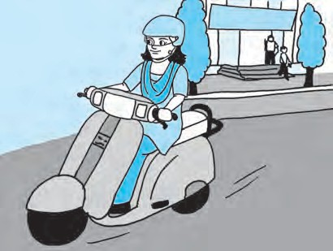**Solution :** The amount, that is, the total money owed to the bank at the end of the time, is to be calculated here. The principal is

50000 rupees. At 12 p.c.p.a., the interest on 100 rupees for one year is 12 rupees. We shall write the ratio of interest to capital in two ways to obtain an equation.

On 50000 rupees let the interest be *x* rupees. On 100 rupees the interest is 12 rupees.

*x*

50000 =

x 12

12

100

50000 × 50,000 = 100 × 50,000 (Multiplying both sides by 50000)

*x* = 6000

Amount (to be returned to the bank) = principal + interest

= 50,000 + 6,000

 Amount to be returned to the bank = ` 56,000

**Example** Aakash deposited 25000 rupees in a bank at a rate of 8 p.c.p.a.for 3 years. How much interest does he get every year? How much, altogether?

**Solution :** Here, the principal is 25000 rupees, time is 3 years and rate of interest is 8 on 100 rupees. The interest on 100 rupees is 8 rupees. Let us suppose the interest on 25000 rupees for 1 year is *x*. Let us find the ratio of interest to principal.

Then,

*x*

25000 =

8

100

  *x*

25000

8

× 25000 = 100

 *x* = 2000

× 25000 (Multiplying both sides by 25000 )

Aakash got 2000 rupees interest for one year.

For three years he got = 2000 × 3 = 6000 rupees interest.



**Let’s learn.**

Let’s learn the formula used to solve problems based on simple interest.

The principal is the same every year and the rate of interest too remains the same. The interest calculated in this way is called simple interest. Let us calculate the total interest when the principal P is deposited for T years at R rate of interest. Suppose the interest for one year is I.

The ratio of interest to principal for one year: Solving the same example using the formula:

I R

=  I =

P 100

P  R

#### 100

P  R  T

Principal = P = 25000, R = 8, T = 3

P  R  T

Interest for T years = I × T =

100

Total interest =

100

Total interest I =

Principal  Rate  Time

100

# 25000  8  3

=

# 100

= 6000

 Total interest is 6000 rupees.



**Now I know !**

Total interest I =

P  T  R

100

where P = principal, T = time in years, R = rate of interest

**Example** Sandeepbhau borrowed 120000 rupees from a bank for 4 years at the rate of

8 1 p.c.p.a. for his son’s education. What is the total amount he returned to

2

the bank at the end of that period ?

**Solution :** Principal = 120000, P = 120000, R = 8.5, T = 4

P  R  T

 Total interest =

#### 100

= 120000  8.5 4

100

120000  85 4

=

100 10

= 120  

= 40800

The total amount returned to the bank = 120000 + 40800 = 160800 rupees.

**Practice Set 40**

1. If Rihanna deposits 1500 rupees in the school fund at 9 p.c.p.a for 2 years, what is the total amount she will get?
2. Jethalal took a housing loan of 2,50,000 rupees from a bank at 10 p.c.p.a. for 5 years. What is the yearly interest he must pay and the total amount he returns to the bank?

3*. Shrikant deposited 85,000 rupees for 2 1

2

years at 7 p.c.p.a. in a savings bank

account. What is the total interest he received at the end of the period?

1. At a certain rate of interest, the interest after 4 years on 5000 rupees principal is 1200 rupees. What would be the interest on 15000 rupees at the same rate of interest for the same period?
2. If Pankaj deposits 1,50,000 rupees in a bank at 10 p.c.p.a. for two years, what is the total amount he will get from the bank?



**Let’s learn.**

When three of the four quantities, principal, time, rate and amount are given, to find the fourth: In the formula, we place any letter in place of the unknown quantity and solve the equation thus obtained to find the answer.

**Example** Principal = 25000 rupees, Amount = 31,000 rupees, Time = 4 years, what is the rate of interest?

Here, Amount Principal = Total interest 31000 25000 = 6000

Principal = 25000 rupees, time = 4 years, interest = 6000 rupees Let us now use the formula.

#### Principal  Rate  Time

Simple interest =

Then, 6000 =

R =

100

### 25000  R  4

100

6000  100

25000  4

where R = rate of interest

 R = 6

 Rate of interest is 6 p.c.p.a

**Example** Unmesh borrowed some money for 5 years at simple interest. The rate of interest is 9 p.c.p.a. If he returned 17400 rupees altogether at the end of 5 years, how much had he borrowed?

Principal  Rate  Time

Interest =

#### 100

This formula cannot be used directly to solve the problem because we do not

know either interest or principal. However, the interest on a principal of 100 rupees for 5 years is 45 rupees. Hence, the amount is 100 + 45 = 145 rupees. Now we can express the ratio of principal and amount in two ways and obtain an equation.

If Unmesh’s principal is P then

P

=

17400

100

145

 P = 100 17400

145

= 12000

 The principal that Unmesh borrowed was 12000 rupees.



**Let’s discuss.**

* Can we solve the problem by using the formula to obtain a different kind of equation ?

**Practice Set 41**

1. If the interest on 1700 rupees is 340 rupees for 2 years the rate of interest must be ......... .

(i) 12 % (ii) 15 % (iii) 4 % (iv) 10 %

1. If the interest on 3000 rupees is 600 rupees at a certain rate for a certain number of years, what would the interest be on 1500 rupees under the same conditions ?

(i) 300 rupees (ii) 1000 rupees (iii) 700 rupees (iv) 500 rupees

1. Javed deposited 12000 rupees at 9 p.c.p.a. in a bank for some years, and withdrew his interest every year. At the end of the period, he had received altogether 17,400 rupees. For how many years had he deposited his money ?

4* . Lataben borrowed some money from a bank at a rate of 10 p.c.p.a. interest for 2 1

2

years to start a cottage industry. If she paid 10250 rupees as total interest, how much money had she borrowed ?

1. Fill in the blanks in the table.

|  |  |  |  |  |  |
| --- | --- | --- | --- | --- | --- |
|  | Principal | Rate of interest (p.c.p.a.) | Time | Interest | Amount |
| (i) | 4200 | 7% | 3 years | ...... | ...... |
| (ii) | ...... | 6% | 4 years | 1200 | ...... |
| (iii) | 8000 | 5% | ...... | 800 | ...... |
| (iv) | ...... | 5% | ...... | 6000 | 18000 |
| (v) | ...... | 2 1 %  2 | 5 years | 2400 | ...... |

**Activity** :  Visit different banks and find out the rates of the interest they give for different types of accounts.

* + With the help of your teachers, start a Savings Bank in your school and open an account in it to save up some money.





11

Circle



**Let’s recall.**

 Identify the radii, chords and diameters in the circle alongside and write their names in the table below.

C

O

D

F

E

|  |  |  |  |  |
| --- | --- | --- | --- | --- |
| Radii |  |  |  |  |
| Chords |  |  |  |  |
| Diameters |  |  |  |  |

A B

Circumference of a Circle

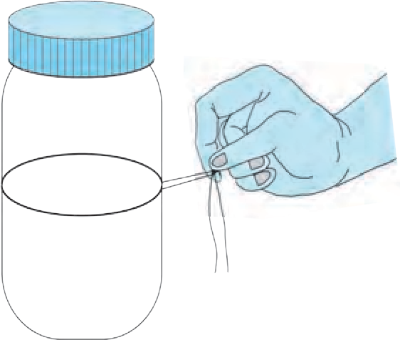**Activity I** Place a cylindrical bottle on a paper and trace the outline of its base. Use a thread to measure the circumference of the circle.

**Activity II** Measure the circumference of a bangle with the help of a thread.

**Activity III** Measure the circumference of any cylindrical object using a thread.

**Relationship between Circumference and Diameter Activity** Measure the circumference and diameter of the objects given below and enter



**Let’s learn.**

the ratio of the circumference to its diameter in the table.

|  |  |  |  |  |
| --- | --- | --- | --- | --- |
| Sr. No. | Object | Circumference | Diameter | Ratio C  D |
| 1. | Bangle | 19 cm | 6 cm | 19  6 = 3.16 |
| 2. | Circular dish | ........ | ........ | ........ |
| 3. | Lid of a jar | ........ | ........ | ........ |

Examine the ratio of the circumference to the diameter. What do we see?

The ratio of the circumference of any circle to its diameter is a little over 3 and remains constant. This constant is represented by the Greek letter π. Great mathematicians have proved through hard work that this number is not a rational number. In practice, the value

of π is taken to be 22 or 3.14. If the value of π has not been given in a problem, it is

taken to be 22 . 7

*c* = π*d*

7

circumference(c)

If radius is ‘*r*’, diameter ‘*d*’ and circumference ‘*c*’, But *d* = 2*r*  *c* = π × 2*r* or

*c* = 2π*r*

diameter (d) = π

**Example** The diameter of a circle is

14 cm. Find its circumference.

**Example** The radius of a circle is 35 cm.

Find its circumference.

**Solution** : Diameter : *d* = 14 cm

Circumference = π*d*

**Solution** : Radius of the circle *r* = 35 cm Circumference = 2π*r*

*c* = 22

7

× 14

*c* = 2 × 22

7

× 35

Circumference of the circle = 44 cm Circumference of the circle = 220 cm.

**Example** The circumference of a circle is 198 cm. Find its radius and diameter.

**Example** The circumference of a circle is

62.80 cm. Taking π = 3.14, find its diameter.

**Solution** : Circumference c = 2π*r*

198 = 2 × 22 × *r*

7

**Solution** : Circumference *c* = π*d*

62.80 = 3.14 × *d*

*r* = 198 × 1

2

× 7 22

62.80 = *d*

3.14

Radius = 31.5 cm 20 = *d*

 Diameter = 2 × 31.5 = 63 cm.  Diameter = 20 cm

**Example** The radius of a circular plot is 7.7 metres. How much will it cost to fence the plot with 3 rounds of wire at the rate of 50 rupees per metre?

**Solution** : Circumference of circular plot = 2π*r* = 2 × 22

7

× 7.7 = 48.4

Length of wire required for one round of fencing = 48.4 m.

Cost of one round of fence = length of wire × cost per metre.

= 48.4 × 50

= 2420 rupees.

Cost of 3 rounds of fencing = 3 × 2420 = 7260 rupees

**Example** The diameter of the wheel of a bus is



0.7 m. How many rotations will a wheel complete while travelling a distance of 22 km ?

**Solution** : Circumference of circle = π*d*

When finding the ratio of like terms, their units must be the same.

22 km = 22 × 1000 = 22000 m.

= 22 7

× 0.7

= 2.2 m

When the wheel completes one rotation it crosses a distance of 2.2 m., (1 rotation = 1 circumference)

distance Total number of rotations = circumference

= 22000

2.2

= 220000

22

= 10000

A wheel completes 10000 rotations to cover the distance of 22 km.

**Practice Set 42**

1. Complete the table below.

|  |  |  |  |
| --- | --- | --- | --- |
| Sr. No. | Radius (*r*) | Diameter (*d*) | Circumference (*c*) |
| (i) | 7 cm | ......... | ......... |
| (ii) | ......... | 28 cm | ......... |
| (iii) | ......... | ......... | 616 cm |
| (iv) | ......... | ......... | 72.6 cm |

1. If the circumference of a circle is 176 cm, find its radius.
2. The radius of a circular garden is 56 m. What would it cost to put a 4-round fence around this garden at a rate of 40 rupees per metre ?
3. The wheel of a bullock cart has a diameter of 1.4m. How many rotations will the wheel complete as the cart travels 1.1 km ?



**Let’s recall.**

**Arc of the Circle**

### A B A B

A

B

A plastic bangle is shown alongside. Suppose it breaks at points A and B. What is each of these pieces called as a part of a circle?



**Let’s learn.**

The chord AB divides the circle alongside Y

A

B

into two parts. Of these, the arc AXB is smaller and is called a **minor arc**. Arc AYB is bigger and is called the **major arc**. Minor arc AXB is also expressed as arc AB.

If two arcs of a circle have common end

points and the arcs make one complete circle, X

the arcs are said to be corresponding arcs. Y

Here, arc AYB and arc AXB are mutually corresponding arcs.

In the figure alongside, chord RT is a R T

diameter of the circle. The diameter gives rise to two equal arcs. They are called **semicircular**

arcs. X

* **Central Angle and the Measure of an Arc**

In the figure, ‘O’ is the vertex of the



O

A

B

AOB. An angle whose vertex is the centre of the circle is called a **central angle**.

The AOB in the figure is the central angle corresponding to arc AZB. **The measure of the**

**angle subtended at the centre by an arc is** Z

**taken to be the measure of the arc**.

* **The measure of a minor arc**

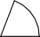

A

Y

70

O

Q

In the figure alongside, the measure

of AOQ = 70°. X

 Measure of the minor arc AYQ is 70°

It is written as *m*(arc AYQ) = 70°

* The measure of a major arc

A

Y

O

290

Q

Measure of a major arc = 360° measure of the corresponding minor arc

 Measure of major arc AXQ in the figure X

= 360° 70° = 290°

* + The measure of a circle

When the radius OA of a circle turns anti-clockwise, as shown in the figure alongside, through a complete angle, it turns through an angle that measures 360°. Its end point A



O

completes one circle. A

 The angle subtended at the centre by the circle is 360°.

 The measure of the complete circle is 360°.

* + Measure of a semicircular arc

Y

O

X

Now, look at the figure and determine the measures of the semicircular arcs AXB

and AYB. A B



**Now I know !**

•

•

•

The measure of a minor arc is equal to its correcsponding central angle.

The measure of a major arc = 360°

measure of corresponding minor arc.

The measure of a semicircular arc = 180°

**Practice Set 43**

1. Choose the correct option.

If arc AXB and arc AYB are corresponding arcs and *m*(arc AXB) = 120° then

*m*(arc AYB) = .

(i) 140° (ii) 60° (iii) 240° (iv) 160°

X

P

O

Y

1. Some arcs are shown in the circle with centre ‘O’.

Write the names of the minor arcs, major arcs and Q R

semicircular arcs from among them.

1. In a circle with centre O, the measure of a minor arc is 110°. What is the measure of the major arc PYQ?

|  |  |
| --- | --- |
|  | |
| **ICT Tools or Links** |  |
| Using the MOVE option of the Geogebra software, observe the relationship between a central angle and its corresponding arc, for different measures of the arc. | |





12

Perimeter and Area

Perimeter



**Let’s recall.**

The sum of the lengths of all sides of a closed figure is the perimeter of that figure. Perimeter of a polygon = sum of lengths of all sides.

 Perimeter of a square = 4 × side Perimeter of square of side *a* = 4*a*

Perimeter of a rectangle = 2 length + 2 breadth Perimeter of a rectangle with length *l* and breadth *b* is 2*l* + 2*b*

**Example** The perimeter of a rectangle is 64 cm. If its length is 17 cm, what is its breadth?

**Solution :** Let its breadth be *x* cm.

2 length + 2 breadth = perimeter 2 (length + breadth) = 64

2 (17 + *x*) = 64

**Example** The perimeter of a rectangle of length 28 cm and breadth 20 cm is equal to the perimeter of a square. What is the length of the side of that square?

**Solution :** Perimeter of rectangle

= 2 (length + breadth)

= 2 (28 + 20)

= 96

2 17  *x*

2

= 64

2

If the side of that square is *a* then 4*a* = 96

Perimeter of square = 96

17 + *x* = 32

*x* = 15

The breadth of the rectangle is 15 cm.

4*a* = 96

 *a*  96  24

4

Side of the square is 24 cm.

**Practice Set 44**

1. If the length and breadth of a rectangle are doubled, how many times the perimeter of the

old rectangle will that of the new rectangle be?

1. If the side of a square is tripled, how many times the perimeter of the first square will that of the new square be?

15 m

1. Given alongside is the diagram of a playground. It shows the length of its sides. Find the perimeter of the playground.

10 m

1. As shown in the figure, four napkins all of the same size were made from a square piece of cloth of length 1 m. What length of lace will be required to trim all four sides of all the napkins ?

5 m

15 m

|  |  |
| --- | --- |
|  |  |
|  |  |



**Let’s recall.**

Area

* Area of square = side × side = (side)2
* Area of rectangle = length × breadth = *l* × *b*

Area is measured in square metres, square cm, square km, etc.

Activity I

Measure the length and breadth of the courts laid out for games such as kho-kho, kabaddi, tennis, badminton, etc. Find out their perimeters and areas.

Activity II

A wall in Aniruddha’s house is to be painted. The wall is 7 m long and 5 m high. If the painter charges 120 rupees per square metre, how much will he have to be paid?

**Example** A rectangular garden is 40 m long and 30 m wide. A two-metre wide path is to be paved inside the garden along its boundary, using tiles 25 cm × 20 cm in

size. How many such tiles will be required ?

Let us find the area to be paved.

Area of garden = 40 × 30 = 1200 sqm

30 m

40 m

2 m

2 m

Area not to be paved = 36 × 26 = 936 sqm

100 cm = 1 m

25 cm = 25 m

100

 Area to be paved = 1200 936 = 264 sqm

Area of each tile = 25

100

20

× 100

1

= 20

sqm

Area of one tile is 1

20

sqm.

Hence, let us find the number of tiles required to tile 264 sqm.

Number of tiles = Total area

Area of one paver

= 264 **÷**  1

20

= 264 × 20 = 5280

Therefore, 5280 tiles will be required.

**Example** A rectangular playground is 65 m long and 30 m wide. A pathway of 1.5 m width goes all around the ground, outside it. Find the area of the pathway.

**Solution** : The playground is rectangular.

### P Q

A

B

D

C

30 m

1.5 m

 ABCD is the playground. Around it is a pathway

1.5 m wide.

65 m

Around  ABCD we get the rectangle  PQRS Length of new rectangle PQRS = 65 + 1.5 + 1.5 = 68 m Breadth of new rectangle PQRS = 30 + 1.5 + 1.5 = 33 m

### S R

Area of path = Area of rectangle PQRS Area of rectangle ABCD

= 68 × 33 65 × 30 = = sqm.



**Let’s discuss.**

* Is there another way to find the area of the pathway in the problem above?

**Example** The length and the width of a mobile phone are 13 cm and 7 cm respectively.

It has a screen PQRS as shown in the figure. What is the area of the screen?

**Solution :** ABCD is the rectangle formed by the edges of the mobile. PQRS is the rectangle formed by leaving a 1.5 cm wide edge alongside AB, BC, and DC, and a 2 cm edge alongside DA.

1.5 cm C P Q

S

R

A

2 cm

D

1.5 cm

13 cm

1.5 cm

Length of rectangle PQRS = cm Breadth of rectangle PQRS = cm

Area of screen = Area of rectangle PQRS = ........ × ........ = sqm

Activity

Take mobile handsets of different sizes and find the area of their screens.

B

7 cm

**Practice Set 45**

1. If the side of a square is 12 cm, find its area.
2. If the length of a rectangle is 15 cm and breadth is 5 cm, find its area.
3. The area of a rectangle is 102 sqcm. If its length is 17 cm, what is its perimeter ?

4*. If the side of a square is tripled, how many times will its area be as compared to the area of the original square ?

Area of a Right-angled Triangle



**Let’s learn.**

**Activity** Cut out two right-angled triangles having the same measures. Join them as shown in the figure. See how they form a rectangle. The sides of length p and q that form the right angles of the triangles are also the ones that form the sides of the rectangle. From the figure we see that

Area of a rectangle = 2 × area of right-angled triangle q

 2 × area of right-angled triangle = p × q p  p

p  q

Area of right-angled triangle = q

2



**Now I know !**

Area of a right-angled triangle = 1 × product of sides forming the right angle

2

If one of the sides of a right-angled triangle forming the right angle is taken to be the base, the other becomes the height of the triangle.

Thus, the area of a right-angled triangle = 1

2

base × height

If ∆ABC is any triangle, then any side can be taken as the base. Then the

measure of the perpendicular on the base from the apex opposite to it, is the height of the triangle.

Take any ∆PQR and take QR as the base. PM is the perpendicular from P on QR.

**Figure 1** : Point M is in seg QR.

P

**Figure 2** : Point M is outside seg QR.

P

Q R  R

M

base

height

height

M Q base 

∆PMR and ∆PMQ are right-angled triangles. ∆PMR and ∆PMQ are right-angled triangles.

A(∆PQR) = A (∆PMQ) + A(∆PMR) A(∆PQR) = A(∆PMR) A (∆PMQ)

= 1 × *l*(QM) × *l*(PM) + 1 × *l*(MR) × *l*(PM) = 1 × *l*(MR) × *l*(PM) 1 × *l*(MQ) × *l*(PM)

2 1 2 2 2

= 2 [*l*(QM) + *l*(MR)] × *l*(PM)

= 1 *l*(QR) × *l*(PM)

2

= 1 × base × height

2

= 1 [*l*(MR) *l*(MQ)] × *l*(PM)

2

= 1 × *l*(QR) × *l*(PM)

2

= 1 × base × height

A(∆PQR) = 1

2

× base × height

2

A(∆PQR) =

1. × base × height

2



Area of triangle = 1 × base × height

2

**Now I know !**

**Example** If the sides that form the right angle of a triangle are 3.5 cm and 4.2 cm long, find the area of the triangle.

**Solution :** Area of a right-angled triangle

**Example** If the base of a triangle is

5.6 cm and height is 4.5 cm, what is its area?

**Solution :** Area of a triangle

= 1 × product of sides forming right

1. angle

= 1 × 3.5 × 4.2

2

= 7.35 sqcm

= 1 × base × height

2

= 1 × 5.6 × 4.5

2

= 12.6 sqcm

(Note that sqcm is also written as cm2).

**Pratice set 46**

1. A page of a calendar is 45 cm long and 26 cm wide. What is its area ?
2. What is the area of a triangle with base 4.8 cm and height 3.6 cm ?
3. What is the value of a rectangular plot of land 75.5 m long and 30.5 m broad at the rate of 1000 rupees per square metre ?
4. A rectangular hall is 12 m long and 6 m broad. Its flooring is to be made of square tiles of side 30 cm. How many tiles will fit in the entire hall ? How many would be required if tiles of side 15 cm were used?
5. Find the perimeter and area of a garden with measures as shown in the figure alongside.

**Surface Area**



**Let’s learn.**

**The surface area of any three-dimensional object is the sum of the areas of all its faces**.

* + **Surface Area of a Cuboid**

A B • A cuboid has six faces.

C

F

*b*

* Each face is a rectangle.

D *h* • Opposite faces have the same area.

*h* E • Each edge is perpendicular to the two other edges it meets.

G *l* H

* + - Let *l* be the length of the horizontal face of the cuboid and *b* be the breadth. Let *h* be the height of its vertical sides.

Area of rectangle ABCD = Area of rectangle GHEF = *l* × *b* Area of rectangle ADGF = Area of rectangle BCHE = *b* × *h* Area of rectangle CHGD = Area of rectangle ABEF = *l* × *h* Total surface area of cuboid = Sum of area of all rectangles

Total surface area of cuboid = 2 (length × breadth + breadth × height + length × height)

= 2 (*l* × *b* + *b* × *h* + *l* × *h*) = 2 (*lb* + *bh* + *lh*)

* + - * Surface Area of a Cube
* A cube has 6 faces.
* Each face is a square.
* Area of all faces is equal.
* Let the side of each square be *l.*
* Area of one face of the cube = Area of square
* Total surface area of the cube = Sum of areas of 6 squares.

= 6 × side2

= 6 × *l* 2

**Example** How much sheet metal is required to make a closed rectangular box of length

1.5 m, breadth 1.2 m and height 1.3 m ?

**Solution :** length of box = *l* = 1.5 m, breadth = *b* = 1.2 m, height = *h* = 1.3 m.

Surface area of box = 2 (*l* × *b* + *b* × *h* + *l* × *h*)

= 2 (1.5 × 1.2 + 1.2 × 1.3 + 1.5 × 1.3)

= 2 (1.80 + 1.56 + 1.95)

*h* = 2 (5.31)

= 10.62 sqm

*b* 10.62 sqm of sheet metal will be needed to make the box.

*l*

**Example** One side of a cubic box is 0.4 m. How much will it cost to paint the outer surface of the box at the rate of 50 rupees per sqm?

**Solution :** side = *l* = 0.4 m.

Total surface area of cube = 6 × (*l*)2

= 6 × (0.4)2

= 6 × 0.16 = 0.96 sqm

Cost of painting 1 sqm is 50 rupees.

 Cost of painting 0.96 sqm will be = 0.96 × 50

= 48 rupees

It will cost 48 rupees to paint the outer surface of the box.

**Practice Set 47**

1. Find the total surface area of cubes having the following sides.

(i) 3 cm (ii) 5 cm (iii) 7.2 m (iv) 6.8 m (v) 5.5 m

1. Find the total surface area of the cuboids of length, breadth and height as given below:

(i) 12 cm, 10 cm, 5 cm (ii) 5 cm, 3.5 cm, 1.4 cm

(iii) 2.5 cm, 2 m, 2.4 m (iv) 8 m, 5 m, 3.5 m

1. A matchbox is 4 cm long, 2.5 cm broad and 1.5 cm in height. Its outer sides are to be covered exactly with craft paper. How much paper will be required to do so ?
2. An open box of length 1.5 m, breadth 1 m, and height 1 m is to be made for use on a trolley for carrying garden waste. How much sheet metal will be required to make this box ? The inside and outside surface of the box is to be painted with rust proof paint. At a rate of 150 rupees per sqm, how much will it cost to paint the box?

**Maths is fun !**

There are some three-digit numbers which can be divided by the product of their digits without leaving a remainder.

**Example** (i) Take the number 175, 1 × 7 × 5 = 35, 175  5

35

(ii) Take the number 816, 8 × 1 × 6 = 48, 816  17

48

12

The numbers 135, 312, 672 are some more numbers like these.

Can you find other such numbers?

(iii) Take the number 612, 6 × 1 × 2 = 12, 612  51





13

Pythagoras’ Theorem

Right-angled Triangle



**Let’s recall.**

We know that a triangle with one right angle is called a right-angled triangle and the side opposite to the right angle is called the hypotenuse.

* + Write the name of the hypotenuse of each of the right-angled triangles shown below.

A

L Z

M X

B C

N

Y

The hypotenuse of The hypotenuse of The hypotenuse of

∆ABC ∆LMN ∆XYZ

Pythagoras’ Theorem

Pythagoras was a great Greek mathematician of the 6th century BCE. He made important contributions to mathematics. His method of teaching mathematics was very popular. He trained several mathematicians.

People of many countries had long known of a certain principle related to the right-angled triangle. It is also given in the book called Shulvasutra, of ancient India. As Pythagoras was the first to prove the theorem, it is named after him. This theorem of Pythagoras states that **in a right-angled triangle, the square of the hypotenuse is equal to the sum of the squares of the other two sides**.

**Activity** : Draw right-angled triangles given the hypotenuse and one side as shown in the rough figures below. Measure the third side. Verify Pythagoras’ theorem.

### A

B

(i)

### C

5

(ii)

P

10

6

R

Q

(iii)

### Z

17

X

15

Y

A



**Let’s learn.**

height

### B

#### base C

With reference to the figure alongside, the theorem of Pythagoras can be written as follows :

In ∆ABC, if B is a right angle, then [*l*(AC)]2 = [*l*(AB)]2 + [*l*(BC)]2

Generally, in a right-angled triangle, one of the sides forming the right angle is taken as the base and the other as the height.

Then, the theorem can be stated as

(hypotenuse)2 = (base)2 + (height)2.

Follow the steps given below to **verify Pythagoras’ theorem.**

**Activity** : From a cardsheet, cut out eight identical right-angled triangles. Let us say the length of the hypotenuse of these triangles is ‘a’ units, and sides forming the right angle are ‘b’ and ‘c’ units. Note that the area of this triangle is *bc* .

2

Next, on another cardsheet, use a pencil to draw two

squares ABCD and PQRS each of side (b + c) units. Now, place 4 of the triangle cut-outs in the square ABCD and the remaining 4 in the square PQRS as shown in the figures below. Mark by lines drawn across them, the parts of the squares covered by the triangles.

*c*

*b*

*a*

A *c b* B

*a*

*a*

*a*

*a*

*b c*

*c b*

D *b c* C

Figure (i)

P *b c* Q

*b b*

*c c*

### S R

*b* Figure (ii) *c*

Observe the figures. In figure (i) we can see a square of side *a* units in the uncovered portion of square ABCD. In figure (ii) we see a square of side b and another of side c in the uncovered portion of the square PQRS.

In figure (i), area of square ABCD = *a*2 + 4 × area of right-angled triangle

1

= *a*2 + 4 ×

= *a*2 + 2*bc*

2 *bc*

In figure (ii), area of square PQRS = *b*2 + *c*2 + 4 × area of right-angled triangle

1

= *b*2 + *c*2 + 4 ×

= *b*2 + *c*2 + 2*bc*

2 *bc*

Area of square ABCD = Area of square PQRS

 *a*2 + 2*bc* = *b*2 + *c*2 + 2*bc*

 *a*2 = *b*2 + *c*2



**Let’s discuss.**

* Without using a protractor, can you verify that every angle of the vacant quadrilateral in figure (i) is a right angle ?

**Activity** : On a sheet of card paper, draw a right-angled triangle of sides 3 cm, 4 cm and 5 cm. Construct a square on each of the sides. Find the area of each of the squares and verify Pythagoras’ theorem.

A

B

C

Given two sides of a right-angled triangle, you can find the third side, using Pythagoras’ theorem.

**Example** In ∆ABC, C = 90°, *l*(AC) = 5 cm and *l*(BC) = 12 cm. What is the length of seg (AB)?

**Solution** : In the right-angled triangle ABC, C = 90°.

Hence, side AB is the hypotenuse. B

According to Pythagoras’ theorem,

*l*(AB)2 = *l*(AC)2 + *l*(BC)2

= 52 + 122 12

= 25 + 144

*l*(AB)2 = 169

*l*(AB)2 = 132 C A

*l*(AB) = 13 5

 Length of seg AB = 13 cm.

**Practice Set 48**

1. In the figures below, find the value of ‘*x*’.

Q *x* D

L

*x*

24

7 9

17

### M N P

*x* E

#### 8

(i)

### 41 R

(ii)

(iii) F

1. In the right-angled ∆PQR, P = 90°. If *l*(PQ) = 24 cm and *l*(PR) = 10 cm, find the length of seg QR.
2. In the right-angled ∆LMN, M = 90°. If *l*(LM) = 12 cm and *l*(LN) = 20 cm, find the length of seg MN.
3. The top of a ladder of length 15 m reaches a window 9 m above the ground. What is the distance between the base of the wall and that of the ladder ?



**Let’s learn.**

If, in a triplet of natural numbers, the square of the biggest number is equal to the sum of the squares of the other two numbers, then the three numbers form **a Pythagorean triplet.** If the lengths of the sides of a triangle form such a triplet, then the triangle is a right-angled triangle.

**Example** Do the following numbers form a Pythagorean triplet : (7, 24, 25) ?

**Solution** : 72 = 49, 242 = 576, 252 = 625

 49 + 576 = 625

 72 +242 = 252

7, 24 and 25 is a Pythagorean triplet.

**Activity** : From the numbers 1 to 50, pick out Pythagorean triplets.

**Practice Set 49**

1. Find the Pythagorean triplets from among the following sets of numbers.

(i) 3, 4, 5 (ii) 2, 4, 5

(iii) 4, 5, 6 (iv) 2, 6, 7

1. 9, 40, 41 (vi) 4, 7, 8
2. The sides of some triangles are given below. Find out which ones are right-angled triangles?

(i) 8, 15, 17 (ii) 11, 12, 15 (iii) 11, 60, 61 (iv) 1.5, 1.6, 1.7

(v) 40, 20, 30





14

Algebraic Formulae - Expansion of Squares

### A



**Let’s recall.**

*x*

*x*

*x*

M

2*x*

### D

S B

### N

*y*  P C

A rectangle ABCD is shown in the figure alongside. Its length is *y* units and its breadth, 2*x* units. A square of side *x* units is cut out from this rectangle. We can use operations on algebraic expressions to find the area of the shaded part. Let us write the area of rectangle ABCD as A( ABCD)

Area of the shaded part = A( ABCD) A( MNCP)

= 2*xy x* 2

Area of the shaded part = A( ASPD) + A( SBNM)

= (*y x*) × 2*x* + *x* 2

= 2*xy* 2*x* 2 + *x* 2

= 2*xy x* 2



**Let’s learn.**

The Expanded Form of the Square of a Binomial

The product of algebraic expressions is called their ‘expansion’ or their ‘expanded form’. There are some formulae which help in writing certain expansions. Let’s consider

some of them.

P *x y* Q

|  |  |
| --- | --- |
| I | II |
| III | IV |

Activity I

*x x*

*y y*

S *x y* R

* + In the figure alongside, the side of the square PQRS is (*x* + *y*).

 A ( PQRS) = (*x* + *y*)2

The square PQRS is divided into 4 rectangles : I, II, III, IV

A( PQRS) = Sum of areas of rectangles I, II, III, IV.

 A ( PQRS) = A (Rectangle I) + A (Rectangle II) + A (Rectangle III) + A (Rectangle IV) (*x* + *y*)2 = *x*2 + *xy* + *xy* + *y*2 = *x*2 + 2*xy* + *y*2

 (*x* + *y*)2 = *x*2 + 2*xy* + *y*2

Now, let us multiply (*x* + *y*)2 as algebraic expressions. (*x* + *y*) (*x* + *y*) = *x* (*x* + *y*) + *y* (*x* + *y*)

= *x*2 + *xy* + *yx* + *y*2  (*x* + *y*)2 = *x*2 + 2*xy* + *y*2

The expression obtained by squaring the binomial (*x* + *y*) is equal to the expression obtained by finding the area of the square. Therefore, (*x* + *y*)2 = *x*2 + 2*xy* + *y*2 is the formula for the expansion of the square of a binomial.

**Activity II** In the figure alongside, the square with side *a* is divided into 4 rectangles, namely, square with side (*a b*), square with side *b* and two rectangles of sides (*a b*) and *b*.

A (square I) + A (rectangle II) + A (rectangle III) + A (square IV) = A ( PQRS)

(*a b*)2 + (*a b*) *b* + (*a b*) *b* + *b*2 = *a*2

(*a b*)2 + 2*ab* 2*b* 2 + *b*2 = *a*2 P

(*a b*)2 + 2*ab b*2 = *a*2

 (*a b*)2 = *a*2 2*ab* + *b*2

Let us multiply the algebraic expressions and obtain the formula.

(*a* - *b*)2 = (*a b*) × (*a b*)

= *a* (*a b*) *b* (*a b*)

= *a*2 *ab ab* + *b*2

= *a*2 2*ab* + *b*2 S

*a-b b* Q

*a * R

|  |  |
| --- | --- |
| I | II |
| III | IV |



**Now I know !**

* (*a* + *b*)2 = *a*2 + 2*ab* + *b*2
* (*a b*)2 = *a*2 2*ab* + *b*2

We can verify the formulae by substituting *a* and *b* with any numbers.

Thus, if *a =* 5*, b =* 3, then (*a* + *b*)2 = (5 + 3)2 = 82 = 64

*a*2 + 2*ab* + *b*2 = 52 + 2 × 5 × 3 + 32

= 25 + 30 + 9 = 64

(*a b*)2 = (5 3)2 = 22 = 4

*a*2 2*ab* + *b*2 = 52 2 × 5 × 3 + 32

= 25 30 + 9 = 4

Use the given values to verify the formulae for squares of binomials.

(i) *a* = 7 , *b* = 8 (ii) *a* = 11 , *b* = 3 (iii) *a* = 2.5 , *b* = 1.2

|  |  |  |  |  |  |
| --- | --- | --- | --- | --- | --- |
| **Expand.** |  | | | | |
| **Example** | (2*x* + 3*y*)2  = (2*x*)2 + 2(2*x*) × (3*y*) + (3*y*)2 | **Example** | (5*x*  = (5*x*)2 | 4)2 | 2(5*x*) × (4) + |
|  | = 4*x*2 + 12*xy* + 9*y*2 |  | = 25*x*2 |  | 40*x* + 16 |
| **Example** | (51)2 | **Example** | (98)2 |  |  |

42

22

|  |  |  |
| --- | --- | --- |
| = (50 + 1)2 | = (100 | 2)2 |
| = 502 + 2 × 50 × 1 + 1 × 1 | = 1002 | 2 × 100 × 2 + |
| = 2500 + 100 + 1 | = 10000 | 400 + 4 |
| = 2601 | = 9604 |  |

1. Expand.

**Practice Set 50**

  *a b* 2

 2 2

(i) (5*a* + 6*b*)2 (ii)    (iii) (2*p* 3*q*)2 (iv)  *x*   

 2 3 

 1 2

 *x* 

 1 2

(v) (*ax* + *by*)2 (vi) (7*m* 4)2 (vii)

 *x*  

(viii)  *a*  *a* 

 2   

1. Which of the options given below is the square of the binomial (8 1 ) ?

*x*

+

* 1. 64 1

*x*2

* 1. 64 + 1

*x*2

* 1. 64 16 1

*x x*

+

2

* 1. 64 + 16 1

*x x*

2

1. Of which of the binomials given below is *m*2*n*2 + 14*mnpq* + 49*p*2*q*2 the expansion?

(i) (*m* + *n*) (*p* + *q*) (ii) (*mn pq*) (iii) (7*mn* + *pq*) (iv) (*mn* + 7*pq*)

1. Use an expansion formula to find the values.

(i) (997)2 (ii) (102)2 (iii) (97)2 (iv) (1005)2



**Let’s learn.**

**\* Expansion of (***a* **+** b**) (***a* - b**)**

(*a* + *b*) (*a b*) = (*a* + *b*) × (*a b*)

= *a* (*a b*) + *b* (*a b*)

= *a*2 *ab* + *ba b*2

= *a*2 *b*2

(*a* + *b*) (*a b*) = *a*2 *b*2



**Now I know !**

(*a* + *b*) (*a b*) = *a*2

*b*2

**Example** (3*x* + 4*y*) (3*x* 4*y*) = (3*x*)2 (4*y*)2 = 9*x*2 16*y*2

**Example** 102 × 98 = (100 + 2) (100 2) = (100)2 (2)2 = 10000 4 = 9996

**Practice Set 51**

1. Use the formula to multiply the following.

(i) (*x* + *y*) (*x y*) (ii) (3*x* 5) (3*x* + 5)

(iii) (*a* + 6) (*a* 6) (iv)  *x*  6   *x*  6 





1. Use the formula to find the values.

 

   

5

5

(i) 502 × 498 (ii) 97 × 103 (iii) 54 × 46 (iv) 98 × 102

Factorising Algebraic Expressions



**Let’s learn.**

We have learnt to factorise whole numbers. Now let us learn to factorise algebraic expressions. First, let us factorise a monomial.

15 = 3 × 5, that is, 3 and 5 are factors of 15.

Similarly, 3*x* = 3 × *x,* Hence, 3 and *x* are factors of 3*x* Consider 5*t*2. 5*t*2 = 5 × *t*2 = 5 × *t* × *t*

1, 5, *t*, *t*2, 5*t*, 5*t*2 are all factors of 5*t*2. 6 *ab*2 = 2 × 3 × *a* × *b* × *b*

When factorising a monomial, first factorise the coefficient if possible and then factorise the part with variables.

**Practice Set 52**

* Factorise the following expressions and write them in the product form.

(i) 201 *a*3 *b*2 , (ii) 91 *xyt*2 , (iii) 24 *a*2 *b*2 , (iv) *tr*2*s*3



**Let’s learn.**

Factorising a Binomial

4, *x* and *y* are factors of every term in the binomial 4*xy* + 8*xy*2

 4*xy* + 8*xy*2 = 4(*xy* + 2*xy*2) = 4*x* (*y* + 2*xy*) = 4*xy* (1 + 2*y*)

We can factorise a binomial by identifying the factors common to both terms and writing them outside the brackets in product form.

This is how we factorise 9*a*2*bc* + 12*abc*2 = 3(3*a*2*bc* + 4*abc*2) = 3*abc* (3*a* + 4*c*) (*a* + *b*) (*a b*) = *a*2 *b*2 is a formula we have already learnt.

Hence, we also get the factors *a*2 *b*2 = (*a* + *b*) (*a b*) Factorise:

**Example** *a*2 4*b*2 = *a*2 (2*b*)2

= (*a* + 2*b*) (*a* 2*b*)

**Example** 3*a*2 27*b*2 = 3(*a*2 9*b*2)

= 3(*a* + 3*b*) (*a* 3*b*)

**Practice Set 53**

* Factorise the following expressions.

(i) p2 - q2 (ii) 4*x*2 - 25*y*2 (iii) *y*2 - 4 (iv) *p*2 - 1

25

(v) 9*x*2 - 1 *y*2 (vi) *x*2 - 1

(vii) *a*2*b* - *ab* (viii) 4*x*2*y* - 6*x*2

16 *x*2



94

*y*2 - 8*z2*

(x) 2*x*2 - 8*y*2



(ix) 1

2



15

Statistics

Average



**Let’s learn.**

The following table shows how many minutes Asmita took to cycle to school every morning, from Monday to Saturday.

|  |  |  |  |  |  |  |
| --- | --- | --- | --- | --- | --- | --- |
| **Day** | **Mon** | **Tue** | **Wed** | **Thu** | **Fri** | **Sat** |
| **Minutes** | 20 | 20 | 22 | 18 | 18 | 20 |

We see from the table that she takes 18 minute on some days, 20 on others and even 22 minutes on one day. If we consider these six school days, what would you say is the approximate time she takes to cycle to school ?

In mathematics, to make such an estimate, we find the ‘average’. If we add together the number of minutes required on each day and divide the sum by six, the number we get is, approximately, the time required every day. It is the ‘average’ of all six numbers.

Sum of the number of minutes taken to cycle to school on each of six days

Average =

Total days

20 + 20 + 22 + 18 + 18 + 20

=

6

= 118

6

= 19 2

3

On an average, Asmita takes 19 2

3

minutes to cycle to school every day.

**Example** A school conducted a survey to find out how far their students live from the school. Given below is the distance of the houses of six of the students from the school. Let us find their average distance from the school.

950 m, 800 m, 700 m, 1.5 km, 1 km, 750 m

**Solution :** To find the average, we must first express all the distances in the same units.

Sum of the distance between home and school for six students

Average =

1 km = 1000 m

1.5 km = 1500 m

Total number of students

950 + 800 + 700 + 1500 + 1000 + 750

= 6

5700

6

=

= 950 m

The average distance at which the students live from the school is 950 m.



**Let’s discuss.**

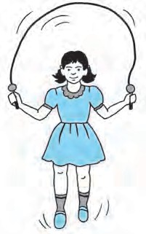**Example** Rutuja practised skipping with a rope all seven days of a week. The number of times she jumped the rope in one minute every day is given below.

60, 62, 61, 60, 59, 63, 58

Sum of the number of jumps on seven days

Average =

=

Total number of days

+  +  +  +  +  + 

=

7

Average number of jumps per minute = 60.42

The samples that we have of the quantity we are measuring are called ‘readings’ or ‘scores’.

We know that the number of jumps will be counted in natural numbers. Never will there be a fractional number of jumps. However, their average can be a fractional number.



**Now I know !**

Sum of all scores in the given data Average = Total number of scores

**Activity** :  Make groups of 10 children, in your class. Find the average height of the children in each group.

* With the help of your class teacher, note the daily attendance for a week and find the average attendance.

**Practice Set 54**

1. The daily rainfall for each day of a week in a certain city is given in millimetres. Find the average rainfall during the week. 9, 11, 8, 20, 10, 16, 12
2. During the annual function of a school, a Women’s Self-helf Group had set up a snacks stall. Their sales every hour were worth ` 960, ` 830, ` 945, ` 800,

` 847, ` 970 respectively. What was the average of the hourly sales?

1. The annual rainfall in Vidarbha in five years is given below. What is the average rainfall for those 5 years ? 900 mm, 650 mm, 450 mm,

733 mm, 400 mm

1. A farmer bought some sacks of animal feed. The weights of the sacks are given below in kilograms. What is the average weight of the sacks ?

49.8, 49.7, 49.5, 49.3, 50, 48.9, 49.2,

48.8

Frequency Distribution Table



**Let’s learn.**

Sometimes, in collected data, some scores appear again and again. **The number of times a particular score occurs in a data is called the frequency of that score**. In such cases a frequency table is made with three columns, one each for the score, the tally marks and the frequency.

1. In the first column, scores are entered in ascending order. For example, enter 1, 2, 3, 4, 5, 6 in order one below the other.
2. Read the scores in the data in serial order and enter a tally mark ‘।’ for each in the

second column of the table in front of that score, e.g. if you read the score ‘3’, make a tally mark in front of 3 in the second column. Place four tally marks like this ।।।।, but make the fifth one like this ।।।।. It makes it easier to count the total number of

tally marks.

1. Count the total number of tally marks in front of each score and enter the number in the next, i.e. third, column. This number is the frequency of the score.
2. Lastly, add all the frequencies. Their sum is denoted by the letter N. This sum is equal to the total number of scores.

Making a Frequency Table of the Given Information/ Data

**Example** The distance at which some children live from their school is given below in kilometres.

1, 3, 2, 4, 5, 4, 1, 3, 4, 5, 6, 4, 6, 4, 6

Let us see how to make a frequency table of this data.

|  |  |  |
| --- | --- | --- |
| Scores | Tally marks | Frequency |
| 1 | ।। | 2 |
| 2 | । | 1 |
| 3 | ।। | 2 |
| 4 | ।।।। | 5 |
| 5 | ।। | 2 |
| 6 | ।।। | 3 |
|  | Total frequency N = 15 | |

We strike off a score to indicate that it has been counted. The list of scores below shows that the first three scores have already

been counted.

(1, 3, 2, 4, 5, 4, 1, 3, 4, 5, 6, 4,

6, 4, 6)



**My friend, Maths : At home, in the market.**

Priya’s mother bought some peas and began to shell them. Priya was sitting nearby studying her maths lesson and she observed that some of the peapods had just 4 peas while some had 7. So, she took 50 of the pods and, as she shelled them, she noted down the number of peas in each of the pods.

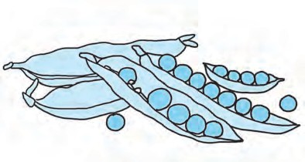She also made a frequency table of the peas in the pods.

|  |  |  |
| --- | --- | --- |
| Number of peas in a pod | Tally marks | Frequency |
| 2 | ।।।। ।।। | 8 |
| 3 | ।।।। ।।।। ।।।। | 15 |
| 4 | ।।।। ।।।। ।। | 12 |
| 5 | ।। | 2 |
| 6 | ।।।। ।। | 7 |
| 7 | ।।। | 3 |
| 8 | ।।। | 3 |
|  | Total frequency N = 50 | |

4, 3, 2, 4, 3, 4, 3, 3, 2, 8

2, 3, 3, 4, 3, 4, 4, 5, 2, 8

8, 2, 5, 3, 4, 4, 3, 6, 2, 3

4, 4, 3, 3, 2, 6, 4, 4, 7, 2

3, 6, 3, 6, 6, 6, 7, 6, 7, 3

**Mother :** Can you find out the average number of peas in a pod?

**Priya :** I will have to add 50 numbers and then divide their sum by 50. It will be tedious work.

**Mother :** Let’s make it easier. You can tell

**Mother :** It is easier to do seven simple multiplications and add them up, isn’t it? This is how the frequency table proves useful when we have a huge amount of data.

**Priya :** The sum of all scores was 206.

from the frequency table how many pods had 2 peas, how

So, their average = 206

50

= 4.12.

many had 3 and so on, right?

**Priya :** Yes ! 8 pods had 2 peas each, 15 had 3, 12 had 4.... Oh, now I see. If I multiply and find the products like 2 × 8, 3 ×15,

1. × 12 and then add all the products I will get the sum of all those 50 numbers.

**Mother :** Peas in a pod are always found

in whole numbers, but the average can be a fraction. In this case, we can say that there were about 4 peas in every pod.



**Now I know !**

**Practice Set 55**

1. The height of 30 children in a class is given in centimetres. Draw up a freqency table of this data.

131, 135, 140, 138, 132, 133, 135, 133, 134, 135, 132, 133, 140, 139, 132, 131, 134,

* A simple way to tabulate scores is by using tally marks.
* A table in which the number of tally marks indicates the frequency is called a frequency table.
* When the number of scores is very large, a frequency table is used to find their average.

133, 140, 140, 139, 136, 137, 136, 139, 137, 133, 134, 131, 140

1. In a certain colony, there are 50 families. The number of people in every family is given below. Draw up the frequency table.

5, 4, 5, 4, 5, 3, 3, 3, 4, 3, 4, 2, 3, 4, 2, 2, 2, 2, 4, 5, 1, 3, 2, 4, 5, 3, 3, 2, 4, 4, 2, 3,

4, 3, 4, 2, 3, 4, 5, 3, 2, 3, 2, 3, 4, 5, 3, 2, 3, 2

1. A dice was cast 40 times and each score noted is given below. Draw up a frequency table for this data.

3, 2, 5, 6, 4, 2, 3, 1, 6, 6, 2, 3, 5, 3, 5, 3, 4, 2, 4, 5, 4, 2, 6, 3, 3, 2

4, 3, 3, 4, 1, 4, 3, 3, 2, 2, 5, 3, 3, 4

1. The number of chapatis that 30 children in a hostel need at every meal is given below. Make a frequency table for these scores.

3, 2, 2, 3, 4, 5, 4, 3, 4, 5, 2, 3, 4, 3, 2, 5, 4, 4, 4, 3, 3, 2, 2, 2, 3, 4, 3, 2, 3, 2

The ‘average’ is a useful figure in the study of all branches of science including medicine, geography, economics, social science, etc.



Miscellaneous Problems : Set 2

1. Angela deposited 15000 rupees in a bank at a rate of 9 p.c.p.a. She got simple interest amounting to 5400 rupees. For how many years had she deposited the amount?
2. Ten men take 4 days to complete the task of tarring a road. How many days would 8 men take?
3. Nasruddin and Mahesh invested ` 40,000 and ` 60,000 respectively to start a business. They made a profit of 30%. How much profit did each of them make?
4. The diameter of a circle is 5.6 cm. Find its circumference.
5. Expand.

(i) (2*a* 3b)2 (ii) (10 + y)2 (iii)   *p*   *q*  2 (iv)  *y*  3  2

 3 4   *y* 

1. Use a formula to multiply.

   

|  |  |  |  |
| --- | --- | --- | --- |
| (i) (*x* | 5) (*x* + 5) | (ii) (2*a* | 13) (2*a* + 13) |
| (iii) (4*z* | 5*y*) (4*z* + 5*y*) | (iv) (2*t* | 5) (2*t* + 5) |

1. The diameter of the wheel of a cart is 1.05 m. How much distance will the cart cover in 1000 rotations of the wheel?
2. The area of a rectangular garden of length 40 m, is 1000 sqm. Find the breadth of the

garden and its perimeter. The garden is to be enclosed by 3 rounds of fencing, leaving an entrance of 4 m. Find the cost of fencing the garden at a rate of 250 rupees per metre.

A

21

From the given figure, find the length of

20 hypotenuse AC and the perimeter of ∆ABC.

B  C

1. If the edge of a cube is 8 cm long, find its total surface area.
2. Factorise. 365y4z3 146y2z4

Multiple Choice Questions

Choose the right answers from the options given for each of the following questions.

1. If the average of the numbers 33, 34, 35, *x*, 37, 38, 39 is 36, what is the value of *x* ?

(i) 40 (ii) 32 (iii) 42 (iv) 36

1. The difference of the squares, (612 512) is equal to .................. .

(i) 1120 (ii) 1230 (iii) 1240 (iv) 1250

1. If 2600 rupees are divided between Sameer and Smita in the proportion 8 : 5, the share of each is ............... and respectively.

(i) ` 1500, ` 1100 (ii) ` 1300, ` 900

(iii) ` 800, ` 500 (iv) ` 1600, ` 1000

**ANSWERS**

Practice Set 1 **1.** --- **2.** --- **3.** In the interior of the triangle **4.** On the hypotenuse of

right-angled triangle **5.** To draw circumcentre of the triangle.

Practice Set 2 --- Practice Set 3 ---

Practice Set 4 --- Practice Set 5 ---

Practice Set 6 : **1.**(i) Seg MG  Seg GR

1. Seg MG  Seg NG
2. Seg GC  Seg GB
3. Seg GE  Seg GR
4. (i) Seg AB  Seg WA
5. Seg AP  Seg YC
6. Seg AC  Seg PY
7. Seg PW  Seg BY
8. Seg YA  Seg YQ
9. Seg BW  Seg ZX

(There may be many correct answers for each of the above questions.)

Practice Set 7 :  AOB  BOC

AOB  RST AOC  PQR

DOC  LMN BOC  RST

Practice Set 8 : (i) 35 (ii) 54 (iii) 36

1. 59 and 61, 71 and 73 **5.** (2,3), (5,7),

(11,12), (17,19), (29,30) etc. **6.** 2

Practice Set 11 : (i) 2 × 2 × 2 × 2 × 2

(ii) 3 × 19 (iii) 23 (iv) 2 × 3 × 5 × 5

1. 2 × 2 × 2 × 3 × 3 × 3
2. 2 × 2 × 2 × 2 × 13 (vii) 3 × 3 × 5 × 17

(viii) 2 × 3 × 3 × 19 (ix) 13 × 29 (x) 13 × 43

Practice Set 12 : **1.** (i) 5 (ii) 8 (iii) 5

(iv) 1 (v) 2 (vi) 7 (vii) 3 (viii) 3

(ix) 1 (x) 21

11

**2.** (i) HCF 25, Simplest form 21

4

1. HCF 19, Simplest form 7
2. HCF 23, Simplest form 7

3

Practice Set 13 : **1.** (i) 60 (ii) 120 (iii) 288

1. 60 (v) 3870 (vi) 90 (vii) 1365 (viii) 180

(ix) 567 (x) 108

**2.** (i) 1; 1184 (ii) 1; 2346 (iii) 15; 60

(iv) 9; 126 (v) 26; 312

Practice Set 14 : **1.** (i) 30 (ii) 40, 20

1. (i) 14; 28 (ii) 16; 32 (iii) 17; 510

(iv) 23; 69 (v) 7; 588

1. (i) 252 (ii) 150 (iii) 1008 (iv) 60 (v)240

(iv) 56 (v) 124 (vi) 84 (vii) 441

1. 105
2. 365 **5.** (i) 12

11

1. 17

19

1. 23

29

**6.** 144

Practice Set 9 : **1.** (i) 6 (ii) 7

2

1. 3

4

1. 255 **8.** 14m **9.** 18 and 20

Practice Set 15 : **1.** Points in the interior : R,

1. 2

3

1. 17

4

1. 6 (vii) 5

3

(viii) 1

6

C, N, X

Points in the exterior : T, U, Q, V, Y

1. 6

5

1. 1

63

**2.** 24  5, 72  15,

Points on the arms of the angles : A, W, G, B

**2.** ANB and BNC, BNC and ANC,

48  ( 10) etc. **3.** 5  7, 15  21,

20  ( 28) etc.

Practice Set 10 : **1.** 1 **2.** 4,5 and 17,19

1. 29, 31, 37, 41, 43, 47, 53, 59, 61, 67, 71,

73, 79, 83, 89, 97 Total prime numbers 16

ANC and ANB, PQR and PQT

**3.** (i) The pairs are adjacent. (ii) and (iii) are not adjacent because the interiors are not separate. (iv) The pairs are adjacent.

Practice Set 16 : **1.** (i) 50°(ii) 27° (iii) 45°

1. 35° (v) 70° (vi) 0° (vii) (90-*x*)°

**2.** 20° and 70°

Practice Set 17 : **1.** (i) 165° (ii) 95° (iii) 60°

1. 17 , 11 , 13

24 24 24

(viii)  1 ,  2 ,  5

1. 6 , 8 , 9

7 7 7

etc.

(iv) 143 ° (v) 72° (vi) 180° (vii) (180 *a*)°

**2.** Pairs of complementary angles : (i) B and N (ii) D and F (iii) Y and E Pairs of supplementary angles : (i) B and

G (ii) N and J. **3.** X and Z are complementary angles. **4.** 65° and 25° **5.** (i)

P and M (ii) T and N (iii) P and T

(iv) M and N(v) P and N (vi) M and T **6.** 160°

**7.** *m*A = (160 *x*)°

Practice Set 18 : **1.** Ray PL and Ray PM;

8 8 8

Practice Set 24 : **1.** 3.25 **2.** 0.875 **3.** 7.6

• • •

**4.** 0.416 **5.** 3.142857 **6.** 1.3 **7.** 0.7

Practice Set 25 : **1**. 149 **2**. 0 **3**. 4 **4**. 60

17

**5**. 20

Practice Set 26 : **1.** -- **2.** (i) 1024 (ii) 125

64

1. 2401 (iv) 216 (v) 729 (vi) 8 (vii) 125

1

16

Ray PN and Ray PT. **2.** No. Because the

 6 8

Practice Set 27 : (i) 76 (ii) ( 11)7 (iii)  7 

rays do not form a straight line.

Practice Set 19 : ---

 3 8

1.   2 
2. *a*

 

23  *p* 10

1.  5 

   

Practice Set 20 : **1.** *m*APB = 133°,

*m*BPC = 47°, *m*CPD = 133°,

**2.** *m*PMS = (180 *x*)°, *m*SMQ = *x*°*, m*QMR = (180 *x*)°,

Practice Set 28 : **1.** (i) *a*2 (ii) *m*3 (iii) *p*10

(iv) 1 **2.** (i) 1 (ii) 49 (iii) 4 (iv) 16

5

 15 12

Practice Set 29 : **1.** (i)   (ii) 38

Practice Set 21 : **1.** *m*A = *m*B = 70°

1. 40°, 60°, 80° **3.** *m*ACB = 34°,

 1 12

 2 6

 12 

 6 10

* 1.  
  2.  5  (v) 620 (vi)  7 

*m*ACD = 146°, *m*A = *m*B = 73°

 7 

 2 20

 

 5 6



 3 6



 2 6

71 67

1.  
2.  
3.   (x)  5 

Practice Set 22 : **1.** (i)

430

252 (ii) 15

16 14

13

 3 

 7 2

 8 

 3 5

 4   

 6 3

(iii)

(iv) 255

**2.** (i)

1. (iii)
2. (i)   (ii) 

 (iii)  1  or 63

323 77

77 45 6

 2 

 11   

7

(iv) 6

6

1. (i) 55

16

1. 25
2.  2

3

1. 0

(iv) 1

*y*4

1. (i) 5

2

17

1.  8

3

1.  39
2. 1

7

1.  3

22

Practice Set 30 : **1.** (i) 25 (ii) 35 (iii) 17

(iv) 64 (v) 33

4

1. (i) 3

100

1. 121
2. 7

4

1.  1

6

1. 2

5

Practice Set 31 : ---

1.  10

7

1.  9

88

1. 25

2

23 22 21

Practice Set 32 : Monomials = 7 x ; a ; 4 Binomials = 5y 7 z ; 5m 3

Practice Set 23 : (i) 3 , 4 , 5 (ii) , ,

Trinomials = 3 x3 5x2 11; 3y2 7y + 5

7 7 7 30 30 30

1.  9 ,  7 , 4 (iv) 6 , 0,  4 (v)  2 ,  1 , 3

Polynomials = 1 8a 7a2 7a3

15 15 15 9 9

4 4 4

Practice Set 33 :  (i) 22*p* + 18*q*

102

(ii) 18*a* + 24*b*+ 21*c* (iii) 19*x*2 20*y*2

1. 11*a*2*b*2 + 44*c* (v) 3*y*2 8y + 9

(vi) 4*y*2 + 10*y* 8

(iv) 2*m* 19*n* + 11*p* **20.** (i) *x* = 10

1. *y* = 5

**Multiple choice questions : 1.** Incentre

Practice Set 34 : (i) *xy* + 7*z*

(ii) 4*x* + 2*y +4z* (iii) 12*x*2 + 16*xy* +20*y*2

 7 12

**2.**  3  **3.** 3 **4.**





3 **5.** 10 × 3 + (5 + 2)

2

1. 10*x*2 + 24*xy* + 16*y*2
2. 12*x* + 30*z* 19*y*

Practice Set 35 : **1.** (i) 288*x2y2* (ii) 92*xy3z2*

1. 48*ac* + 68*bc* (iv) 36*x*2 + 73*xy* + 35*y*2

**2.** (40*x*2 + 49*x* + 15) sqcm

Practice Set 36 : **1.** 2(7*x* + 12*y*)

Practice Set 37 : **1.** ` 240 **2.** 32 bunches of

feed **3.**18 Kg **4.** ` 24000 **5.** ` 104000

Practice Set 38 : **1.** 10 days; 4 days

**2.** 50 pages **3.** 2 hours; 3 hours **4.** 20 days

Practice Set 39 : **1.** ` 12800; ` 16000

**2.** ` 10000; ` 24000 **3.** ` 38000; ` 9120

**2.** 345*x5y4z3* **3.** (i) 1 (ii) 5

2

(iii) 1 (iv) 3

**4.** ` 147; ` 343 **5.** ` 54000; ` 15120

(v) 5 (vi) 69

5

1. 16 years, 11 years **5.** 130

Practice Set 40 : **1.** ` 1770

1. 30 Notes **7.** 132, 66

Miscellaneous Problems : Set 1 : 1. (i) 80

1. 6 (iii) 48 (iv) 25 (v) 8 (vi) 100

**2.** (i) 15; 675 (ii) 38; 228 (iii) 17; 1683

**2.** ` 25000; ` 375000 **3.** ` 14875 **4.** ` 3600

1. ` 180000

Practice Set 41 : **1.** 10% **2.** ` 300 **3.** 5 years

**4.** ` 41000 **5.** (i) ` 882, ` 5082

(ii) ` 5000, ` 6200 (iii) 2 years, ` 8800

1. 8; 96 **3.** (i) 14

17

1. 13

11

3

1. 4
2. ` 12000, 10 years (v) ` 19200, ` 21600

**4.** (i) 28 (ii) 15 (iii) 36 (iv) 45

1. 16 **5.** -- **6.** (i) 77 (ii) 25 (iii) 49

24

(iv) 1026 **7.** (i) 41 (ii) 23 (iii) 8

Practice Set 42 : **1.** (i) 14 cm; 44 cm

(ii) 14 cm; 88 cm (iii) 98 cm; 196 cm

(iv) 11.55 cm; 23.1 cm **2.** 28 cm

63

48 20

**3.** ` 56320 **4.** 250 rotations

(iv)

20 **8.** -- **9.** -- **10.** -- **11.** -- **12.** --

Practice Set 43 : **1.** 240°

**13.** (i) 55° (ii) (90 - *a*)° (iii) 68°

(iv) (50 + *x*)° **14.** (i) 69° (ii) 133° (iii) 0°

(iv) (90 + *x*)° **15.** -- **16.** (i) 110° (ii) 55°

**2.** Names of minor arcs - arc PXQ, arc PR, arc RY, arc XP, arc XQ, arc QY

Names of major arcs - arc PYQ,

 3 3

 7 2

arc PQR, arc RQY, arc XQP, arc QRX

1. 55° **17.** (i) 57 (ii)  2  (iii)  2 

Names of semicircular arcs - arc QPR,

 4 3

   

1

arc QYR **3.** 250°

1.  5  **18.** (i) 1 (ii) 1000 (iii) 64

  Practice Set 44 : **1.** 2 times **2.** 3 times

(iv) 16 **19.** (i) 8*a* + 10*b* 13*c*

(ii) 21*x*2 10*xy* 16*y*2 (iii) 18*m n*

**3.** 90 m **4.** 8 m

Practice Set 45 : **1.** 144 sqcm **2.** 75 sqcm

**3.** 46 cm **4.** 9 times

Practice Set 46 : **1.** 1170 sqcm **2.** 8.64 sqcm

(ii) 2*x*  5 *y* 2*x*  5 *y*  (iii)  *y*  2 *y*  2

(iv)  *p*  5  *p*  5  (v)  3*x*  4 *y*  3*x*  4 *y* 

 1  1   1  1 

     

**3.** ` 2302750 **4.** 800 tiles; 3200 tiles

**5.** 156 m; 845 sqm

(vi)  *x*  1  *x*  1  (vii) *ab* *a* 1

  

*x*

*x*

    

1

Practice Set 47 : **1.** (i) 54 sqcm (ii) 150 sqcm

(iii) 311.04 sqm (iv) 277.44 sqm

(viii) 2*x*2 2*xy*  3*x* (ix)

(x) 2  *x*  2 *y*  *x*  2 *y* 

2  *y*  4*z*  *y*  4*z* 

(v) 181.5 sqm **2.** (i) 460 sqcm (ii) 58.8 sqcm

(iii) 31.6 sqm (iv) 171 sqcm **3.** 39.5 sqcm

**4.** 6.5 sqm, ` 1950

Practice Set 48 : **1.** (i) 25 units (ii) 40 units

1. 15 units **2.** 26 cm **3.** 16 cm **4.** 12 m

Practice Set 49 : **1.** (i) Yes. (ii) No. (iii) No.

1. No. (v) Yes. (vi) No.
2. (i) Yes. (ii) No. (iii) Yes. (iv) No. (v) No.

Practice Set 50 : **1.** (i) 25*a*2  60*ab*  36*b*2

Practice Set 54 : **1.** 12.29 mm **2.** ` 892

1. 626.6 mm **4.** 49.4 kg

Practice Set 55 : **1.**

|  |  |  |  |  |  |  |  |  |  |  |  |
| --- | --- | --- | --- | --- | --- | --- | --- | --- | --- | --- | --- |
| **Height** | 131 | 132 | 133 | 134 | 135 | 136 | 137 | 138 | 139 | 140 | **Total** |
| **Children** | 3 | 3 | 5 | 3 | 3 | 2 | 2 | 1 | 3 | 5 | 30 |

2.

|  |  |  |  |  |  |  |
| --- | --- | --- | --- | --- | --- | --- |
| **People** | 1 | 2 | 3 | 4 | 5 | Total |
| **Families** | 1 | 13 | 16 | 13 | 7 | 50 |

**3.**

*a*2  *ab b*2

|  |  |  |  |  |  |  |  |
| --- | --- | --- | --- | --- | --- | --- | --- |
| **Score** | 1 | 2 | 3 | 4 | 5 | 6 | Total |
| **Frequency** | 2 | 8 | 13 | 8 | 5 | 4 | 40 |

(ii)

4  3  9

1. 4 *p*2 12 *pq*  9*q*2 **4.**
2. *x*2  4  4

*x*2

1. *a*2 *x*2  2*abxy*  *b*2 *y*2

1

|  |  |  |  |  |  |
| --- | --- | --- | --- | --- | --- |
| **Chapatis** | 2 | 3 | 4 | 5 | Total |
| **Children** | 9 | 10 | 8 | 3 | 30 |

1. 49*m*2  56*m*  16 (vii) *x*2  *x* 

4

1 16 1

Miscellaneous Problems : Set 2 : 1. 4 years

(viii) *a*2  2  **2.** 64  

*a*2 *x x*2

**3.** *mn*  7 *pq*2 **4.** (i) 994009 (ii) 10404

**2.** 5 days **3.** ` 12000; ` 18000 **4.** 17.6 cm

**5.** (i) 4*a*2 12*ab*  9*b*2 (ii) 100  20 *y*  *y*2

1. 9409 (iv) 1010025

Practice Set 51 : **1.** (i) *x*2  *y*2 (ii) 9*x*2  25

1. *p*2   *pq*  *q*2

9 6 16

1. *y*2  6  9

*y*2

*x* 2  36

**6.** (i) *x*2  25 (ii) 4*a*2 169 (iii) 16*z*2  25 *y*2

1. 4*t* 2  25 **7.** 3.3 km

(iii) *a*

2

− 36 (iv) 25

1. (i) 249996

**8.** 25 m; 130 m; ` 94500 **9.** 29 Units;

(ii) 9991 (iii) 2484 (iv) 9996

Practice Set 52 : (i) 3 67  *a*  *a*  *a*  *b*  *b*

1. 13 7  *x*  *y*  *t*  *t*
2. 2  2  2  3 *a*  *a*  *b*  *b*
3. *t*  *r*  *r*  *s*  *s*  *s*

Practice Set 53 : (i)  *p*  *q* *p*  *q*

70 Units **10.** 384 cm2 **11.** 73*y*2 *z*3 5 *y*2  2*z* 

**Multiple choice questions : 1.** 36 **2.** 1120

1. ` 1600, ` 1000.

104

* + पञाठ्यपुसतक मंडळञाची

िैवशष्ट्यपूण्भ पञाठ्येततर प्कञाशने.

* + नञामिंत लेखक, किी, विचञारिंत यञांचयञा सञावितयञाचञा समञािेश.
  + शञालेय सतरञािर पूरक

िञाचनञासञाठी उपयुक्त.

पुस्तक मागणीसाठी [www.ebalbharati.in,](http://www.ebalbharati.in/) [www.balbharati.in](http://www.balbharati.in/) संके्त स्थळावर भेट द्ा.

साहित्य पाठ्यपुस्तक मंडळाच्या हिभागी्य भांडारांमध्यये हिक्रीसाठी उपलब्ध आिये.

**ebalbharati**

विरञागीय रञांडञारे संपक्क क्रमञांक : पुणे -  २५६५९४६५, कोलिञापूर-  २४६८५७६, मुंबई (गोरेगञाि)

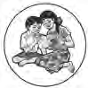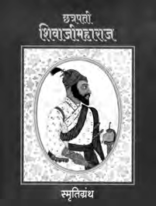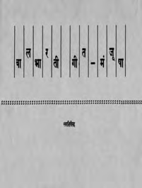

-  २८७७१८४२, पनिेल -  २७४६२६४६५, नञावशक -  २३९१५११, औरंगञाबञाद - 

२३३२१७१, नञागपूर -  २५४७७१६/२५२३०७८, लञातूर -  २२०९३०, अमरञािती -  २५३०९६५

7 41.00

